MASSACHUSETTS WIC APPROVED

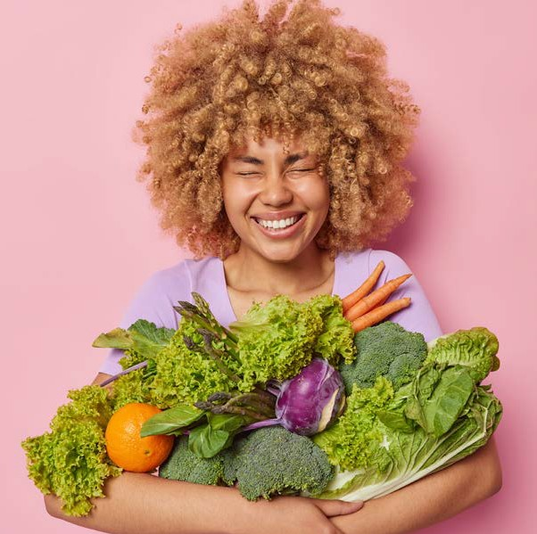
FOOD GUIDE

GOOD FOOD and
A WHOLE LOT MORE!

July 2023

Shopping with your WIC Card

- Buy what you need. You do not have to buy all your foods at one time!
- Have your card ready at check out.
- Before scanning any of your foods, tell the cashier you are using a WIC Card.
- When the cashier tells you, slide your WIC Card in the Point of Sale (POS) machine or hand your WIC Card to the cashier.
- Enter your PIN and press the enter button on the keypad.
- The cashier will scan your foods.
- The amount of approved food items and dollar amount of fruits and vegetables you purchase will be deducted from your WIC account.
- The cashier will give you a receipt which shows your remaining benefit balance and the date benefits expire. Save this receipt for future reference.
- It’s important to swipe your WIC Card before any other forms of payment. Any remaining balance can be paid with either cash, EBT, SNAP, or other form of payment accepted by the store.

Table of Contents

Fruits and Vegetables 1-2
Fresh Frozen Canned
Whole Grains 2-6
Whole Wheat Pasta Bread
Tortillas Brown Rice Oatmeal
Dairy 7-11
Milk Cheese Tofu Yogurt Eggs Soy milk
Peanut Butter and Beans 12-13
Peanut Butter
Dried Beans, Lentils, and Peas Canned Beans
Cereal 14-19
Hot Cereal Cold Cereal
Juice 20-23
Bottled Juice - Shelf Stable Frozen Juice
Infant Foods 24-26
Infant Fruits and Vegetables Infant Cereal
Infant Formula
For Fully Breastfeeding Moms and Babies Only (Infant Meats, Canned Fish)

1
Fruits & Vegetables

Fruits & Vegetables

FRESH
- Any size
- Any brand
- Whole, cut, bagged or packaged
- Organic allowed
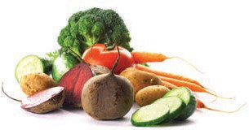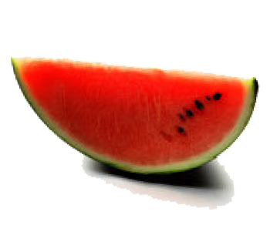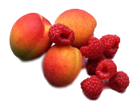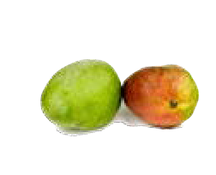
Not allowed
DO NOT BUY:
🚫 Added sugars, fats or oils
🚫 Dried fruits or vegetables
🚫 Herbs & spices
🚫 Fruit baskets
🚫 Party trays with added food items (dip, dressing, nuts, etc.)
🚫 Salad bar items
🚫 Salad kits
SHOPPING TIP
The availability of fresh produce varies by season. If a fresh produce item does not scan properly
at checkout, let the store know so it can be added as an approved item.

FROZEN
- Any size
- Any brand
- Any package type (bag, box, etc.)
- Any plain fruit or vegetable, or plain mixtures
- Organic allowed
Not allowed
DO NOT BUY:
🚫 Added fats, oils or salt
🚫 Added sugar, dextrose or artificial sweetener
🚫 Non-fruit or non-vegetable ingredients (pasta, rice, cheese, etc.)
🚫 Vegetables with sauce
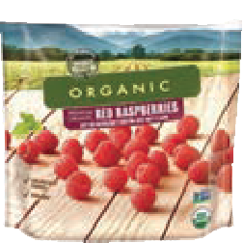
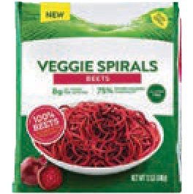
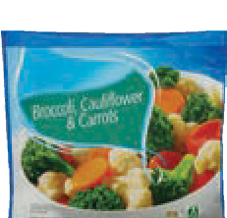
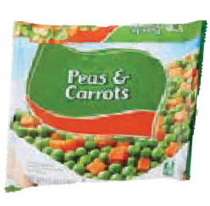

CANNED
  - Any size
  - Any brand
  - Any container (can, jar, plastic)
  - Any plain fruit or fruit mixtures packed in water or juice
  - Any plain vegetable or vegetable mixtures
  - Organic allowed
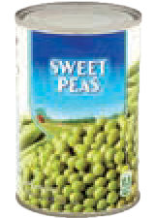
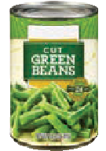
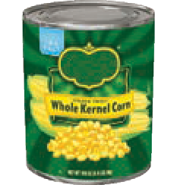

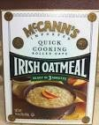
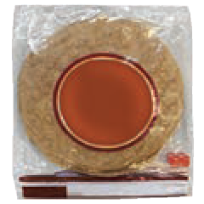
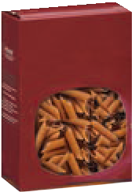
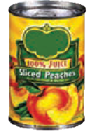
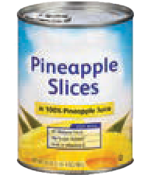
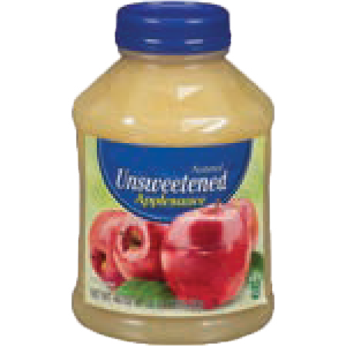
Whole Grains
16 oz
Brown Rice
Not allowed
DO NOT BUY:
🚫 Canned fruit packed in syrup
🚫 Sauce (pizza, spaghetti or tomato)
🚫 Items with added sugars, fats or oils
🚫 Pickled vegetables
🚫 Salsa
SHOPPING TIP
Whole grain benefit includes choices of:
Pasta: Whole wheat & whole grain Bread: Whole wheat & whole grain Tortillas: Whole wheat & corn Brown Rice
Oatmeal
16 oz

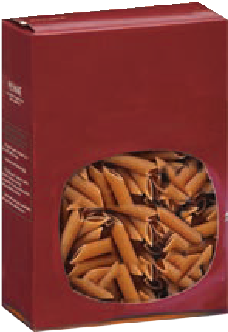
WHOLE WHEAT PASTA
  - 16 ounce (1 pound) packages
  - 100% Whole Wheat
16 oz
  - 100% Whole Grain
  - Any shape

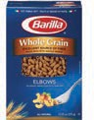
Barilla
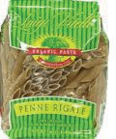
Luigi Vitelli

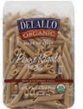
Delallo
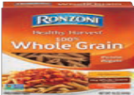
Ronzoni

Store Brands
365
Bowl & Basket Essential Everyday Good & Gather Great Value
O Organics Stop & Shop Signature Select

BREAD
- 16 ounce (1 pound) loaves
- Whole Wheat
- Whole Grain

SHOPPING TIP
Choose only 16 oz (1lb) loaves of bread
Many bread loaves are larger than 16 ounces (1 pound).
They are not WIC-approved. Check the weight carefully.

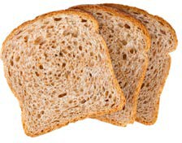
Store Brands
Big Y
Bowl & Basket Gold Medal Great Value Hannaford Krasdale Market Basket Roche Bros
Signature Select Stop & Shop Town Talk Trucchi’s

16 Ounce (1 pound) loaves

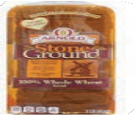
Arnold
- Stone Ground Wheat
- Select Wheat Sandwich rolls
Bimbo
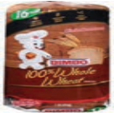
- 100% Whole Wheat

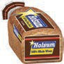
Holsum
  - 100% Wheat
  - All Natural 100% Wheat

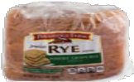
Pepperidge Farm
  - Whole Grain Seeded Rye

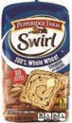
Pepperidge Farm
  - Swirl 100% Whole Wheat Cinnamon with Raisins

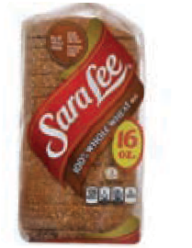
Sara Lee
  - Classic 100% Whole Wheat

Pepperidge Farm
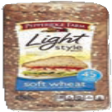
- Light Style Soft Wheat

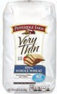
Pepperidge Farm
- 100% Whole Wheat Very Thin

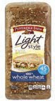
Pepperidge Farm
- Light Style 100% Whole Wheat

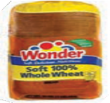
Wonder
- 100% Whole Wheat

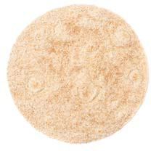
TORTILLAS
- 16 ounce (1 pound) packages
- 100% Whole Wheat
- Corn

Store Brands

SHOPPING TIP

Looking for tortillas? Try the bread aisle, the cooler section or with the taco supplies
Guerrero: Corn, Whole Wheat Hannaford: Corn, Whole Wheat Market Basket: Corn, Whole Wheat Nature’s Promise: Whole Wheat Signature Select: Whole Wheat Stop & Shop: Corn, Whole Wheat

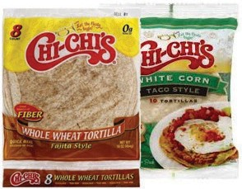
Chi-Chi’s
  - White corn, Taco Style
  - Whole Wheat, Fajita Style

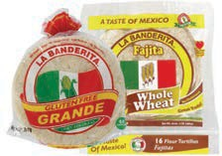
La Banderita
  - Corn
  - Whole Wheat, Fajita

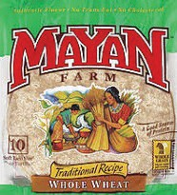
Mayan Farms
  - Whole Wheat Soft Taco

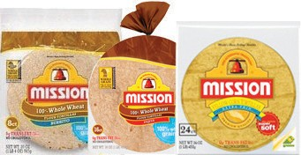
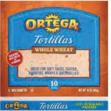
Mission
- Whole Wheat, Soft Taco
- Whole Wheat, Fajita
- Yellow Corn, Extra Thin

Ortega
- Whole Wheat

BROWN RICE
Not allowed
DO NOT BUY:
🚫 Added sugars, fats, oils or salt

- 14–16 ounce packages
- Bags, boxes and plastic jars
- Regular
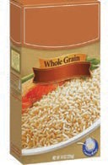
- Instant-cooking
- Quick-cooking
Brown Rice
- Boil-in-bag

Brown Rice

OATMEAL
- 16 ounce packages
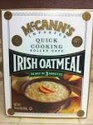
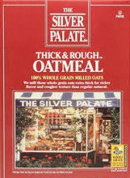

McCann’s Irish Oatmeal
Silver Palate Thick and Rough Oatmeal

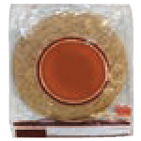
SHOPPING TIP

You can choose a mix of bread, pasta, tortillas, rice, and oatmeal to add up to the total number of packages of Bread/Whole Grains on your Family Foods Benefit list. Here are two examples:

+ = TWO (2)

16 oz

ONE (1)
16 ounce package tortillas

ONE (1)
16 ounce loaf bread
16 oz
PACKAGES of
16 oz. Bread/ Whole Grains

+ +

16 oz

ONE (1)
16 ounce package rice

16 oz

ONE (1)
16 ounce package tortillas

ONE (1)
16 ounce loaf bread
16 oz

= THREE (3) PACKAGES of 16 oz. Bread/Whole Grains

Dairy
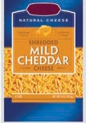
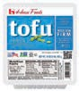
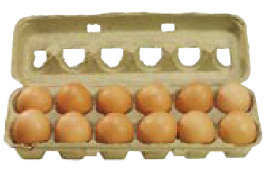
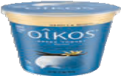

MILK

- Fluid: Least expensive brand
- Evaporated or Dry Milk: Any brand
- Long-Life Milk: Any brand
- Lactose Free Milk: Any brand
SHOPPING TIP
Choose only what is approved for you.
- Whole milk for children 12-24 months
- Low-fat (1%) and nonfat (skim) milk for women and children 2-5 years

Fluid
Not allowed
DO NOT BUY:
🚫 Organic
🚫 Flavored

Least Expensive Brand
- Fat-free, 1%, Low-fat, 2% Reduced fat, Whole

Long-life/Self-stable Nonfat dry milk power

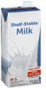
Quart
  - Any Brand
16 and 32 ounce boxes
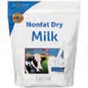
    - Any Brand

Lactose-free Evaporated Milk

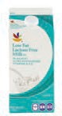
96 ounce and half gallons
7
Milk
  - Any Brand
12 ounce cans, Whole, Low-fat or Fat-free
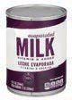
    - Any Brand

CHEESE

- 16 oz. packages only
- Blocks
- American slices
- String, Shredded
- Regular, Low-fat
- Any brand: American, Colby, Cheddar, Monterey Jack, Mozzarella or Muenster

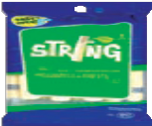
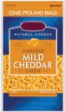
Not allowed
DO NOT BUY:
🚫 Imported or deli cheese
🚫 Sliced cheese (except American)
🚫 Cheese food/product spread
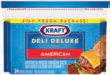
🚫 Individually wrapped slices
🚫 Flavored
🚫 Organic

TOFU

- 16 oz. packages only
- Organic allowed

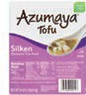
Azumaya
  - Silken Tofu

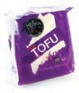
Heiwa
  - Organic

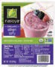
Nasoya
  - Lite Silken Tofu
  - Organic Silken Tofu
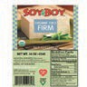
  - Organic Super Firm Tofu

SoyBoy
  - Organic Firm Tofu

Franklin Farms
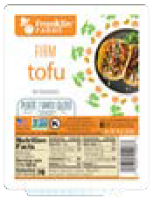
- Extra Firm Tofu
- Firm Tofu
- Medium Firm Tofu
- Soft Tofu

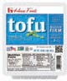
House Foods
- Extra Firm Tofu
- Firm Tofu
- Medium Firm Tofu

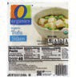
O Organics
- Silken Tofu

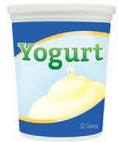
YOGURT
Dairy
- 32 ounce tubs
- 8-packs and 16-packs of 2 oz. tubes
- 8-packs multipack of 4 oz. containers
- Greek allowed
- Organic allowed
Not allowed
DO NOT BUY:
🚫 Artificial Sweeteners
SHOPPING TIP
Choose only what is approved for you.
- Whole milk yogurt for children 12-24 months
- Low-fat and nonfat yogurt for women and children 2-5 years

32 ounce tubs
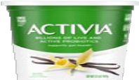
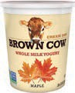
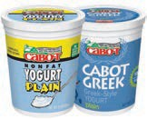
Activia
- Any flavor

Brown Cow
- Any flavor

Cabot &
Cabot Greek
- Any flavor

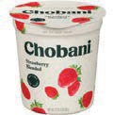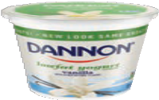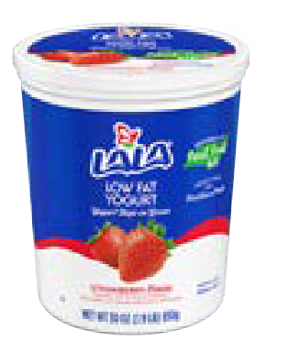

Dannon
Chobani
- Any flavor

- Any flavor
LALA
- Any flavor

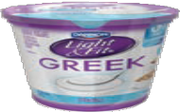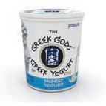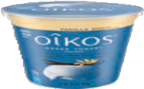

Light & Fit
9
Yogurt
- Plain Only
Greek Gods
- Any flavor
Oikos Greek
- Any flavor

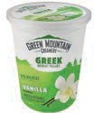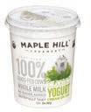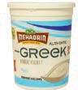

Green Mountain Creamery
  - Any flavor
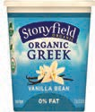
Stonyfield Organic, Greek
  - Any flavor
Maple Hill
- Any flavor

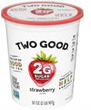
Two Good
- Any flavor
Mehadrin
  - Any flavor
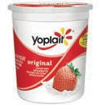
Yoplait
  - Any flavor

32 ounce tubs: Store Brands

365
Best Yet
Bowl & Basket
Hannaford Lucerene Dairy Market Basket

Essential Everyday Nature’s Promise

Food Club Good & Gather Great Value
Open Nature
Pics by Price Chopper Stop & Shop

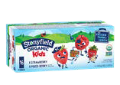
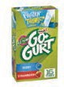
Stonyfield Kids Tubes
Tubes
- 8 pack – 2 oz. tubes (1LB package)*
- 16 pack – 2 oz. tubes (2LB package)

Yoplait GO-GURT Tubes
- 8 pack – 2 oz. tubes (1LB package)*
- 16 pack – 2 oz. tubes (2LB package)

Multipacks

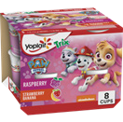
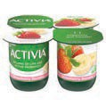
Activia Multipack
- 4 pack (1LB package)*

Yoplait Multipack 4 oz.
- 8 pack (2LB package)
*Can purchase two (2) 1LB packs to equal 32 oz.

11
Eggs and Soy Milk

EGGS

- Whole dozen
- Medium, Large, Extra Large and Jumbo
- Brown and white
- Least expensive brand

Dozen, Grade A Medium, Large, Extra Large and Jumbo
Not allowed
DO NOT BUY:
🚫 Organic
🚫 Enhanced or specialty (Omega-3)
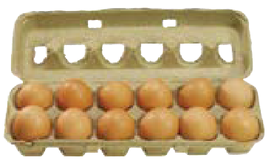
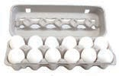

SOY MILK BEVERAGE

- Refrigerated: 64 ounce (1/2 gallon)
- Shelf-stable: 32 ounce (1 quart)

Refrigerated: 64 ounce (1/2 gallon)

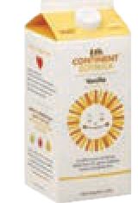
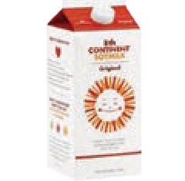
8th Continent
  - Original
  - Vanilla

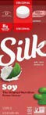
Silk
  - Original

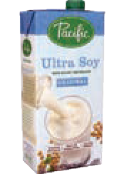
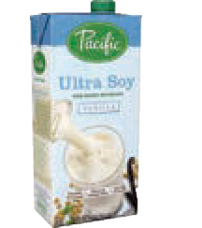
Shelf-stable: 32 ounce (1 quart)

Pacific
Not allowed
DO NOT BUY:
🚫 Organic
  - Ultra Soy Original
  - Ultra Soy Vanilla

Peanut Butter & Beans
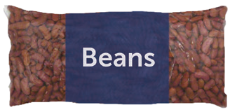
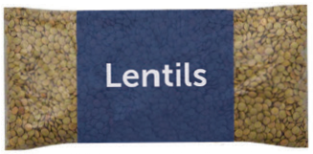
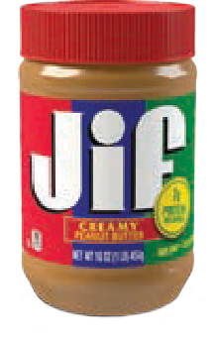
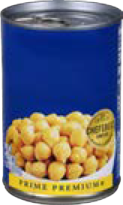

Chickpeas

A

PEANUT BUTTER
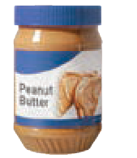
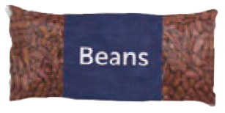
SHOPPING TIP
One (1) 18 oz Peanut Butter/Dry Beans on your Family Food Benefits list means you can buy:
OR
B

ONE (1)
16 oz package of dry beans, lentils, peas
A

ONE (1)
16–18 oz jar of peanut butter
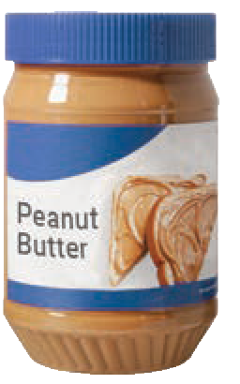
- 16–18 ounce jars
- Smooth/Creamy
- Chunky/Crunchy
- Plastic or glass jars

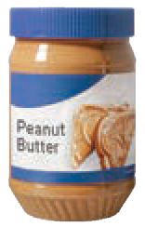
16–18 ounce jars Not allowed
DO NOT BUY:

Any brand

Jif

Peter Pan
🚫 Reduced fat
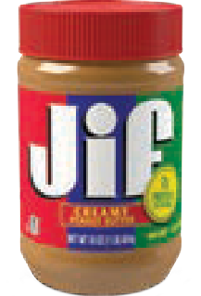
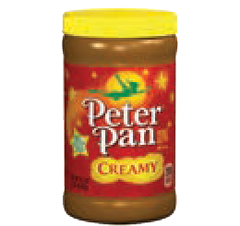
🚫 Organic
🚫 Specialty peanut butters
🚫 Peanut butter spreads
🚫 Flavored

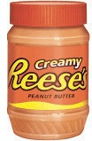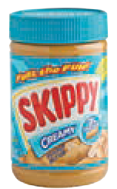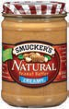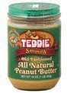

Reese’s
Skippy Smuckers
Teddie

B

DRIED BEANS, LENTILS & PEAS

- Any brand
- 16 ounce (1 pound) packages
- Any type of mature beans, lentils or peas
Not allowed
DO NOT BUY:
🚫 Organic

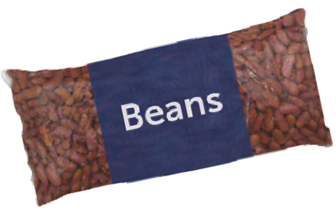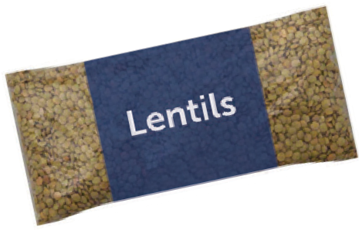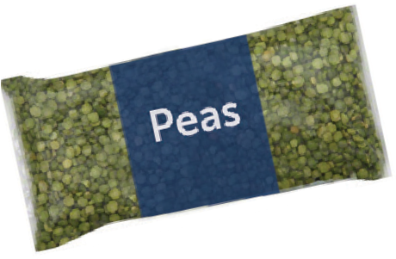

CANNED BEANS

- 15–16 ounce cans
- Any brand
- Plain mature beans, peas or lentils

Not allowed
DO NOT BUY:
🚫 Organic
🚫 Green or wax beans*
🚫 Green peas or green pigeon peas*

13
Peanut Butter & Beans
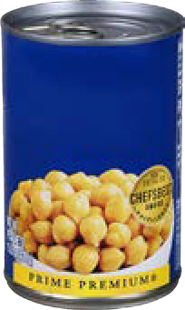
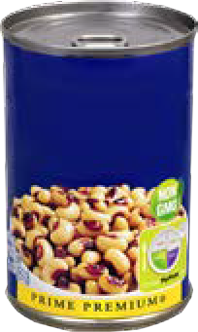
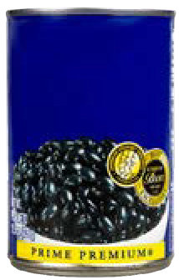
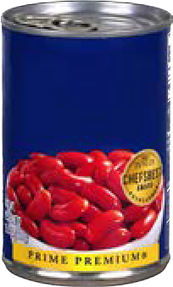
*These items can be purchased with fruit & vegetable benefits
Chickpeas
Black Eyed Peas
Red
Kidney Beans
Black Beans

Cereal
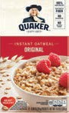
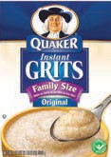
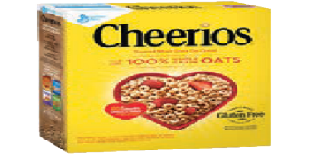
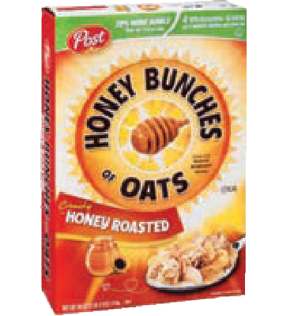
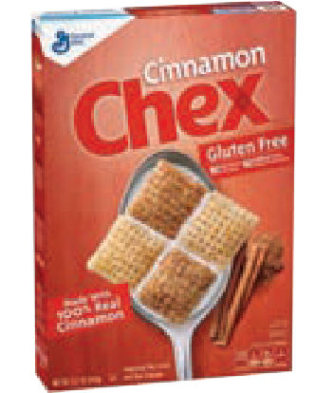

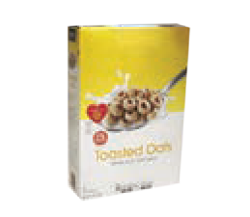
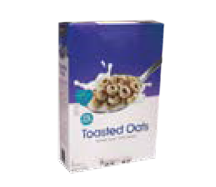
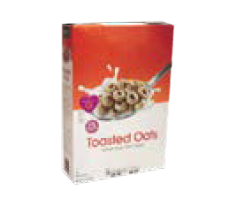
SHOPPING TIP
Combine hot or cold cereal packages to add up to the total ounces on your Family Food Benefits list. Here are three ways to buy up to 36 ounces of cereal:

+ +

ONE (1)
12 oz cereal

ONE (1)
12 oz cereal

ONE (1)
12 oz cereal
12 oz
12 oz
12 oz

= 36 oz of cereal

+ = 32.5 oz of cereal

ONE (1)
18 oz cereal

ONE (1)
14.5 oz cereal
14.5 oz
18 oz

+ = 36 oz of cereal

ONE (1)
18 oz cereal

ONE (1)
18 oz cereal
18 oz
18 oz

HOT CEREAL
Key
Whole grain Gluten-free
- 11 ounce or larger packages
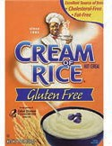
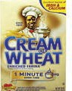
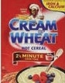
Cream
of Rice
Gluten
Free

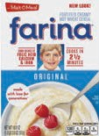
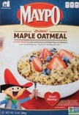
Farina
  - Original Hot Wheat Cereal

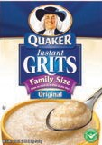
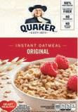
Quaker Instant Grits

Store Brands

Cream of Wheat
- 1 Minute
- 2½ Minute

Maypo
Maple Oatmeal Vermont Style Oatmeal

Quaker Instant Oatmeal Packets
Maple Oatmeal

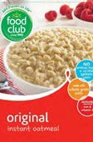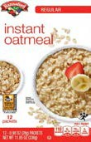
Food Club
- Instant Oatmeal (Regular)

Hannaford
- Instant Oatmeal (Regular)

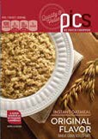
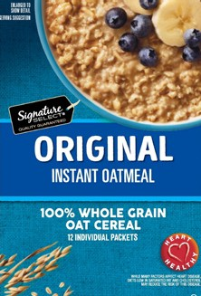
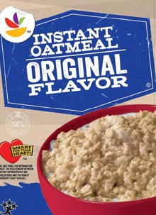
Pic’s by Price
Chopper
- Instant Oatmeal
(Regular)

Signature
Select
- Instant Oatmeal
(Regular)

Stop & Shop
- Instant Oatmeal (Regular)

COLD CEREAL
Key
Whole grain Gluten-free
  - 11 ounce or larger packages

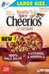
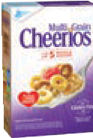
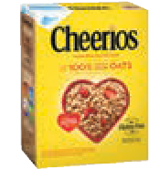
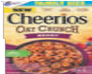
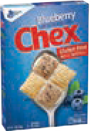
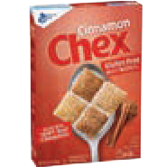
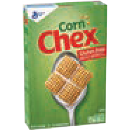
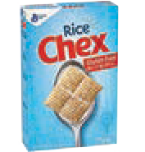
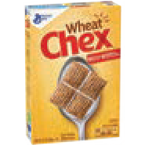
General Mills
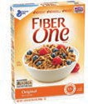
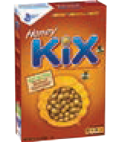
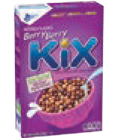
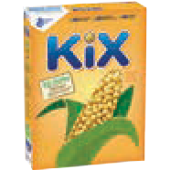
Cheerios
Multigrain Oat Crunch Berry
Original
Vanilla Spice

Chex
Blueberry Cinnamon Corn
Rice
Wheat

Fiber One
Honey Clusters

Kix
Berry Berry Honey Original

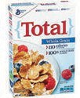
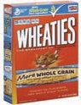
Total Wheaties

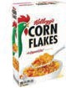
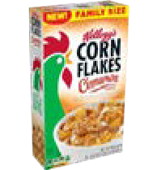
Kellogg’s
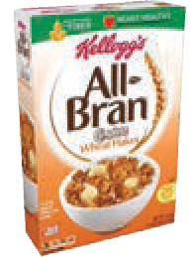
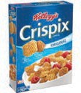
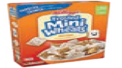
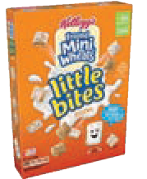
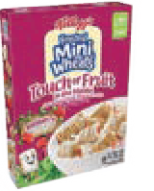
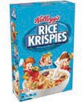
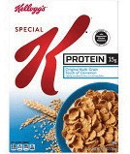
All Bran
Complete Wheat Flakes

Corn Flakes
- Cinnamon
- Original

Crispix
- Original

Frosted Mini Wheats
Cinnamon Roll Little Bites: Original, Chocolate
Touch of Fruit: Blueberry, Raspberry,
Strawberry

Rice Krispies
- Original

Special K
Banana Multigrain: Touch of Cinnamon
Protein Honey Almond
Protein Original

Post
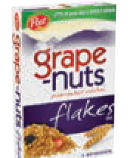
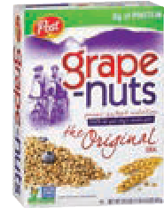
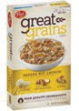
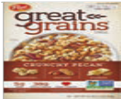
Grape Nuts
Flakes Original

Great Grains
Banana Nut Crunch
Crunchy Pecan

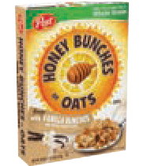
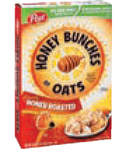
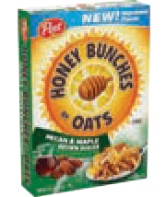
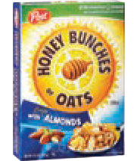
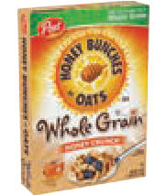
Honey Bunches Of Oats
Honey Crunch
    - Honey Roasted
    - Pecan & Maple Brown Sugar Vanilla Bunches
    - With Almonds

Quaker

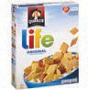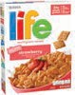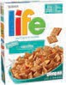
Life
Original Strawberry
Vanilla

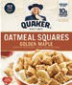
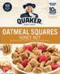
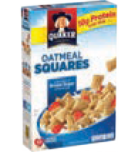
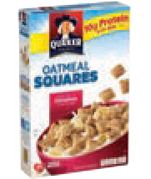
Oatmeal Squares
Golden Maple Hint of Brown Sugar
Hint of Cinnamon Honey Nut

Store Brands

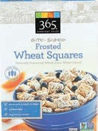
365
365 Frosted Wheat Squares

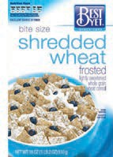
Best Yet
Bite Size Frosted Shredded Wheat Bran Flakes
- Corn Flakes
- Crispy Rice
Frosted Shredded Wheat
- Honey Oats & Flakes
- Toasted Oats

Store Brands (Continued)

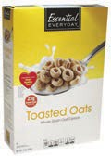
Essential Everyday
Bran Flakes
- Crispy Rice
Frosted Shredded Wheat
- Honey Oats & Almonds
- Honey Oats & Flakes

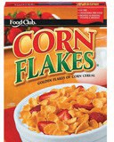
Food Club
Bran Flakes
- Corn Flakes
- Corn Squares
- Crisp Rice

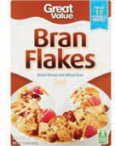
Great Value
Bran Flakes
- Corn Flakes
- Corn Squares
- Crisp Rice
Crunchy Nugget
Frosted Shredded Wheat

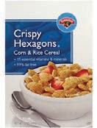
Hannaford
Bran Flakes
Bite Size Frosted Shredded Wheat
Bite Size Strawberry Frosted Shredded Wheat
- Corn Flakes
- Crispy Hexagons
- Crispy Rice
Easy Living Oat Squares Frosted Shredded Wheat Multigrain Tasteeos

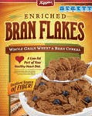
Kiggins
Bran Flakes
- Corn Flakes
- Crispy Rice

- Honey & Oats with Almonds
- Rice Squares
- Toasted Oats

Multigrain O’s O’s
- Rice Squares
- Wheat Squares
- Toasted Oats

Nutty Nuggets
- Oats & More with Almonds
- Oats & More with Honey
- Tasteeos
- Toasted Corn Squares
- Toasted Rice Squares Toasted Wheat Wheat Flakes

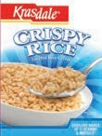
Krasdale
  - Corn Flakes
  - Crispy Rice Toasted Oats

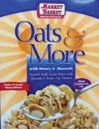
Market Basket
Bran Flakes
  - Corn Biscuits
  - Corn Flakes
  - Crispy Hexagons
Frosted Shredded Wheat

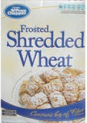
Pics by Price Chopper
Bran Flakes
- Corn Flakes
- Crispy Rice
Frosted Shredded Wheat Good Choice Oat Crunch
- Honey Oats & Flakes with Almonds

- Oats & More with Almonds
- Oats & More with Honey
- Rice Biscuits
- Tasteeo's

Toasted Oats Nutty Nuggets
- Toasted Corn Crisps
- Toasted Rice Crisps Toasted Oats Strawberry Frosted Shredded Wheat

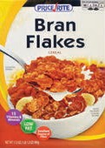
Price Rite
Bite Size Shredded Wheat Bran Flakes
  - Corn Flakes
  - Crispy Rice
Frosted Shredded Wheat

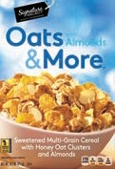
Signature Select
Bran Flakes
Bite Sized Frosted Wheat
- Corn Flakes
- Corn Pockets
- Crispy Rice

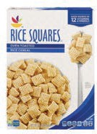
Stop & Shop
Bite Sized Frosted Shredded Wheat
Bran Flakes
  - Corn Flakes
  - Corn & Rice Hexagons
  - Crispy Rice

  - Honey Oat Clusters With Almonds
Multigrain Toasted Oats

  - Oats & More with Almonds
  - Oats & More with Honey
  - Rice Pockets Toasted Oats

Juice
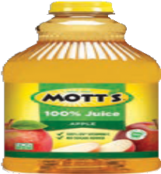
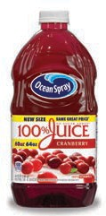
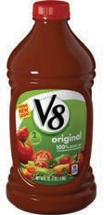
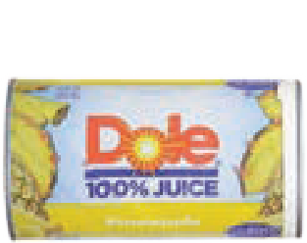
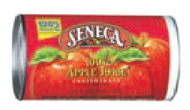

SHELF-STABLE

    - Shelf-stable 100% Juice: 64 ounce bottles

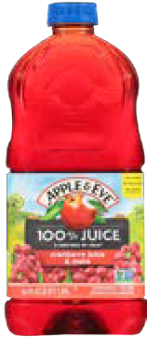
Apple & Eve
      - Apple
      - Big Birds Apple
      - Cookie Monsters Berry
      - Cranberry and More
      - Cranberry Apple
      - Cranberry Grape
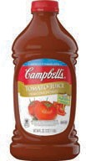
      - Cranberry Pomegranate

- Cranberry Raspberry
- Elmo & Tangos Punch
- Grovers White Grape
- Mango Strawberry
- Natural Style Apple
- Naturally Cranberry

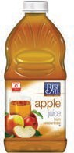
Best Yet
- Apple Juice
- Apple Kiwi Strawberry
- Cranberry
- Grape
- Pineapple
- White Grape
- White Grapefruit

Campbell’s
- Tomato
- Tomato Low Sodium

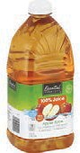
Essential Everyday
  - Apple Cider
  - Apple
  - Cranberry
  - Grape
  - Orange

- Pineapple Juice
- Vegetable
- White Grape
- White Grapefruit

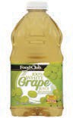
Food Club
Not allowed
DO NOT BUY:
🚫 Organic
🚫 Light
🚫 Fiber added

  - Apple
  - Grape
  - Grapefruit
  - White Grape
  - Vegetable

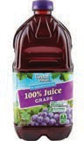
Great Value
- Apple
- Cranberry
- Cranberry Pomegranate
- Grape
- Orange

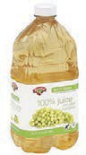
Hannaford
- Apple
- Cherry
- Cranberry
- Cranberry Grape
- Fruit Punch
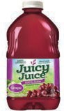
- Grape

Juicy Juice
- Any flavor

- Pineapple
- Tomato
- Vegetable
- White Grape
- White Grape Peach

- Pineapple
- Tomato
- Vegetable
- Vegetable Low Sodium
- White Grape
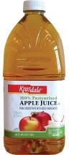
- White Grapefruit

Krasdale
  - Apple
  - Grape
  - White Grape

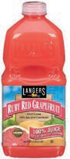
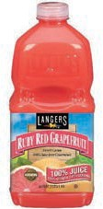
Langers
- Apple
- Apple Berry Cherry
- Apple Cranberry
- Apple Grape
- Apple Kiwi Strawberry
- Apple Orange Pineapple
- Apple Peach Mango

- Cranberry Plus
- Cranberry
- Cranberry Grape Plus
- Cranberry Raspberry Plus
- Disney Apple Cranberry Grape
- Disney Berry
- Disney Grape

- Disney Punch
- Grape
- Grape Plus
- Orange
- Pomegranate Cranberry Plus
- Pineapple
- Tomato Juice
- White Grape

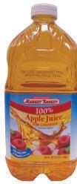
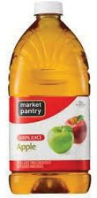
Market Basket
  - Apple
  - Cranberry
  - Cranberry & Grape
  - Grape
  - White Grape
  - White Grape Peach
Market Pantry
- Apple
- Cranberry
- Tomato
- White Grape

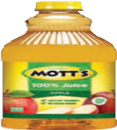
Motts
  - Apple, Sensibles Apple
  - Apple Cherry
  - Apple Mango
  - Apple White Grape

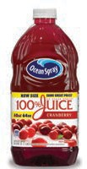
Ocean Spray
    - Apple
    - Concord Grape
    - Cranberry
    - Cranberry Blackberry
    - Cranberry Cherry
    - Cranberry Elderberry

    - Cranberry Concord Grape
    - Cranberry Mango
    - Cranberry Pineapple
    - Cranberry Pomegranate
    - Cranberry Raspberry
    - Cranberry Watermelon

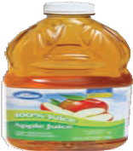
Pic's by Price Chopper

      - Apple
      - Berry
      - Cherry
      - Cranberry Grape
      - Cranberry Raspberry
      - Grape
      - Grapefruit
    - Pineapple
    - Tomato
    - Vegetable
    - Vegetable Low Sodium
    - White Grape
    - White Grape Peach

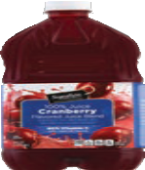
Signature Select
      - Apple
      - Berry Blend
      - Cranberry
      - Cranberry Grape
      - Cranberry Raspberry
      - Grape
      - Grapefruit

    - Orange
    - Pineapple
    - Tomato
    - Vegetable Low Sodium
    - White Grapefruit
    - White Grape

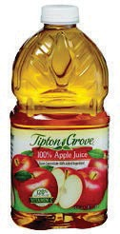
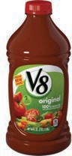
Tipton Grove
V8 Vegetable
- Original Vegetable
- Spicy Hot Vegetable
- Low Sodium

      - Apple
      - Grape
      - Orange
      - Pineapple

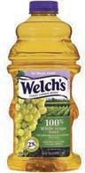
Welch’s 100%
- Grape
- Orange Pineapple
- White Grape
- White Grape Peach
- Red Grape
- Tropical Trio

FROZEN

- Frozen concentrate:
Not allowed
DO NOT BUY:
🚫 Organic
11.5–12 ounce cans

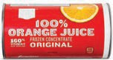
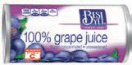
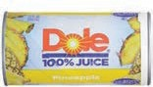

Any store brand Orange Juice
Best Yet
- Apple
Dole
- 100 % juice,
Any flavor

- Grape
- Grapefruit

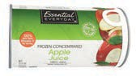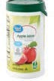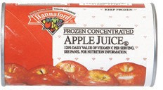

Essential Everyday
  - Apple

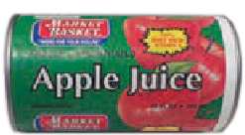

Market Basket
    - Apple
    - Grape
Great Value
- Apple
- Grape

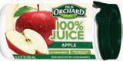

Old Orchard
- Green peel strip,
Any flavor

Hannaford
  - Apple
  - Grape
  - Pineapple Orange
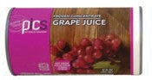
Pics by Price Chopper
- Apple
- Apple Raspberry
- Grape
- White Grape

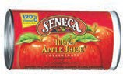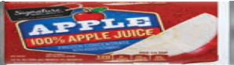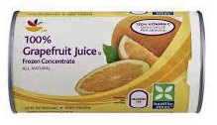

Seneca
  - Apple
Signature Select
- Apple
Stop & Shop
- Apple
- Grape
- Grapefruit

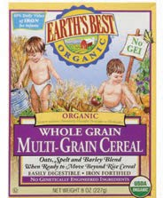
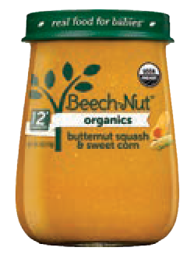
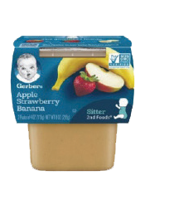
Infant Foods

FRESH FRUIT & VEGETABLE OPTION
At 9 months of age, half of the jarred infant food benefit can be replaced with fresh fruits and vegetables:
- $4 for partially breastfeeding or fully formula feeding infants
- $8 for fully breastfeeding infants
If this option is not already on your Shopping List and you would like it, contact your local WIC office.

INFANT FRUITS & VEGETABLES
Not allowed
DO NOT BUY:
🚫 Mixtures with cereal or food combinations
🚫 Dinners
🚫 Pouches
🚫 Desserts

- Any variety fruit or vegetables
- Any variety mixed fruits and mixed vegetables

4 ounce jars
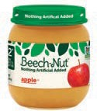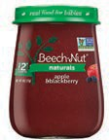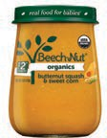

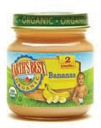
Beech-Nut (Stage 2)

Earth’s Best (Stage 2)
Beech-Nut Naturals
(Stage 1 & Stage 2)
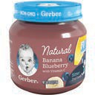
Gerber Naturals (1st & 2nd Foods)
Beech-Nut Organics
(Stage 1 & Stage 2)
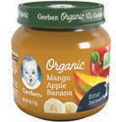
Gerber Organic (1st & 2nd Foods)

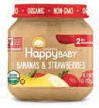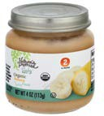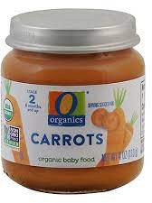

Happy Baby Organics
(Stage 1 & Stage 2)
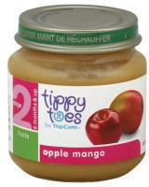
Tippy Toes (Stage 2)
Nature's Promise
O Organics

2nd Foods/Stage 2 (2-packs of 4 ounce tubs)
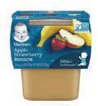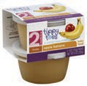

Gerber (2nd Foods)
Tippy Toes (Stage 2)

INFANT CEREAL
*Must have benefits for the 2-packs to purchase the tubs.
- 8 ounce packages only
- Single and multigrain
- Organic allowed

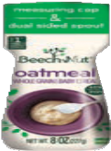
Beech-Nut
- Multigrain
- Oatmeal
- Organic Multigrain
- Organic Oatmeal

Not allowed
DO NOT BUY:
🚫 Added fruit, formula or vegetables

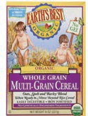
Earth’s Best Organic
  - Whole Grain Multigrain
  - Whole Grain Oatmeal
Gerber
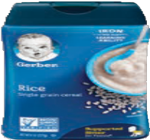
- Multigrain
- Oatmeal
- Organic Oatmeal
- Organic Oatmeal Millet Quinoa
- Organic Rice
- Rice
- Whole Wheat

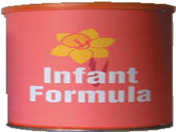
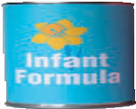
INFANT FORMULA
- Purchase size and type shown on WIC Shopping List

For Fully Breastfeeding Moms and Babies ONLY

INFANT MEATS

- 2.5 ounce jars
- Stage 1 or Stage 2
Not allowed
DO NOT BUY:
🚫 Added sugar or salt
🚫 Dinners

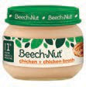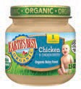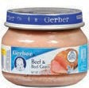

Beech-Nut Classics (Stage 1)
Earth’s Best (Stage 1)
Gerber (Stage 2)

CANNED FISH
- Sizes and varieties shown
- Packed in water
- Sardines may include bones and skin

Not allowed
DO NOT BUY:
🚫 Albacore tuna

Chunk Light Tuna
Sardines Salmon

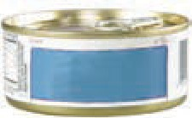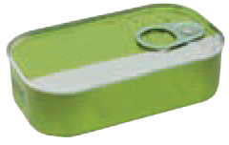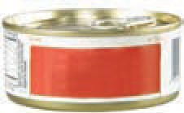

Tuna

Salmon
Any brand
- 5 ounce

Any brand
- 3.75 ounce

Any brand
- 5 ounce

Common Questions about your Card

What should I do if my card is lost or stolen?
Call your local WIC Program right away! They will stop anyone from using your food benefits and help you get a new card.

Is there a fee to replace my WIC Card?

Massachusetts WIC will replace your card free of charge.

What happens if I can’t do my own shopping and need someone else to shop for me?
You may have someone else shop for you if you wish. You can give them your WIC Card and PIN. Just make sure this is someone you can trust!

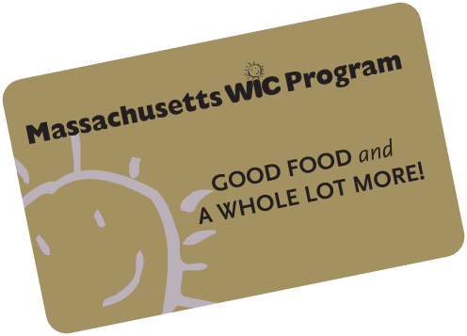

What if I forgot my PIN or want to change it?
You can contact your local WIC office to change your PIN.

What if I enter the wrong PIN?

DO NOT try to guess your PIN. After several incorrect attempts, your PIN will be locked. This is done as a protection from someone guessing your PIN and getting your food benefits.

There are three ways to unlock your card:

- call your local program
- call the 800 number on the back of your card
- wait until midnight and your account will automatically unlock

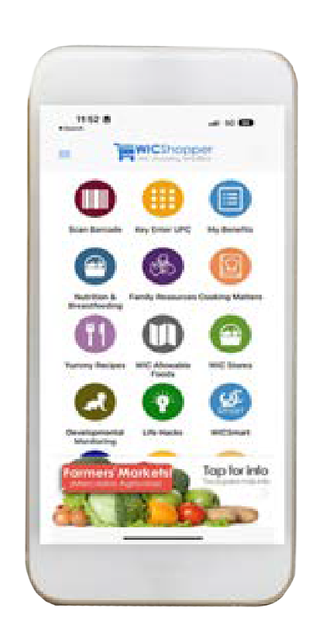

Simplify your shopping
Download the
‘WIC Shopper’ App!
- Check your WIC balance
- Locate a WIC authorized store
- Scan a product to determine if it’s WIC approved
- Access WIC recipes

@MassWIC
1-800-WIC-1007

Retail Stores call:
1-800-552-9425 – Retail Hotline
mass.gov/wic

This institution is an equal opportunity provider.
7/23 Form # 183

