INDOOR AIR QUALITY ASSESSMENT

Southborough Town House
17 Common Street
Southborough, Massachusetts



Prepared by:
Massachusetts Department of Public Health
Bureau of Environmental Health
Indoor Air Quality Program
November 2010

Background/Introduction
At the request of Mr. Phil Rinehart, Facilities Director for the town of Southborough, the Massachusetts Department of Public Health (MDPH), Bureau of Environmental Health (BEH) provided assistance and consultation regarding indoor air quality concerns at the Southborough Town House (STH), located at 17 Common Street, Southborough, MA. On May 11, 2010, a visit to conduct an assessment was made to this building by Cory Holmes, Environmental Analyst/Regional Inspector for BEH’s Indoor Air Quality (IAQ) Program.
The building is a two-story, red brick structure with a basement constructed in the early 1900s. The building was reportedly renovated in the late 1970s. An addition was built in the 1980s. The building serves as the town hall and consists of local governmental offices and meeting rooms. Windows are not openable in the building. The ductwork to the heating, ventilation and air conditioning (HVAC) system was reportedly cleaned two years ago. Current building improvement projects reportedly include re-pointing of the chimney and upgrading of the boiler system and controls.

Methods
Air tests for carbon monoxide, carbon dioxide, temperature and relative humidity were conducted with the TSI, Q-Trak, IAQ Monitor, Model 7565. Air tests for airborne particle matter with a diameter less than 2.5 micrometers were taken with the TSI, DUSTTRAK™ Aerosol Monitor Model 8520. BEH staff also performed visual inspection of building materials for water damage and/or microbial growth.

Results
The building has an employee population of approximately 20 and can be visited by up to 50 members of the public daily. Tests were taken during normal operations and results appear in Table 1.

Discussion

Ventilation
It can be seen from Table 1 that carbon dioxide levels were below 800 parts per million (ppm) in all areas surveyed, indicating adequate air exchange in the building at the time of the assessment (Table 1). The HVAC system consists of several air handling units (AHUs) located in the basement (Pictures 1 and 2). Conditioned air is distributed to occupied areas via ducted supply diffusers (Picture 3). Air is returned back to the AHUs via ceiling or wall-mounted return vents (Pictures 4 and 5).
To maximize air exchange, the MDPH recommends that both supply and exhaust ventilation operate continuously during periods of occupancy. In order to have proper ventilation with a mechanical supply and exhaust system, the systems must be balanced to provide an adequate amount of fresh air to the interior of a room while removing stale air from the room. It is recommended that HVAC systems be re-balanced every five years to ensure adequate air systems function (SMACNA, 1994). The date of the last balancing of these systems was not available at the time of the assessment.
The Massachusetts Building Code requires that each room have a minimum ventilation rate of 20 cubic feet per minute (cfm) per occupant of fresh outside air or openable windows (SBBRS, 1997; BOCA, 1993). The ventilation must be on at all times that the room is occupied. Providing adequate fresh air ventilation with open windows and maintaining the temperature in the comfort range during the cold weather season is impractical. Mechanical ventilation is usually required to provide adequate fresh air ventilation.
Carbon dioxide is not a problem in and of itself. It is used as an indicator of the adequacy of the fresh air ventilation. As carbon dioxide levels rise, it indicates that the ventilating system is malfunctioning or the design occupancy of the room is being exceeded. When this happens, a buildup of common indoor air pollutants can occur, leading to discomfort or health complaints. The Occupational Safety and Health Administration (OSHA) standard for carbon dioxide is 5,000 parts per million parts of air (ppm). Workers may be exposed to this level for 40 hours/week, based on a time-weighted average (OSHA, 1997).
The MDPH uses a guideline of 800 ppm for publicly occupied buildings. A guideline of 600 ppm or less is preferred in schools due to the fact that the majority of occupants are young and considered to be a more sensitive population in the evaluation of environmental health status. Inadequate ventilation and/or elevated temperatures are major causes of complaints such as respiratory, eye, nose and throat irritation, lethargy and headaches. For more information concerning carbon dioxide, please see Appendix A.
Temperature readings in the building ranged from 67º F to 70 º F, which were within or close to the lower end of the MDPH recommended comfort guidelines on the day of the assessment. The MDPH recommends that indoor air temperatures be maintained in a range of 70 º F to 78 º F in order to provide for the comfort of building occupants. In many cases concerning indoor air quality, fluctuations of temperature in occupied spaces are typically experienced, even in a building with an adequate fresh air supply. Occupants in the Planning Board/Conservation Commission Area complained of drafts from the supply vent. These vents should be adjusted if possible or occupants should be relocated from the vicinity of vent to reduce drafts/improve comfort.
The relative humidity measured in the building ranged from 24 to 35 percent, which was below the MDPH recommended comfort range in all areas surveyed during the assessment. The MDPH recommends a comfort range of 40 to 60 percent for indoor air relative humidity. Relative humidity levels in the building would be expected to drop during the winter months due to heating. The sensation of dryness and irritation is common in a low relative humidity environment. Low relative humidity is a very common problem during the heating season in the northeast part of the United States.

Microbial/Moisture Concerns
BEH staff examined the exterior of the building to identify breaches in the building envelope and/or other issues that could provide a source of water penetration. Several potential sources were identified:
- Efflorescence was observed on exterior brick (Picture 6). Efflorescence is a characteristic sign of water intrusion, but it is not mold growth. As penetrating moisture works its way through mortar around brick, it leaves behind characteristic white, powdery mineral deposits; and
- Missing/damaged mortar was seen around exterior brick in some areas (Picture 7).
These conditions can undermine the integrity of the building envelope and provide a means of water entry by capillary action into the building through exterior walls, foundation concrete and/or masonry (Lstiburek & Brennan, 2001). In addition, these breaches in exterior areas can provide a means of drafts and pest entry into the building.
The US Environmental Protection Agency and the American Conference of Governmental Industrial Hygienists (ACGIH) recommends that porous materials (carpeting, ceiling tiles, etc.) be dried with fans and heating within 24 to 48 hours of becoming wet (US EPA, 2001; ACGIH, 1989). If porous materials are not dried within this time frame, mold growth may occur. Water-damaged porous materials cannot be adequately cleaned to remove mold growth. The application of a mildewcide to moldy porous materials is not recommended.
Plants were noted in several offices and common areas. Plants can be a source of pollen and mold which can be respiratory irritants to some individuals. Plants should be properly maintained and equipped with drip pans made of a non-porous material (e.g., glass or metal) and should be located away from univents to prevent the aerosolization of dirt, pollen and mold.

Other IAQ Evaluations
Indoor air quality can be negatively influenced by the presence of respiratory irritants, such as products of combustion. The process of combustion produces a number of pollutants. Common combustion emissions include carbon monoxide, carbon dioxide, water vapor, and smoke (fine airborne particle material). Of these materials, exposure to carbon monoxide and particulate matter with a diameter of 2.5 micrometers (μm) or less (PM2.5) can produce immediate, acute health effects upon exposure. To determine whether combustion products were present in the indoor environment, BEH staff obtained measurements for carbon monoxide and PM2.5.

Carbon Monoxide
Carbon monoxide is a by-product of incomplete combustion of organic matter (e.g., gasoline, wood and tobacco). Exposure to carbon monoxide can produce immediate and acute health effects. Several air quality standards have been established to address carbon monoxide and prevent symptoms from exposure to these substances. The MDPH established a corrective action level concerning carbon monoxide in ice skating rinks that use fossil-fueled ice resurfacing equipment. If an operator of an indoor ice rink measures a carbon monoxide level over 30 ppm, taken 20 minutes after resurfacing within a rink, that operator must take actions to reduce carbon monoxide levels (MDPH, 1997).
The American Society of Heating Refrigeration and Air-Conditioning Engineers (ASHRAE) has adopted the National Ambient Air Quality Standards (NAAQS) as one set of criteria for assessing indoor air quality and monitoring of fresh air introduced by HVAC systems (ASHRAE, 1989). The NAAQS are standards established by the US EPA to protect the public health from six criteria pollutants, including carbon monoxide and particulate matter (US EPA, 2006). As recommended by ASHRAE, pollutant levels of fresh air introduced to a building should not exceed the NAAQS levels (ASHRAE, 1989). The NAAQS were adopted by reference in the Building Officials & Code Administrators (BOCA) National Mechanical Code of 1993 (BOCA, 1993), which is now an HVAC standard included in the Massachusetts State Building Code (SBBRS, 1997). According to the NAAQS, carbon monoxide levels in outdoor air should not exceed 9 ppm in an eight-hour average (US EPA, 2006).
Carbon monoxide should not be present in a typical, indoor environment. If it is present, indoor carbon monoxide levels should be less than or equal to outdoor levels. Outdoor carbon monoxide concentrations were non-detect (ND) the day of the assessment (Table 1). No measureable levels of carbon monoxide were detected in the building during the assessment (Table 1).

Particulate Matter
The US EPA has established NAAQS limits for exposure to particulate matter. Particulate matter is airborne solids that can be irritating to the eyes, nose and throat. The NAAQS originally established exposure limits to particulate matter with a diameter of 10 μm or less (PM10). According to the NAAQS, PM10 levels should not exceed 150 micrograms per cubic meter (μg/m³) in a 24-hour average (US EPA, 2006). These standards were adopted by both ASHRAE and BOCA. Since the issuance of the ASHRAE standard and BOCA Code, US EPA established a more protective standard for fine airborne particles. This more stringent PM2.5 standard requires outdoor air particle levels be maintained below 35 μg/m³ over a 24-hour average (US EPA, 2006). Although both the ASHRAE standard and BOCA Code adopted the PM10 standard for evaluating air quality, MDPH uses the more protective PM2.5 standard for evaluating airborne particulate matter concentrations in the indoor environment.
Outdoor PM2.5 concentrations were measured at 12 μg/m³ (Table 1). PM2.5 levels measured indoors ranged from 2 to 8 μg/m³ (Table 1), which were below the NAAQS PM2.5 level of 35 μg/m³. Frequently, indoor air levels of particulates (including PM2.5) can be at higher levels than those measured outdoors. A number of mechanical devices and/or activities that occur indoors can generate particulate during normal operations. Sources of indoor airborne particulates may include but are not limited to particles generated during the operation of fan belts in the HVAC system, use of stoves and/or microwave ovens in kitchen areas; use of photocopiers, fax machines and computer printing devices; operation of an ordinary vacuum cleaner and heavy foot traffic indoors.

Other Conditions
Other conditions that can affect indoor air quality were observed during the assessment. BEH staff inspected AHUs in the basement mechanical room. The AHUs draw in fresh outside air through a bank of pleated filters, which had accumulated dust/debris and appeared in need of changing at the time of the assessment (Picture 8). Filters should be changed as per the manufacturer’s instructions or more frequently if needed.
A number of air diffusers, exhaust/return vents and personal fans were observed to have accumulated dust. If exhaust vents are not functioning, backdrafting can occur, which can re-aerosolize accumulated dust particles. Re-activated univents and fans can also aerosolize dust accumulated on vents/fan blades.
Finally, fluorescent light fixtures were missing covers in the kitchen. Fixtures should be equipped with access covers installed with bulbs fully secured in their sockets. Breakage of glass can cause injuries and may release mercury and/or other hazardous compounds.

Conclusions/Recommendations
In view of the findings at the time of the visit, the following recommendations are made:
- Change filters for air-handling equipment (e.g., AHUs) as per the manufacturers’ instructions or more frequently if needed. Vacuum interior of units during regular filter changes, particularly condensate drip pans to prevent mold growth and the aerosolization of dirt, dust and particulate matter.
- Continue with plans to upgrade boiler control system.
- Consider adopting a balancing schedule of every 5 years for all mechanical ventilation systems, as recommended by ventilation industrial standards (SMACNA, 1994).
- Consider adjusting vents in the Planning Board/Conservation Commission Area if possible or relocate work stations from vicinity of vent to reduce drafts/improve comfort.
- For buildings in New England, periods of low relative humidity during the winter are often unavoidable. Therefore, scrupulous cleaning practices should be adopted to minimize common indoor air contaminants whose irritant effects can be enhanced when the relative humidity is low. To control for dusts, a high efficiency particulate arrestance (HEPA) filter equipped vacuum cleaner in conjunction with wet wiping of all surfaces is recommended. Drinking water during the day can help ease some symptoms associated with a dry environment (e.g., throat and sinus irritations).
- Repair cracked masonry and missing/damaged mortar.
- Continue with plans to re-point chimney.
- Ensure plants have drip pans and avoid over-watering. Examine drip pans periodically for mold growth. Disinfect with an appropriate antimicrobial where necessary. Remove plants from porous materials (e.g., paper plates), discard if moldy.
- Clean accumulated dust and debris periodically from the surface of air diffusers, exhaust/return vents and blades of personal fans.
- Replace all covers for fluorescent light fixtures.
- Refer to resource manuals and other related indoor air quality documents for further building-wide evaluations and advice on maintaining public buildings. Copies of these materials are located on the MDPH’s website: http://mass.gov/dph/iaq.

References
ACGIH. 1989. Guidelines for the Assessment of Bioaerosols in the Indoor Environment. American Conference of Governmental Industrial Hygienists, Cincinnati, OH.
ASHRAE. 1989. Ventilation for Acceptable Indoor Air Quality. American Society of Heating, Refrigeration and Air Conditioning Engineers. ANSI/ASHRAE 62-1989.
BOCA. 1993. The BOCA National Mechanical Code-1993. 8th ed. Building Officials & Code Administrators International, Inc., Country Club Hills, IL.
Lstiburek, J. & Brennan, T. 2001. Read This Before You Design, Build or Renovate. Building Science Corporation, Westford, MA. U.S. Department of Housing and Urban Development, Region I, Boston, MA.
MDPH. 1997. Requirements to Maintain Air Quality in Indoor Skating Rinks (State Sanitary Code, Chapter XI). 105 CMR 675.000. Massachusetts Department of Public Health, Boston, MA.
OSHA. 1997. Limits for Air Contaminants. Occupational Safety and Health Administration. Code of Federal Regulations. 29 C.F.R 1910.1000 Table Z-1-A.
SBBRS. 1997. Mechanical Ventilation. State Board of Building Regulations and Standards. Code of Massachusetts Regulations. 780 CMR 1209.0.
SMACNA. 1994. HVAC Systems Commissioning Manual. 1st ed. Sheet Metal and Air Conditioning Contractors’ National Association, Inc., Chantilly, VA.
US EPA. 2001. “Mold Remediation in Schools and Commercial Buildings”. Office of Air and Radiation, Indoor Environments Division, Washington, DC. EPA 402-K-01-001. March 2001. Available at: http://www.epa.gov/iaq/molds/mold_remediation.html
US EPA. 2006. National Ambient Air Quality Standards (NAAQS). US Environmental Protection Agency, Office of Air Quality Planning and Standards, Washington, DC. http://www.epa.gov/air/criteria.html
Picture 1

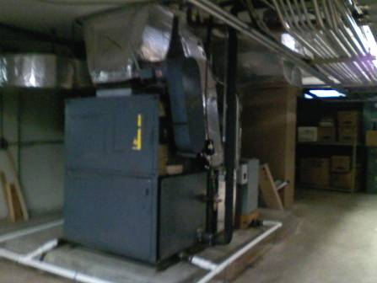

Basement Air Handling Unit

Picture 2

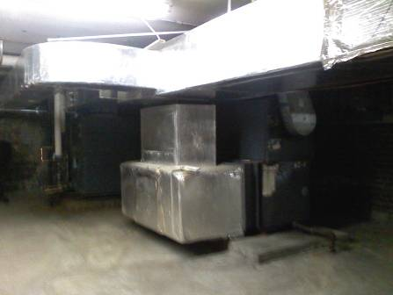

Basement Air Handling Unit

Picture 3

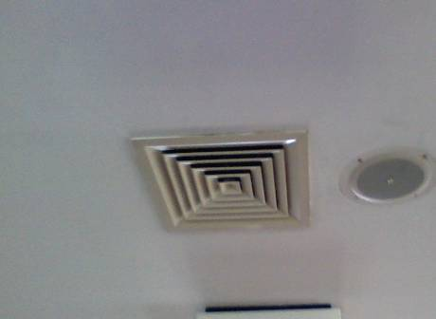

Ceiling-Mounted Supply Diffuser

Picture 4

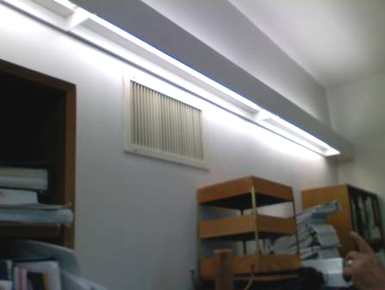

Wall-Mounted Return Vent

Picture 5

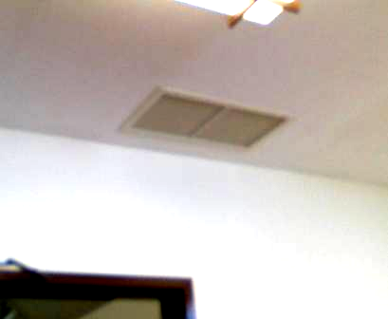

Ceiling-Mounted Return Vent

Picture 6

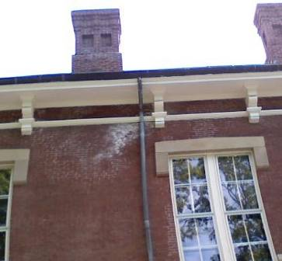

Efflorescence, White Mineral Deposits on Exterior Brick

Picture 7

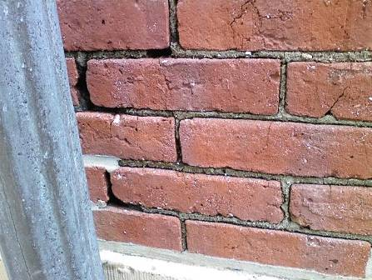

Missing/Damaged Mortar around Exterior Brick

Picture 8

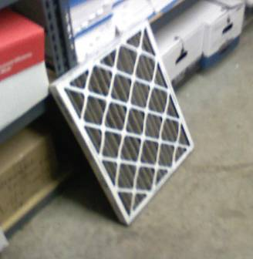

Pleated Filter for AHUs
Location | Occupants  in Room | Temp  (°F) | Relative  Humidity  (%) | Carbon  Dioxide  (ppm) | PM2.5  (µg/m3) | Carbon Monoxide  (ppm) | Windows  Openable | Ventilation |  | Remarks
Outside  (Background) |  | 60 | 65 | 350 | 12 | ND
Town Administrator | 3 | 69 | 33 | 749 | 2 | ND | Y | Y | N
Basement |  |  |  |  |  |  |  |  |  | AHU-filters need changing, dehumidifiers
Reception | 4 | 68 | 35 | 672 | 3 | ND | N | Y | Y
Assistant Town Administrator | 1 | 68 | 34 | 686 | 4 | ND | N | Y | Y | Passive vent
Town Clerk Admin | 1 | 70 | 30 | 734 | 3 | ND | N | Y | Y
Treasures’ Area | 2 | 70 | 30 | 677 | 3 | ND | N | Y | Y | Plants
Kitchen |  |  |  |  |  |  |  |  |  | Missing fluorescent light covers
Treasure’s Office | 1 | 70 | 30 | 668 | 6 | ND | N | Y | Y
Accounting | 1 | 69 | 30 | 685 | 4 | ND | N | Y | Y | Fan-dusty, plants, stained carpeting
Accounting Office | 1 | 69 | 31 | 655 | 6 | ND | N | Y | Y
Hearing Room | 0 | 68 | 29 | 578 | 4 | ND | N | Y | Y
Building Department | 0 | 67 | 25 | 506 | 3 | ND | N | Y | Y
Planning Board/ Conservation Commission | 2 | 69 | 31 | 570 | 4 | ND | N | Y | Y | Complaints of ducts blowing on occupants, plants
Assessors Area | 2 | 70 | 31 | 620 | 8 | ND | N | Y | Y | Cobwebs on windowsill, plants
Assessor’s Office | 0 | 70 | 30 | 606 | 4 | ND | N | Y | N
Town Planner | 0 | 68 | 24 | 506 | 4 | ND | N | Y | Y
Copy Room | 0 | 67 | 26 | 519 | 3 | ND | N | Y | Y | Dusty vent
IT Room | 0 | 68 | 26 | 528 | 4 | ND | Y | Y | Y

