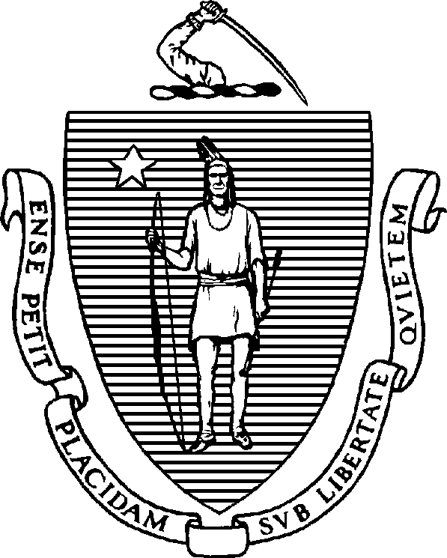

CHARLES D. BAKER
Governor
KARYN E. POLITO
Lieutenant Governor

The Commonwealth of Massachusetts
Executive Office of Health and Human Services Department of Public Health
250 Washington Street, Boston, MA 02108-4619

MARYLOU SUDDERS
Secretary
MARGRET COOKE
Commissioner

Tel: 617-624-6000
www.mass.gov/dph

DETERMINATION OF THE COMMISSIONER OF PUBLIC HEALTH PURSUANT TO BOARD OF REGISTRATION IN NURSING LICENSURE POLICY 10-03

In accordance with Board of Registration in Nursing (Board) Licensure Policy 10-03, I have determined there are or will be insufficient nurses in Massachusetts to properly respond to disease outbreak or other critical public health concern.

Therefore, I direct the Board to activate Licensure Policy 10-03, to expedite the processing of reciprocal license applications for nurses, effective December 1, 2022.

Margret R. Cooke
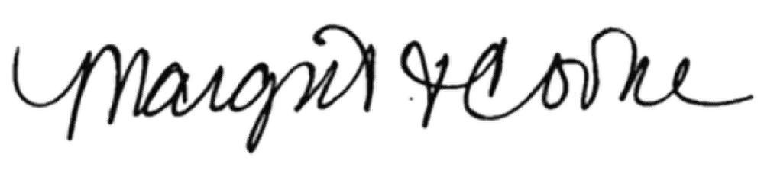
Commissioner, Massachusetts Department of Public Health November 30, 2022

