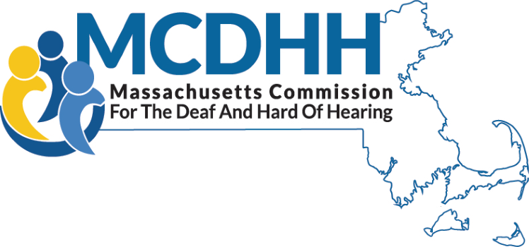
www.mass.gov/mcdhh

Independent Living Services for Deaf and Hard of Hearing

MCDHH contracts with agencies to provide DHILS programs (Deaf and Hard of Hearing Independent Living Services) at sites throughout the state. The programs provide a peer based, consumer-oriented environment enabling Deaf and hard of hearing persons to increase their independence and achieve their life goals. These programs employ persons who are themselves Deaf, late-deafened, oral deaf, or hard of hearing. Consumers work with Independent Living Specialists to set and achieve their own personal goals for independence with their families and in schools, employment, and the community.

Who can participate in DHILS programs?

Any D/deaf, late-deafened, or hard of hearing person age 18 up is eligible for DHILS services.

How are DHILS programs funded? Is there a charge for services?

The eight independent living programs for deaf and hard of hearing people in Massachusetts are funded through state contracts administered by MCDHH. There is no charge for participation.

SERVICES OFFERED

- ASL-fluent DHILS staff
- Training on a wide range of independent living skills topics such as the use of assistive technology, self-advocacy, communication skills, how to manage money for daily needs, how to find support groups, how to find housing, etc.
- Topical workshops for consumer education
- Access to DHILS-based alternative support and recreational groups and activities
- Information and referral
- Peer Mentoring
- Outreach and Community Education
- Assistive Technology
- Outreach and Community Education

REGIONS

Berkshires

Viability Inc.
703 West Housatonic Street, Suite 209
Pittsfield, MA 01201
https://www.viability.org
DHILS@viability.org
413-347-4050 VP
413-536-4880 Voice
413-536-4880 Ext. 111 TTY

Boston Metro

DEAF, Inc. Boston Office
50 Hunt Street Suite 200
Watertown MA 02472
http://www.deafinconline.org
frontdesk@deafinconline.org
617-505-4823 VP/Voice
617-254-4041 TTY/Voice

Cape Cod and the Islands

DEAF, Inc. Cape Cod & Islands
765 Attucks Ln
Hyannis, MA 02601
http://www.deafinconline.org
frontdesk@deafinconline.org
617-505-4823 VP/Voice
617-254-4041 TTY/Voice

Central Massachusetts

Your Access Advocates (YAA)
Deaf and Hard of Hearing IL Services
18 Chestnut Street Suite 540
Worcester, MA 01608
http://www.youraccessadvocates.org
Jphilip@youraccessadvocates.org
508-762-1164 VP
508-755-1003 TTY
508-798-0350 Voice

Updated 7/21/26
Northeast

DEAF, Inc. Lawrence
370 Merrimack St.
Suite 205
Lawrence, MA 01843
http://www.deafinconline.org
frontdesk@deafinconline.org
617-505-4823 VP/Voice
617-254-4041 TTY/Voice

North Shore

DEAF, Inc. Salem
35 Congress Street, Suite 220
Salem, MA 01970
http://www.deafinconline.org
frontdesk@deafinconline.org
617-505-4823 VP/Voice
617-254-4041 TTY/Voice

Southeast & South Shore

DEAF, Inc. New Bedford
227 Union Street
Mezzanine 2
New Bedford, MA 02740
http://www.deafinconline.org
frontdesk@deafinconline.org
617-505-4823 VP/Voice
617-254-4041 TTY/Voice

Western Massachusetts

Viability, Inc.
476 Appleton St
Suite 3
Holyoke, MA 01040
https://www.viability.org
DHILS@viability.org
413-650-5365 VP
413-536-4880 Voice
413-536-4880 Ext. 111 TTY

