

Comprehensive Career Services

Utilization Guide




Website: Comprehensive Career Services Information Hub
Request For Response (RFR): BD-26-1071-AO-02021-125946

NOTICE:
This document outlines how MassAbility Career Services Staff and Community of Rehabilitation Providers can best implement the agency’s new Comprehensive Career Services contracts.

MassAbility will update the guidebook throughout implementation and will notify users accordingly.

Table of Contents
- Section I
  - Comprehensive Career Services Overview
  - Definition of Terms
- Section II
  - Employment Services Summary
  - Employment General Requirements
  - Employment Referral Process
  - Options Under Employment Services Model
  - Provider and Business Relations Partnership
  - Compensation
  - Milestone and Incentive Guidance- Employment Services
  - Monitoring and Performance Requirements
  - Reporting and Form Templates
  - Language Interpretation and Compensation
  - Finance, Budget, and Contract Orders Guidance
  - Self-CAReS and Expectations for Providers
  - Integrated Resource Team (IRT)
  - Case Studies
- Section III
  - Transition/ Pre-ETS Summary
  - General Requirements for Transition Services
  - Referral Process and Eligibility Review
  - Transition Curriculum
  - Transition Services Components
  - Compensation including Transportation
  - Monitoring & Performance Requirements
  - Reporting and Form Templates
  - Language Interpretation and Compensation
  - Finance, Budget, and Contract Orders
  - Self-CAReS and Expectations for Providers
- Section IV- MassAbility Team
  - Career Services Leadership
  - Business Improvement Partners
  - Area Offices and Directors
  - Career Services & Business Relations Teams
- Section V- Approved Providers
  - Contract Management Overview
  - Area Director Contacts for Contract Management
  - Approved Providers Information

Section I

Comprehensive Career Services Overview
Comprehensive Career Services support individuals with disabilities to prepare for, obtain, and maintain employment. Employment outcomes are the primary focus of MassAbility’s Career Services Division focus primarily on employment outcomes. The two service models address the continuum of employment needs, from student preparedness to active job seeking, to employment support. MassAbility may have awarded qualified providers for the Employment Services model, the Transition Services model, or both.

This RFR includes two approaches to the design and delivery of Employment Services and Transition Services: Service Bundles and Single Services. Awarded providers must provide services for both.

Providers must deliver individualized, culturally responsive, and person-centered Career Services across all services. Providers will collaborate closely with MassAbility staff, employers, and community partners to ensure coordinated supports, monitoring, and that choice, informed decision-making, and achievable employment goals guide every job seeker’s path.

Definition of Terms
Career Portfolio: This is an organized collection of the job seeker's documented work experience, education, certifications, testimonials, letters of recommendation, etc. which carries forward and grows throughout their experience with all service providers.
Coaching Plan: Providers will develop a Coaching Plan with the MassAbility Coaching Plan Template in partnership with the job seeker and the MassAbility Counselor and/or Job Placement Specialist. The plan will identify coaching services, including frequency, delivery method, location, expected outcomes, and success measures.
Competitive Integrated Employment: This is a non-temporary job in an integrated community-based work setting where an employer compensates the recipient of employment services with wages and benefits comparable to those received by other workers in similar positions. Employment is in an integrated location where the individual with disability must be eligible for the same advancement opportunities available to employees without disabilities. An integrated setting is a community-based environment in which an individual with a disability interacts with employees and other persons, as appropriate to the position, who do not have disabilities to the same extent as employees without disabilities. Employment enclaves, work crews, segregated employment sites, and Transitional Employment Program (TEP), are not considered appropriate integrated employment sites and are not acceptable under the terms of this contract.
Contract Order: MassAbility Counselors will authorize the provision of Employment services for eligible participants through Contract Orders.
Enterprise Invoice Management (EIM): EIM is an online service reporting, contract management, and billing system used by Purchase of Service providers to submit service delivery and invoicing information to purchasing departments.
Incentive Payments: Providers may receive performance-based payments when they achieve defined, measurable milestones. Incentive Payments promote and reinforce successful employment outcomes, regardless of whether the provider played a significant or supportive role in achieving the outcome. MassAbility will verify the provider has met all required conditions before issuing payment. Incentive Payments do not replace standard reimbursement rates. Rather, they are supplemental and contingent on performance.
Individual Plan for Employment (IPE): The IPE outlines a job seeker’s individual's vocational goal and the services provided to reach the goal. The IPE determines vocational goal, service delivery, and time frames. The IPE identifies the individual's employment objective as consistent with their strengths, resources, priorities, concerns, abilities, and capabilities, and provides a plan for monitoring progress towards the goal. It also reflects the job seeker’s contributions to developing their plan The job seeker and counselor must agree and sign the plan together. They may amend the plan as needed based on the job seeker's evolving needs.
Integrated Resource Team (IRT): The Integrated Resource Team (IRT) approach is an evidenced-based practice that promotes partnership between the vocational provider, the Career Services Counselor, the participant, and all parties supporting the participant’s vocational services. This includes the Job Placement Specialist, an employment services provider, a partner, a therapist, an independent or supportive living provider, a family member, a friend, a clergy, or anyone who the participant and the counselor identify as critical to job placement support and successful employment outcome. The IRT model designates the vocational counselor as the IRT lead. Model fidelity suggests regular IRT team meetings starting at the beginning of services and continuing through the duration of service provision.
Placement Plan: Providers will develop a Placement Plan through the MassAbility Placement Plan Template in partnership with the job seeker and the MassAbility Counselor, and/or Job Placement Specialist. The plan clearly identifies the services during the job development and placement process, as well as service frequency, delivery method, career goals, intended outcomes, among other key factors.
Job Placement Specialist (JPS): MassAbility’s Business Relations Job Placement Specialists in Area Offices work with counselors to support job seekers set achievable employment goals. JPS staff educate job seekers about labor market trends and opportunities; advise in the development of appropriate IPE goals; and guide the job search process, including connecting job seekers to employers.
Job Seeker: An individual, authorized by MassAbility or MCB for enrollment in Employment Services.
Potentially Eligible Students: Students who have not yet entered MassAbility or MCB’s eligibility process. Students with disabilities aged 14-21, enrolled in an educational program may access transition services without formal application for eligibility, providing their approval for Transition Services by the respective agencies.
Self-CAReS: A MassAbility framework and learning experience that helps young adults identify, build, and strengthen their soft skills. Grounded in youth development principles and informed by young adult feedback, Self-CAReS supports growth in the interpersonal, self-management, and workplace abilities that are essential for long-term career success. CAReS stands for: 1) Capacity: the ability to perform a job and contribute to an organization at a satisfactory level; 2) Advocacy: the ability to understand and communicate what one needs to be successful in at work; Realization, awareness of strengths and limitations and the ability to identify areas of desired growth; and 3) Sufficiency, the ability to work independently and pursue professional goals. Self-CAReS represent developmental domains that help young adults navigate education, employment, and daily life. Growth in these areas can contribute to successful career choices, resilience at work, and overall well-being in employment.
Transition Services Plan: Formerly known as the Pre-ETS service plan, this plan lists the provided Transition Services and the service dates. Providers will submit this plan to MassAbility before initiating services.
Transition Portfolio: Students who participate in any Transition Services will receive documentation of their participation. Documentation may include a digital or paper certificate for one or more Transition Services components. Students who participate in Work-Based Learning (WBL) opportunities will receive documentation that may include a letter of recommendation from the work site, a summary of the WBL activities, and other relevant details for the student’s résumé or portfolio.

Section II

Employment Services Summary
All Employment Services aim to achieve Competitive Integrated Employment as defined in the Definition of Terms on page 3. MassAbility will authorize Employment Services based on the employment goal in the job seeker’s IPE. Services will begin after the counselor and job seeker complete an IPE centered on an established vocational goal. Job seekers, counselors, and when applicable, JPS, will determine whether the job seeker requires one or more single services or the bundle of services. Service progression is not always linear, requiring individualized, person-centered, and flexible selection and sequencing of services.

Employment General Requirements
Providers must:
- Commit to partnership and collaborative service delivery with counselors, Business Relations and families, among others; IRT participation may be requested
- Offer flexible, person-centered service delivery including in-person and virtual offerings
- Develop intentional strategies that engage and retain job seekers in services
- Communicate promptly with MassAbility including e-mail/phone call replies, progress notes and notifications
- Complete monthly reporting completed in the advised format

Employment Referral Process
Collaborative discussions between the counselor, the job seeker, and when applicable the Job Placement Specialist (JPS), will determine Employment Services needs. The process follows:
- Initial Discussion: The Counselor contacts the provider to discuss a potential new referral and confirm program fit and capacity.
- Referral Submission: If appropriate, the counselor sends the Referral to the provider including specific services requested and outlines the job seeker’s specific job goal and other relevant information.
- Introduction Meeting: The counselor schedules a brief (approximately 15-minute) three-way meeting with the provider and the job seeker (in-person or remotely) to review participant choice and commitment and outline expectations including desired wage and hours.
- Agreement: The provider will confirm their ability to provide the requested services within three days of the introduction.
- Contract Order Creation and Transmission: if all parties agree, the counselor amends the IPE to add the service and generates a Contract Order (CO) within one (1) business day of the agreement.

Providers are expected to acquaint themselves with the job seeker before service implementation, as embedded in the Job Development and Placement service bundle. MassAbility will authorize up to three hours of service to meet and plan with the job seeker before service initiation for single service components: Job Search Supports, Work Experience, Job Coaching.

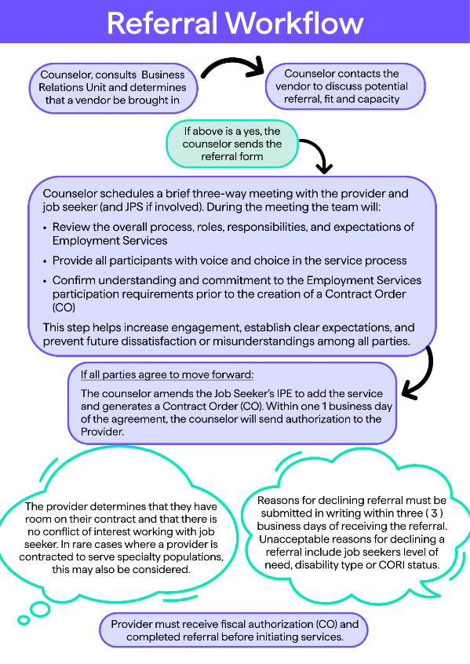
Referral Workflow Visual:
Referral Workflow (Alternative Description):
- Counselor consults with the Business Relations Unit and determines that a vendor should be brought in.
- Counselor contacts the provider to discuss potential referral, fit and capacity.

If the referral is good a fit, and the vendor has the capacity then:
- The counselor will schedule a brief three-way meeting with the provider and job seeker (and the JPS if involved).
- During the meeting the team will:
- Review the overall process, roles, responsibilities, and expectations of Employment Services.
- Provide all participants with voice and choice I the services process.
- Confirm understanding and commitment to the employment services participation requirements prior to the creation of a contract order (CO)
This helps to increase engagement, establish clear expectations, and prevent future dissatisfaction or misunderstanding among all parties.

If all parties agree to move forward:
- The counselor amends the job Seeker’s IPE to add the service and generates a Contract Order (CO).
- Within (1) business day of the agreement, the counselor will send authorization to the provider.

The provider:
- Will determine that they have room on their contract and that there is no conflict of interest working with the job seeker.
- In rare cases where a provider is contracted to serve specialty populations this may also be considered.
- A provider’s reasons for declining the referral must be submitted in writing within three (3) business days of receiving the referral.
- Unacceptable reasons for declining referrals include job seekers’ level of need, disability type or CORI status.

The Provider must receive fiscal authorization (CO) and completed referral before initiating services.
Options Under Employment Services Model
Users may reference decision trees and case examples throughout the guide for help determining and selecting services.
Job Development and Placement Services (Service Bundle) includes the full spectrum of job development and placement supports designed to assist job seekers to achieve successful employment outcomes. These services encompass job development, job placement, and ongoing support activities (up until day 30).

Job Seeking Supports (Single Service) are for individuals primarily served by MassAbility’s Job Placement Specialists or Counselors who require additional time and support to complete a successful job search. Providers will develop Job Search Supports in close partnership with the counselor and/or the Job Placement Specialist (JPS), who will continue to actively support the job seeker throughout the process.

Supports may include résumé refinement, direct interview assistance, hands-on job search activities, transportation to interviews, and the development of online employment profiles.

MassAbility requires providers to bill in 15-minute increments. Providers should bill voicemails, texts, and emails ¼ hour (15 minutes) in EIM. Providers are expected to meet and plan with the job seeker before service implementation and are authorized for up to three (3) hours of services before official service initiation.

Work Experience (Single Service) is for individuals with no prior work history, those with a significant employment gap that raises questions about their current skill level, and/or those who require on-site skill development to strengthen both hard and soft workplace skills. The service focuses on specific skill-enhancement goals outlined by the Counselor rather than direct employment, helping job seekers build and strengthen the skills needed to move toward competitive integrated employment. The job seeker may be paid by the provider, and the cost of said payment is reimbursable by MassAbility.

Use of this service may change year-to-year pending availability of funds. Please connect with MassAbility for additional guidance.

Work Experience placement sites are competitive and integrated. An integrated setting is a community-based environment in which an individual with a disability interacts with employees and other persons, as appropriate to the position, who do not have disabilities. Provider agencies may use their other programs and enterprises as Work Experience sites, following approval.

Area Directors must authorize the time-limited Work Experience opportunities. Providers must first discuss all potential Work Experience opportunities with the participant's Counselor and/or Unit Supervisor to ensure the Work Experience is appropriate, rather than used as a situational assessment.

If Counselor and Unit Supervisor agree that the Work Experience is appropriate, Providers will complete a Work Experience checklist over email. The provider must answer the questions below in writing for counselor presentation to the AD:

- Does the participant lack prior work history, have a significant employment gap that hinders their current skill level, and/or require on-site skill development to strengthen both hard and soft workplace skills?
  - Refer to the RFR for examples
  - If "no", this is not an appropriate use of the component
- How will the Work Experience build and strengthen skills needed to move toward Competitive Integrated Employment? What are the specific skills?
  - Examples may include technical and industry specific skills, communication skills, problem solving and critical thinking, teamwork and collaboration, time management and organizational skills
- Is the Work Experience paid or unpaid?
- What are the total hours and proposed schedule for the proposed Work Experience?
  - The Area Director will review the request and approve or deny over respond over email to the provider and the Counselor. The response will outline reasoning and provides documentation. If applicable, the Counselor will proceed with CO generation

MassAbility will authorize providers for up to three (3) hours of services to meet and plan the service model with the job seeker.

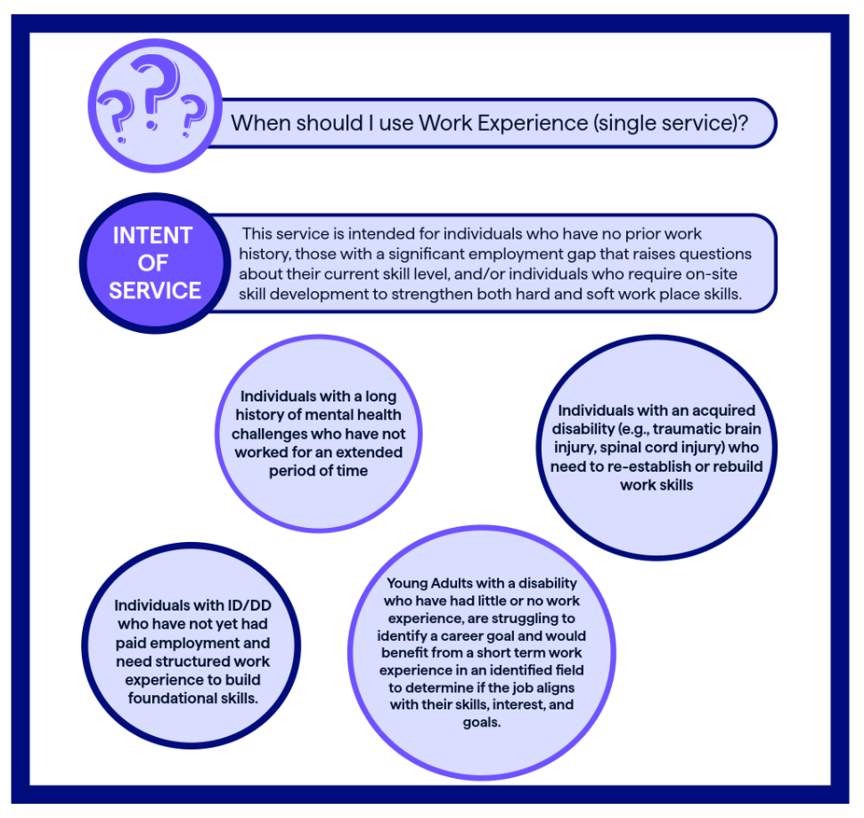
Work Experience Visual:
Work Experience (Alternative Description):
When should I use Work Experience (single service)?
Intent of the Service: This service is intended for individuals who have no prior work history, those with a significant employment gap that raises questions about their current skill level, and/or individuals who require on-site skill development to strengthen both hard work and soft workplace skills.
Individuals that may be a good fit for this service:
- Individuals with a long history of mental health challenges who have not worked for an extended period of time.
- Individuals with ID/DD who have not yet had paid employment and need structured work experience to build foundational skills.
- Individuals with an acquired disability (e.g., traumatic brain injury, spinal cord injury) who need to re-establish or rebuild work skills.
- Young Adults with a disability who have had little or no work experience, are struggling to identify a career goal and would benefit from a short term work experience in an identified field to determine if the job aligns with their skills, interest, and goals.
Job Coaching (Single Service) allows for one-on-one support to complete onboarding, training, or learning a new job. This direct, face-to-face service must connect to the job’s activities and expectations. The coach will meet, establish rapport, and understand the job seeker’s needs and support requirements ahead of their hire. The job seeker will experience increased employment stability by successfully performing their job duties and meeting their employer’s performance expectations. This results in greater independence and a gradual transition from reliance on provider staff to self-sufficiency or the effective use of natural supports in the workplace.
Providers must meet the job seeker prior to service implementation. as embedded in the Job Development and Placement service bundle. MassAbility will authorize providers For Job Coaching single service components, providers will be authorized for up to three (3) hours of services to meet and plan the service model with the job seeker for Job Coaching single service components, before official service initiation. If the provider was contracted for Job Development and Placement Bundle, they will not receive an additional 3 hours to get to know the participant if Job Coaching is needed after day 30. These hours are applicable when the provider is brought in for Job Coaching after Counselor and/or Business Relations placement.

MassAbility Counselors will contract for no more than 25 hours at a time for job coaching. This may be reassessed on a case-by-case basis tied to individual need and job performance.

MassAbility requires providers to bill in 15-minute increments and bill voicemails, texts, and e-mail for ¼ hour (15 minutes) in EIM.

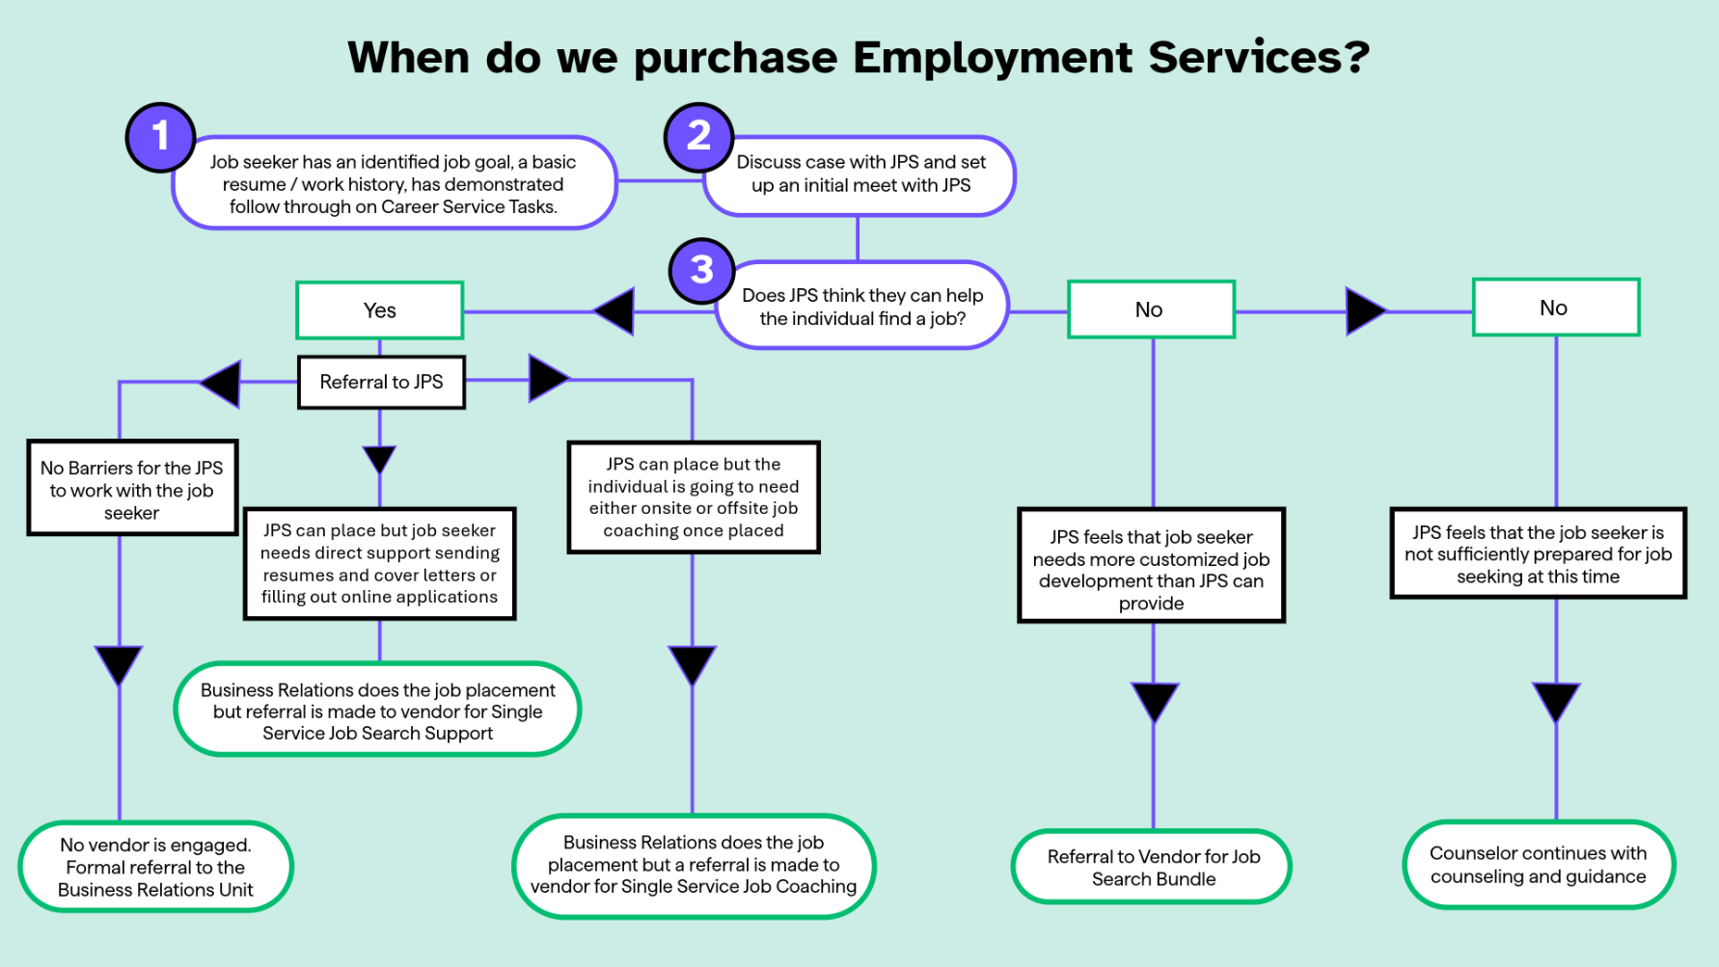
Referral Decision Tree Visual:

Referral Decision Tree (Alternative Description):
When do we purchase employment services?
- Job seeker has identified a job goal, a basic resume/ work history, and has demonstrated follow-through on Career Services tasks.
- The Career Services counselor should discuss the participant case with the JPS and set up an initial meeting with JPS.
- Does the JPS think they can help the participant find a job?

If the JPS believes they can help the participant find a job and does not foresee barriers working with the job seeker:
- No vendor would be engaged, and an additional formal referral would be made to the Business Relations team.

If the JPS believes they can help the participant but believes the job seeker needs direct support with resumes/cover letters, and completing online applications:
- Then the Business relations team does the job placement, but a referral is made to a vendor for single service job support.

If the JPS believes they can place the participant but recognizes the job seeker is going to need either onsite or offsite job coaching once placed:
- Then the Business Relations team does the job placement, but a referral is made to a vendor for single service job coaching.

If the JPS does not believe they can help the job seeker find a placement because they need more assistance than what JPS can offer, then the Career Services Counselor would make a referral to a vendor for a job search bundle.

If the JPS does not believe they can help the job seeker find placement because the job seeker is not sufficiently prepared for job seeking at that time, then the Career Services continue with counseling and guidance.

Provider and Business Relations Partnership
The success of this procurement hinges upon strong partnerships between the counselor, the job seeker, the Business Relations Unit, and the provider. The provider and MassAbility Business Relations Unit will work especially closely. In many cases, the MassAbility Business Relations team will complete job placement and employer development, while the provider will provide supports for the participant and the process. Early engagement, regular communication, and coordination is key for successful collaboration. MassAbility recommends monthly three-way meetings at a minimum with weekly email communication.

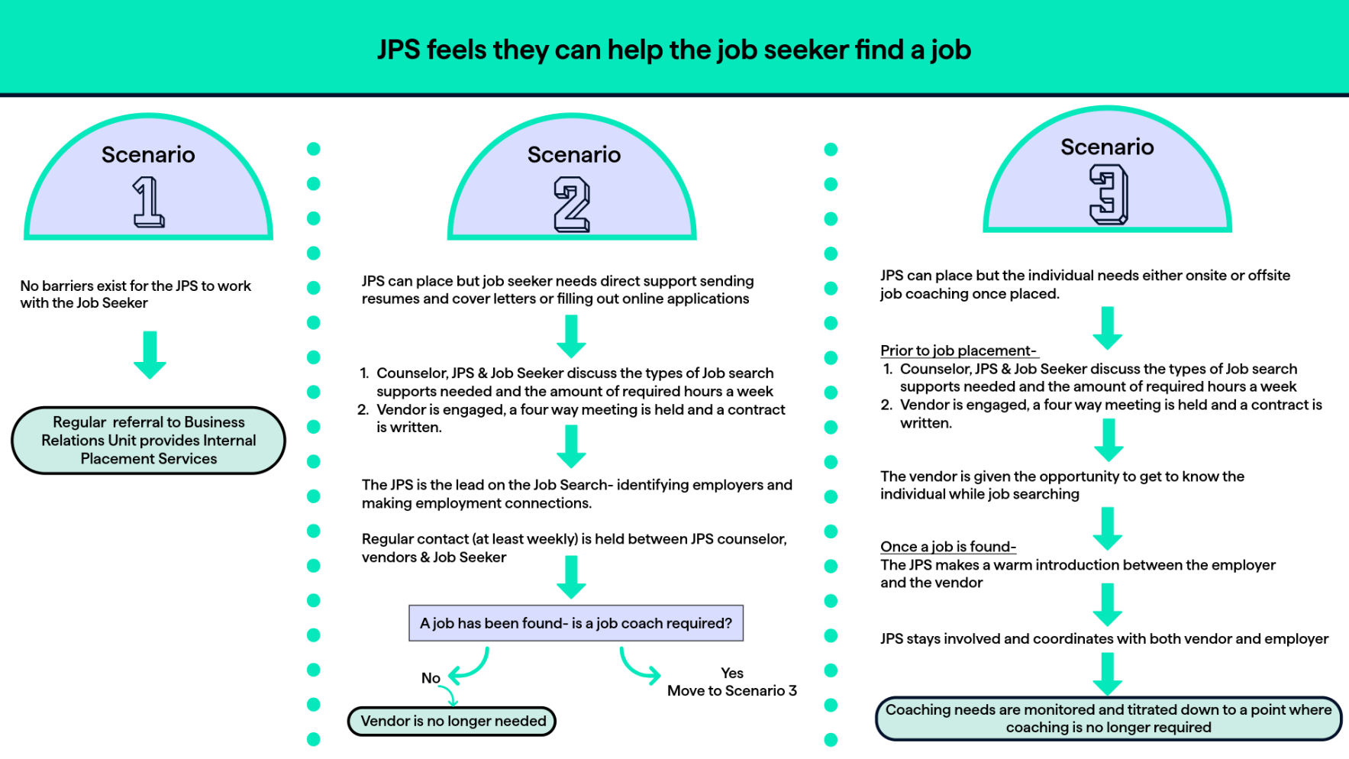
JPS and Vendor Partnering Visual:

JPS and Vendor Partnering (Alternative Description):
JPS feels they can help the job seeker find a job:
Scenario 1: If there are no barriers that exist for the JPS to work with the Job Seeker, then a regular referral to Business Relations Unit provides Internal Placement Services.
Scenario 2: If the JPS can place the job seeker, but they need direct support sending resumes and cover letters or filling out online application.
- Counselors, JPS and Job seeker would discuss the types of job search supports needed and then the amount of required hours a week.
- Vendor would be engaged and a four-way meeting is held and a contract is written.
- The JPS will be the lead on the Job Search- identifying employers and making employment connections.
- JPS will schedule regular contact (at least weekly) with the job seeker, counselor, and vendors.
Once a job is found the JPS will assess if a job coach is needed:
- If a job coach is not needed, then the vendor will no longer be needed.
- If a job coach is needed, then JPS should move to Scenario 3.
Scenario 3: If the JPS can place the job seeker, but the job seeker needs either onsite or offsite job coaching once placed.
Prior to Job Placement-
- Counselor, JPS, & Job Seeker discuss the types of Job search support needed and the amount of required hours a week.
- Vendor is engaged, a four-way meeting is held and a contract is written.
- The vendor will be given the opportunity to get to know the individual while job searching.

Once a job is found-
- The JPS will make a warm introduction between the employer and the vendor.
- The JPS will stay involved and coordinate with both vendor and employer.
- Coaching needs will be monitored and titrated down to a point where coaching is no longer required.

Compensation – Employment *differential for Dukes and Nantucket Counties
MassAbility expects providers to bill hourly services in 15-minute increments. An email, voicemail or text constitutes one unit (15 minutes) and not 4 units (1hour).

Service Component | Rate Type | Trigger | Amount | Notes
Job Development & Placement | Milestone 1 | Employment Plan Developed | $2,730* | Part of $6,825* milestone rate
Job Development & Placement | Milestone 2 | 30-Day Employment Retention | $4,095* | Part of $6,825*  milestone rate
Job Search Support | Hourly | Authorized Job Search Supports delivered | $55.09* | N/A
Work Experience | Hourly | Authorized Support hours delivered | $55.09* | N/A
Work Experience | Add-on | Reimburses Wages and fringe/benefits, when applicable | $20.00 | N/A
Job Coaching | Hourly | Authorized Job Coaching hours delivered | $55.09* | N/A
Early Stabilization Incentive ^ | Outcome payment | Completion of 5 days of CIE | $250 | Applies to all  service components
Sustained Employment Incentive ^ | Outcome payment | 90 days of CIE aligned with IPE | $1,000 | Applies only to JDP and JC

Milestone and Incentive Guidance – Employment Services
MassAbility may compensate providers for Milestone Benchmarks under this RFR and additional incentive payments. Payments relate to objective criteria. MassAbility will issue payments after verifying the fulfilment of all required conditions. Incentive Payments depend upon performance and supplement, rather than replace standard reimbursement rates.

Providers contracted for Single Hourly Services (Job Search Support, Work Experience, Job Coaching) are eligible for the early stabilization incentive and providers contracted for the Bundle or Job Coaching are eligible for the sustained employment incentive.

Milestone 1: Job Development & Placement:
- Employment Plan Form developed in collaboration with job seeker received by MassAbility counselor
- Career goal matches MassAbility IPE
- Job seeker is ready to move forward with provider who schedules and shares the next appointment before billing the MassAbility counselor

Milestone 2: Job Development & Placement:
- Job Seeker completes 30 calendar days in Competitive Integrated Employment
- Counselor/Provider agreement that provider placement activity contributed to the outcome of competitive employment
- Provider provided direct job coaching at appropriate level, leading to sustained employment for 30 consecutive calendar days on the job

Performance-based Incentive Payments:
- Early Stabilization Incentive (counselor/provider steps required)
- Achieved when the job seeker completes the fifth (5th) consecutive day of employment (Job Start Date through Day 5 of employment with the same company)
- Job Placement Form sent to counselor (Applicable to Job Development and Placement Bundle & All Single Service models)

- Sustained Employment Incentive
- Billed when the job seeker maintains ninety (90) consecutive days of employment
- MassAbility receives Sustained Employment Incentive Form (see Forms section)
- Applicable to Employment Services Bundle and Job Coaching hourly single service

Comprehensive Career Services Milestone Payment Guide:

Monitoring & Performance Requirements – Employment Services
MassAbility will measure providers’ performance through quality measures, outputs, and outcomes.

Job Development and Placement Services
Quality of Services | Outputs | Outcome Measures  (what changes for Members)
Measures job seeker satisfaction through MassAbility-issued survey following service completion % of job seekers with a documented Placement Plan within 10 business days of accepted referral  - % of referrals not accepted by the provider  - % of job seekers who report appropriate job leads aligned with their skills, interests, and transportation needs  - % of placements that match the wage and hours goals in the IPE  - Quality of coordination with the counselor and JPS, including timely updates and participation in case discussions  - Timely submission of monthly progress notes, billing, and statistical reports through the OnBase Provider Portal | - Number of job seekers receiving Job Development and Placement Services  - Number of job matches identified and presented to job seekers  - Number of interviews scheduled or secured through provider efforts | - % of job seekers who maintain successful employment for at least 30 days  - % of job seekers who maintain successful placement for 90 days

Job Search Supports
Quality of Services | Outputs | Outcome Measures
Measures job seeker satisfaction through MassAbility-issued survey following service completion  - % of job seekers with a documented Job Search Support Plan within 5 business days of accepted referral  - % of referrals not accepted by the provider  - % of job seekers with Job Search Supports effectively coordinated with Job Placement Specialists  - Timely submission of monthly progress notes, billing, and statistical reports via the OnBase Provider Portal | Number of job seekers receiving Job Search Supports including  - Individualized job-search sessions  - Completed refined résumés  - Provider-supported job application submissions  - Provider-supported scheduled interviews | - % of job seekers obtaining interviews  - % of job seekers placed into IPE aligned employment

Work Experience
Quality of Services | Outputs | Outcome Measures
Measures job seeker satisfaction through MassAbility-issued survey following service completion  - Employer satisfaction with provider coordination and communication  - % of Work Experiences that start within 15 business days of accepted referral  - Timely submission of monthly progress notes, billing, and statistical reports via the OnBase Provider Portal. | - Number of work experiences initiated  - Number of employers hosting Work Experiences  - Number of hours completed  - Number of job seekers receiving a letter of recommendation and/or employer written feedback | - % of job seekers demonstrating progress in identified hard and soft skills  - % of job seekers completing their planned Work Experience

Job Coaching
Quality of Services | Outputs | Outcome Measures
Measures job seeker satisfaction through MassAbility-issued survey following service completion  - Employer satisfaction with accommodation, task-modification support, or other employment supports  - % of Coaching Plans completed within 5 business days of accepted referral  - % of referrals not accepted by the provider  - % of coaching delivered in-person when required by the job seeker  - Timely submission of monthly progress notes, billing, and statistical reports via the OnBase Provider Portal | - Number of job seekers receiving coaching services  - Number of delivered coaching hours delivered | - % maintaining successful placement for 30 days  - % maintaining successful placement for 90 days with continued coaching  - % maintaining successful placement for 90 days without coaching  - % of job seekers transitioning to natural supports

Forms/Report Template Links – Employment Services
- Referral form
- Monthly progress notes (Employment & SES)
- Monthly progress note (SUPPEX)
- Coaching plan
- Employment/Placement plan
- Career portfolio
- Job Placement Form
- Sustained Employment Incentive Form
- Monthly reporting Excel – Employment, SES, SUPPEX
- Work Experience Evaluation

Language Interpretation Services
MassAbility will reimburse providers for spoken language interpretation services to ensure a job seeker’s active and meaningful participation in Employment Services. Family members can also access these services as needed. Both qualified internal staff and contracted interpretation services are reimbursable when included in the Contract Order and authorized and approved by MassAbility.

The rate for language services is in addition to authorized service rates. Reimbursement rates for language interpretation services must align with and cannot exceed established rates in OSD’s RFR for Spoken Language Translation (PRF75) and the Massachusetts Commission for the Deaf and Hard of Hearing (MCDHH)’s Contract for American Sign Language Interpreters and Translators for the Deaf and Hard of Hearing.

Language Interpretation Compensation
Additional guidance on language interpretation compensation, including on invoicing and billing, is forthcoming. Providers will receive reimbursement through a paper payment voucher (PV). Contract Orders are required.

Finance, Budget & Contract Order Guidance
MassAbility’ s federal and state funding is contingent upon federal and state budget appropriations.

MassAbility will contract qualified providers under a Master Service Agreement. The agency may amend contract dollars throughout the year based on performance, use and agency budget and will notify providers as applicable.

Providers may not bill for time spent finding and securing the Work Experience Single Service site. The service rate covers preparation time. MassAbility will reimburse providers for taxes and fringe at the standardized rate found in the Employment Compensation section (Link to Compensation).

The MassAbility Career Counselor authorizes and documents Contract Order in the job seeker’s IPE. Providers must receive a Contract Order for all Employment services to initiate services and complete billing, Language/Translation services and Incentive Payments.

Self-CAReS & Expectations for Providers
MassAbility’s Self-Capacity, Advocacy, Realization, and Sufficiency (Self-CARes) provides a framework and learning experience for young adults to identify, build, and strengthen their soft skills by supporting the growth of interpersonal, self-management, and workplace abilities that are essential for long-term career success. The Self-CAReS approach contributes to successful career choices, resilience at work, and overall well-being in employment.

Providers will learn more about the framework as they incorporating it into their work,

Integrated Resource Team (IRT)
The evidence-based Integrated Resource Team (IRT) approach promotes partnership with the vocational provider (Career Services Counselor), the participant, and all parties that support the participant. This could include an employment services provider, a therapist, an independent or supportive living support, a family member, a friend, a clergy, or any other critical supports for job placement and successful employment outcomes. The vocational counselor will serve as the IRT lead. Regular IRT meetings will begin at the start and continue through the duration of service provision.

Integrated Resource Team Visual:
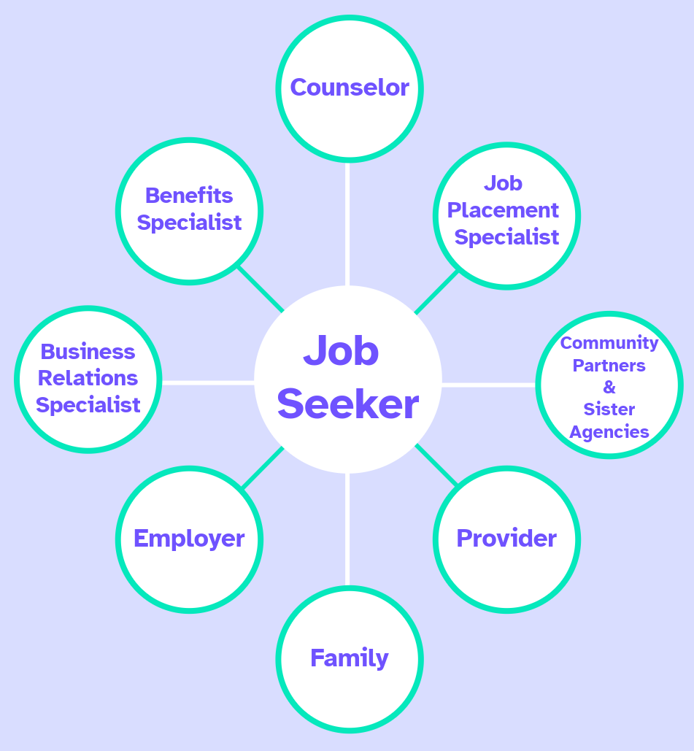

Integrated Resource Team (Alternative Description):
A job seeker’s Integrated Resource Team may include family, the employer, providers, business relations specialist, benefits specialist, counselor, job placement specialist, and community partners and sister agencies.

Case Examples– Employment Services
Review the below examples to understand how MassAbility can contract Comprehensive Career Services Employment Services with providers. This is a diverse, but non-exhaustive list of the use of single services and bundled services and provider internal MassAbility service integration.

Case Example 1 – Single Service Job Search Supports
Thirty-eight-year-old Alice sustained a TBI 5 years ago. She has no physical restrictions but struggles to focus and remember things from one day to the next. Alice worked in retail before acquiring TBI. Following physical and cognitive restorative treatment, she felt ready to return to work in an entry level retail capacity. She has basic computer and internet skills with strong in-person interpersonal skills, but she sometimes struggles with emails and cover letters

The MassAbility Business Relations Team feels that they can place her in a job. Alice needs support completing online applications and with mock interviews. MassAbility contracts a to provide three hours of services per week for four weeks to assist with the job search. Alice receives business names and websites from the JPS. Alice and the provider then meet weekly to work on online applications and conduct weekly mock interviews.

Case Example 2 – Single Service Job Coaching
Joe is a 22-year-old young man diagnosed with ID/DD. He has no physical limitations but lacks prior work experience and requires repetition and practice to learn new tasks. The Business Relations Unit leverages their connections to place Joe in an entry level job in a retail warehouse.

When the JPS began supporting Joe MassAbility brought a provider in to meet and get to know Joe, his needs, and his learning style.

During the job placement process, the JPS informed the employer that Joe could access a job coach as he settles into the job. Upon hire, the JPS coordinates a meeting with the provider and employer to review job duties and expectations. The provider assists Joe with the onboarding paperwork and provides onsite and offsite direct support to Joe. When issues arise, the JPS, Vendor, and Counselor closely communicate to align while supporting Joe’s needs. Within two months, Joe acclimates to the job, and his job coach reduces their time from three hours a week to one hour. By the end of the third month, the job coach disengages and MassAbility closes Joe’s case.

Case Example 3 - Single Service Work Experience
Ellen is a 40-year-old woman with a diagnosed with a mental health disorder. Ellen dropped out of college after receiving her diagnosis and experienced multiple hospitalizations, outpatient treatment programs, and long-term medication management over the next two decades. With relatively stabilized mental health, she would like to enter the workforce but is unsure which profession. Given her strengths and necessary job supports are unclear given her history of mental health issues and lack of recent work experience and references.

MassAbility contracts a provider to help Ellen try out different work scenario, including a week in the backroom of a retail establishment, a week at a manufacturing facility for medical equipment, and a week in food service. The provider pays Ellen through each of these experiences while also offering onsite and offsite support. With this new work experience, references, and increased self-confidence Ellen, the counselor, and the provider feel she is now ready for an entry level position. Ellen believes continuing to speak with her counselor and her therapist about work will provide her the support she needs for success.

Case Example 4 – Job Development and Placement Bundle
Keith is a 30-year-old man who suffered a stroke at age 23. He continues to experience hemiplegia on his right side, slurred speech, and difficulty remembering things. His health has been stable for the past four years and he would like to return to work. Keith has not worked since his stroke, and while he studied engineering in college, he has not retained substantive knowledge that would allow him to work as an engineer now. Keith has always loved books and would love to work in a library putting books back on the shelves.

This goal requires customized job development. MassAbility contracts a provider for full job development and placement. The provider approaches multiple libraries in Keith’s area and finds a library willing to employ him. The provider assists with all aspects of onboarding and provides coaching and support for Keith’s first month of employment. After the first month, Keith is doing well, the library is happy with his work, and subsequently MassAbility determines no further support is required.

Case Example 5 – Using multiple single services
Five years ago, 42-year-old Beth sustained a spinal cord injury from a rock-climbing accident and now uses a manual chair to ambulate. ADHD also impacts her ability to focus and stay on task. Prior to her accident, Beth worked in customer service at Aetna Healthcare. She has strong interpersonal skills and would like to find a job in customer service again.

Beth worked with the JPS to find a job but struggled to send resumes and cover letters. MassAbility contracted a provider for Job Search Supports to spend two hours a week with Beth to help her update her resume and cover letter for the JPS-provided job leads.

Brigham and Women’s Hospital, a strong partner of MassAbility hired Beth as a switchboard operator. The hospital needed to modify the space for a wheelchair user though non-structural means. MassAbility determined that a provider could work with Beth and the employer to modify tasks and the space for Beth’s needs, requiring four hours of onsite work. The provider also helped Beth organize herself to remain on task, avoid feeling overwhelmed, and learn the hospital codes. MassAbility used same provider who helped Beth in her job search and stayed on as a support for the first month of Beth’s employment.

Case Example 6 - The service continuum
Robert is a young man with a learning disability. During high school, Robert benefitted from student transition services. Through his provider, Robert attended a career camp and participated in a summer work experience. This was a positive experience for Robert, leading him to want to find a job after high school. Robert opened a MassAbility Career Service case and identified a job goal in manufacturing. Given the Business Relations team’s industry connections, Robert began to work with the JPS. Robert’s learning disability made it difficult to complete job applications alone. Consequently, MassAbility contracted the same provider who provided Robert’s transition services in high school to provide job search supports. Robert continued to use the provider for coaching services once hired. The existing relationship between Robert and the provider contributed to his success.

Section III

Transition / Pre-ETS Summary
The Workforce Innovation Opportunity Act (WIOA) requires MassAbility to reserve and expend no less than 15 percent of its Career Services federal budget on Transition Services, also known as Pre-Employment Transition Services (Pre-ETS) for students with disabilities. Transition/Pre-ETS allotments are contingent upon federal budget appropriations that are subject to change annually.

Transition Services support students with disabilities enrolled in high school and/or post-secondary educational programs, ages 14 through 21 (up to their 22nd birthday), to prepare for employment. Students may be 1) potentially eligible (PE) for Career Services (CS) but who have not applied to become eligible, or 2) students who have been found eligible for Career Services. Transition Services provide soft skills training and career exploration opportunities for students with disabilities. They complement secondary transition services under the Individuals with Disabilities Education Act (IDEA) and should not be duplicative. MassAbility envisions that students with disabilities participating in Transition Services may not need Career Services to continue on their career path, or alternatively, this will better prepare students for Career Services.

The five WIOA required services are: Work-based learning experiences, Job exploration counseling, Counseling on post-secondary education opportunities, Workplace readiness training, and Self-advocacy. Providers must deliver programming across all five service components.

Providers must offer services during non-school hours to ensure that students can participate without disrupting their academic schedules. Providers are encouraged to design flexible and creative service schedules. In exceptional circumstances where a student is unable to access services outside of school hours in-person or remotely, MassAbility can approve services potentially provided within the school day.

If a provider determines that a student can only access Transition Services during the school day, the provider must submit written justification to the Area Director who manages the contract that includes:
- Service(s) to be provided
- Reason for services through any means other than during the school day
- How the service(s) equates to those provided outside of school hours
- Evidence of discussion with student/family and/or school that in-school services will not disrupt students' academic schedule and will minimize removing student from classroom instruction

If there are no other service options, the Area Director may approve in-school services for a finite period for the specific students who cannot access the service otherwise. For example, MassAbility could approve a four-week self-advocacy training by the provider or other providers in the catchment area if identified students cannot access sessions.

Find information about MassAbility Area Office lists on pages 37 - 40. Providers are encouraged to leverage community spaces but may also connect and negotiate with Area Directors about using MassAbility office space for time-limited programming. Area Offices are open 9 am-5 pm.

One-to-one supports are not built into the Transition/Career Camp model does not include one-to-one supports, nor are they an allowable Pre-ETS expense. Students who require individual supports during the school year may attend a Career Camp with a para-professional, PCA, or other supports as determined by the student’s Local Education Agency (LEA), Individualized Education Program (IEP), and family.

General Requirements for Transition Services:
- Interactive, intentional, youth-friendly strategies for engagement and retention
- Community based programming outside of school hours
- Youth career camp and WBLE anticipated to be most utilized services
- Collaboration with community partners, such as schools, community colleges, ILCs, and the TAP program
- Communication
- Entering and receiving approval for Potentially Eligible Students in the portal before initiation of services
- Complete monthly reporting completed in the advised format (Excel template at this time, electronic portal in future state)

Referral Process and Eligibility Review for Transition
- Dual access model - online self-referral application, provider-initiated referral, direct referrals from MassAbility Career Services counselors
- Proof of disability as required by RSA. This could include IEP, 504 Plan, statement from college disability services, doctor’s note, or medical records showing diagnosis
- The first page of the student’s IEP will suffice if the provider cannot submit the entire IEP
- Providers must select disability type during portal submission through the drop-down menu
- Providers must enter potentially eligible students into the PE Portal and students must be approved by MassAbility before services can commence

Transition Curriculum
Transition Services providers are expected to procure curriculum from an approved list to use for programming. Providers may choose to enhance the standard curriculum and are expected to adapt curriculum to the needs of the students. Providers will learn more about Transition Curriculum and expectations as implementation continues.

Transition Services Components

Youth Career Camp
The Youth Career Camp is a five-day, intensive training offered during school breaks and summer designed to deliver four of the five WIOA required services to groups of students in a focused, accelerated format: Job Exploration Counseling, Workplace Readiness Training, Counseling on Post-Secondary Education or Training, and Self Advocacy. After completion, the students may move into work-based learning opportunities.

Students will develop or strengthen essential skills during the five-day Career Camp, with an emphasis on building the competencies needed to successfully participate in a Work-Based Learning Experience. Students who complete a Work-Based Learning Experience will receive a certificate of completion and/or a letter of recommendation acknowledging their participation and achievements.

Career Camps will include five hours of services each day for five consecutive days. A four-day Career Camp is allowable during weeks with holidays. Alternative options such as five days over the two weeks during the December holiday break may be considered. A camp day consists of two 2.5-hour sessions. (See Reimbursement Grid).

Single-Topic Training Sessions
Single-topic virtual training sessions provide structured, focused instruction on one of the four required services (Self-Advocacy, Job Exploration Counseling, Post-Secondary Education and Training Counseling, Work Readiness Training). Providers will deliver each training series sequential group sessions over multiple weeks, potentially tailored by age group, learning level, or topic emphasis. Providers will schedule training during the school year to ensure consistent participation. Training will complement and not detract from students’ academic schedules.

Work-Based Learning Experiences (internships or job shadows) are available to students who successfully complete a Work Readiness training series and demonstrate the basic skills and behaviors needed to participate safely and productively in community-based work experiences.

Work-Based Learning Opportunities
These opportunities offer meaningful, real-world work experience for students, particularly post-secondary students with time-limited internship opportunities. Providers may coordinate other unpaid work-based learning activities such as volunteer placements, job shadowing, and informational interviews to support early career exploration.

Each student may participate in only one internship per employer host site per program year. All internships and work-based learning experiences must occur in community-based, integrated settings. Work-based learning experiences are exploratory; therefore, students are not required to participate in a paid work experience. Providers will support students participating in paid or unpaid work-based learning develop a Career Portfolio that documents their completed experiences. This portfolio could include letters of recommendation or feedback from employers and other community partners.

Paid Work-based Learning opportunities should be between 40-60 hours per student. Provider agencies may use their other programs and enterprises as Work Based Learning sites after receiving MassAbility approval and confirming the sites are competitive, community-based, and integrated sites. Providers must submit a written request to use agency programs and enterprises for Work-Based Learning to the managing Area Director in advance.

Work-based learning is intended to be an individualized placement. As such, group work, group projects, or placements in a DDS-funded supported work site are not acceptable.

Compensation – Transition *differential for Dukes and Nantucket Counties
In-person sessions are reimbursed at the applicable in-person group or hourly rate.
- Virtual sessions are reimbursed at seventy-five percent (75%) of the corresponding in-person rate, consistent with MassAbility’s virtual delivery policy.
- Blended or partially virtual sessions may be billed as in-person sessions.

Transportation (Compensation for Transition Services only)
In addition to the group session rate, MassAbility will reimburse transportation using a per-session add-on rate. Providers may bill one unit of Transportation for each in-person Single Topic Training session. For sessions held at a school after the school day that require one-day transportation home providers may bill at 50% of the transportation rate through EIM.

Service Component | Rate Type | Trigger | Amount
Youth Career Camp  (In-Person) | Group Session | Paid per session. Camp day is 2 sessions | $1,532.93*
Youth Career Camp  (Virtual) | Group Session | Paid per session. Camp day is 2 sessions | $1,149.70
Single Topic Training  (In-person) | Hourly | N/A | $613.17
Single Topic Training  (Virtual) | Hourly | N/A | $459.88
Work Based Learning Experience | Hourly | Authorized Support hours delivered | $55.09*
Work Based Learning Experience | Add-on | Reimburses Wages and fringe/benefits, when applicable | $20.00

Per Group Session Add-on
Service Component | Rate Type | Trigger | Amount
Transportation | Session | Applies to in-person Camp Day and Single Topic Trainings | $168.94 *
Transportation | Session | Applies to in-person Single Topic Trainings when delivered at school after the school day | $84.47 *

Monitoring & Performance Requirements – Transition Services

Youth Career Camp
Quality of Services | Outputs | Outcome Measures
Measures student satisfaction at the completion of the camp week through MassAbility-issued survey  - % of sessions delivered as scheduled, with required instructional components completed  - % of students attending all five days or meeting the minimum attendance standard set by MassAbility  - Accurate and timely reporting of daily attendance, progress, required documentation, and monthly billing | - Number of students enrolled in each Career Camp  - Number of students who complete the full five-day camp session  - Number of instructional hours delivered across the four required Pre-ETS services:  - Self-Advocacy  - Job Exploration Counseling  - Post-Secondary Education & Training Counseling  - Work Readiness Training  - Number of Youth Career Camps offered per fiscal year  - Number of students completing a Work-Based Learning Experience | - % of students demonstrating measurable improvement in the four Pre-ETS skill areas  - % of students who complete Work Readiness Training and transition to a WBL placement (internship or job shadow)  - % of students who incorporate new learning into their Transition portfolio (e.g., skills summary, career interests list, training reflections and documentation of their work-based learning experience)  - % of students who show increased knowledge of employment expectations, career interests, and essential workplace behaviors, as measured by pre/post assessments

Single Topic Training Sessions
Quality of Services | Outputs | Outcome Measures
Measures student satisfaction at the end of the training series through a MassAbility-administered survey% of scheduled sessions delivered as planned, with required instructional elements completed  - % of students meeting the minimum attendance requirement for the session series  - Provider timeliness and accuracy in reporting daily attendance, progress, required documentation, and monthly billing | - Number of students enrolled in each single-topic training series  - Number of students completing each training series  - Number of one-hour sessions delivered per topic (Self-Advocacy, Job Exploration Counseling, Postsecondary Education & Training, Work Readiness Training)  - Number of training series offered per fiscal year  - Number of referrals to additional Training Sessions or Work-Based Learning Experiences generated from participation | - % of students demonstrating improvement in the training series target transition skill  - % of students who show increased knowledge based on pre/post assessments or activity-based evaluations  - % of students who can articulate at least one next step related to their career interests, training pathways, or work-readiness goals  - % of students who incorporate new learning into their Transition portfolio (e.g., skills summary, career interests list, training reflections)  - % of students who progress to additional Training Sessions or express readiness for a Work-Based Learning Experience

Work-based Learning Experience
Quality of Services | Outputs | Outcome Measures
Measures student satisfaction at the end of the Work-Based Learning Experience through a MassAbility-administered survey  - % of Work-Based Learning Experiences that start within required timelines (e.g., within 10 business days of readiness confirmation)  - Provider timeliness and accuracy in reporting daily attendance, progress, required documentation, and monthly billing  - % of students completing their Work Based Learning Experiences as planned | - Number of students participating in Work-Based Learning Experiences  - Number of WBL opportunities secured, including internships, job shadows, informational interviews, and volunteer placements  - Number of employers hosting WBL students  - Number of hours completed by each student and across all placements  - Number of students who successfully complete their Work-Based Learning Experience  - Number of WBL employer evaluations collected at the conclusion of the experience | - % of students showing improvement in work-readiness skills, such as punctuality, communication, following directions, and workplace behaviors  - % of students who can identify transferable skills gained through the experience, as documented in their Transition portfolio  - % of students who develop or update a Transition portfolio including reflections, skills summaries, or letters of recommendation  - % of students who express increased interest in employment or a career path aligned with the WBL setting (via post-experience assessment)

Forms/Report Template Links- Transition Services
- Potential Eligible (PE) Referral form
- VR Referral form
- Transition services plan
- Transition portfolio
- Monthly reporting Excel – Transition
- Work Based Learning Experience Evaluation

Language Interpretation Services
MassAbility will reimburse providers for spoken language interpretation services to ensure a student’s active and meaningful participation in Transition Services. Family members can also access these services as needed. Both qualified internal staff and contracted interpretation services are reimbursable when included in the Contract Order and authorized and approved by MassAbility. Reimbursement is available whether the provider uses qualified internal staff or contracted interpretation services. Language interpretation services must be authorized by MassAbility.

The rate for language services is in addition to authorized service rates. Reimbursement rates for language interpretation services must align with and cannot exceed, the established rates as set forth in OSD’s RFR for Spoken Language Translation (PRF75) and the Massachusetts Commission for the Deaf and Hard of Hearing (MCDHH)’s Contract for American Sign Language Interpreters and Translators for the Deaf and Hard of Hearing.

Language Interpretation Compensation
Additional guidance on language interpretation compensation, including detailed invoicing and billing, is forthcoming. Providers will receive reimbursement through paper payment voucher (PV). COs for Language Interpretation are not required for Transition Services.

Finance/Budget Guidance & CO Guidance
MassAbility’ s federal and state funding is contingent upon federal and state budget appropriations. The agency expects approximately $6 million will be allocated for Transition Services per year.

MassAbility will contract qualified providers under a Master Service Agreement. The agency may amend contract dollars throughout the year based on performance, use, and budget. Providers will receive notification as applicable.

For the Work-Based Learning Experience service, providers may not bill for the time spent finding/securing the site. The rate for the service includes this preparation time. MassAbility will reimburse providers for taxes and fringe at a standardized rate (link to compensation).

Contract Orders are not required for Transition Services.

Self-CAReS & Expectations for Providers
MassAbility’s Self-Capacity, Advocacy, Realization, and Sufficiency (Self-CARes) provides a framework and learning experience for young adults identify, build, and strengthen their soft skills including the interpersonal, self-management, and workplace abilities essential for long-term career success. The Self-CAReS approach contributes to successful career choices, resilience at work, and overall well-being in employment.

Providers will learn more about the framework as they incorporate it into their work.

Section IV-MassAbility Team

Career Services Leadership
Rachel Reyes
Operations Director
857.286.1284
rachel.reyes@mass.gov

Adam Garber
Sr. Career Services Director
508.370.4700
adam.garber@mass.gov

Fabienne Renelien
Sr. Career Services Director617.312.5382
Fabienne.Renelien@mass.gov

Business Improvement Partners
The 3 Career Services Business Improvement Partners will support providers via technical assistance and troubleshooting as well as insuring quality and compliance.

Amelia DeGregorio
amelia.degregorio@mass.gov
617.519.4087

Molly Eastman Burnham
molly.eastman@mass.gov
617.388.8097

Elizabeth (Bronwen) Lafferty
elizabeth.lafferty@mass.gov
617.680.2018

Area Offices – Referral/Marketing
Providers will work closely with one managing office/Area Director for their contract (see Contract Management for more information) but may service more than that one office for programming and service delivery. Providers are expected and encouraged to stay in regular communication and partner with the MassAbility offices, Directors, and Counselors they are mapped to for both Employment and Transition Services.

MassAbility Statewide Career Services Area Offices

North District
Area Office | Area Director | Areas Served
MassAbility Fitchburg  EOHHS Center  49 Nursery Lane  Fitchburg, MA  01420-5785 | John Person  (617) 447-1197  John.Person@mass.gov | Ashburnham, Ashby, Ayer, Barre, Berlin, Bolton, Clinton, Fitchburg, Gardner, Gilbertville, Groton, Hardwick, Harvard, Hubbardston, Lancaster, Leominster, Lunenberg, New Braintree, Oakham, Pepperell, Princeton, Rutland, Shirley, Sterling, Templeton, Townsend, Westminster, Winchendon
MassAbility Framingham  463 Worcester Road,  Suite 305  Framingham, MA  01701-5356 | Susan Medeiros  (401) 626-6766  Susan.Medeiros@mass.gov | Ashland, Brookline, Dedham, Dover, Framingham, Holliston, Hopkinton, Hudson, Lincoln, Marlborough, Maynard, Medfield, Natick, Needham, Newton, Northborough, Sherborn, Southborough, Stow, Sudbury, Wayland, Wellesley, Westborough, Weston, Westwood
MassAbility Lawrence  280 Merrimack Street, 3rd Floor  Lawrence, MA  01843 | Kemelin Domenech  (978) 764-5249  Kemelin.Domenech@mass.gov | Amesbury, Andover, Boxford, Bradford, Byfield, Georgetown, Groveland, Haverhill, Lawrence, Merrimac, Methuen, Newbury, Newburyport, North Andover, Rowley, Salisbury, West Newbury
MassAbility Lowell  55 Technology Drive  Lowell, MA  01851 | Luce Lopez  (978) 967-500  Luce.Lopez@mass.gov | Acton, Bedford, Billerica, Boxborough, Burlington, Carlisle, Chelmsford, Concord, Dracut, Dunstable, Lexington, Littleton, Lowell, North Reading, Reading, Tewksbury, Tyngsborough, Westford, Wilmington, Woburn
MassAbility Malden  245 Commercial Street  Malden, MA  02148 | Stacey Leibowitz  (781) 506-3604  Stacey.Leibowitz@mass.gov | Arlington, Belmont, Cambridge, Chelsea, Everett, Malden, Medford, Melrose, Revere, Somerville, Stoneham, Waltham, Wakefield, Watertown, Winchester, Winthrop
MassAbility Salem  45 Congress Street, Suite 4120  Salem, MA  01970 | Christina Ssekandi  (857) 360-6569  Christina.Ssekandi@mass.gov | Beverly, Danvers, Essex, Gloucester, Hamilton, Ipswich, Lynn, Lynnfield, Magnolia, Manchester-by-the-Sea, Marblehead, Middleton, Nahant, Peabody, Rockport, Salem, Saugus, Swampscott, Topsfield, Wenham

South District
Area Office | Area Director | Areas Served
MassAbility Braintree  220 Forbes Road  Braintree, MA 02184 | Joanne Sellstone  (857) 338-6251  Joanne.Sellstone@mass.gov | Braintree, Cohasset, Hingham, Hull, Milton, Norwell, Norwood, Quincy, Randolph, Scituate, Walpole, Weymouth
MassAbility Brockton  110 Mulberry Street  Brockton, MA 02302 | David Sykes  (857) 327-0607  David.Sykes@mass.gov | Abington, Avon, Bridgewater, Brockton, Canton, East Bridgewater, Easton, Holbrook, Rockland, Sharon, Stoughton, West Bridgewater, Whitman
MassAbility Fall River  1 Father DeValles Boulevard  Suite 203, Unit 2  Fall River, MA 02723 | Stephen Merrill  (857) 360-7796  Stephen.Merrill@mass.gov | Assonet, Fall River, East Freetown, Freetown, Lakeville, Seekonk, Somerset, Swansea, Westport
MassAbility Hyannis  500 Main Street  Hyannis, MA 02601 | Russell Leete  (508) 454-0876  Russell.Leete@mass.gov | Barnstable, Bourne, Brewster, Cataumet, Centerville, Chatham, Chilmark, Chilton, Cotuit, Dennis, Dennis Port, East Sandwich, Eastham, Edgartown, Falmouth, Forestdale, Gayhead, Gosnold, Harwich, Mashpee, Monument Beach, Nantucket, Oak Bluffs, Orleans, Osterville, Provincetown, Sandwich, Tisbury, Truro, Wellfleet, West Tisbury, Yarmouth
MassAbility New Bedford  16 Kilburn Street  New Bedford, MA 02740 | Stephen Merrill  (857) 360-7796  Stephen.Merrill@mass.gov | Acushnet, Buzzards Bay, Dartmouth, Fairhaven, Marion, Mattapoisett, New Bedford, Rochester, Wareham
MassAbility Plymouth  38 Industrial Park Road  Plymouth, MA 02360-4884 | Russell Leete  (508) 454-0876  Russell.Leete@mass.gov | Halifax, Hanover, Marshfield, Pembroke, Plympton, Hanson, Duxbury, Kingston, Carver, Plymouth
MassAbility Roxbury  1785 Columbus Avenue  Roxbury, MA 02119-1210 | Vinnette McKay  (617) 512-3663  Vinnette.McKay@mass.gov | Allston, Back Bay, Beacon Hill, Boston, Brighton, Charlestown, Dorchester, East Boston, Hyde Park, Jamaica Plain, Kenmore Square, Mattapan, North End, Roslindale, Roxbury, South Boston, South End, West End, West Roxbury

West District
Area Office | Area Director | Areas Served
MassAbility Greenfield  101 Munson Street, Suite 205, Greenfield, MA 01301 | Paula Euber (Covering)  (617) 721-5511  Paula.Euber@mass.gov | Amherst, Ashfield, Athol, Bernardston, Buckland, Charlemont, Colrain, Conway, Cummington, Deerfield, Erving, Gill, Goshen, Greenfield, Hadley, Hatfield, Hawley, Heath, Leverett, Leyden, Monroe, Montague, New Salem, Northfield, Orange, Pelham, Petersham, Phillipston, Rowe, Royalston, Shelburne, Shutesbury, Sunderland, Warwick, Wendell, Whately, Williamsburg
MassAbility North Adams  37 Main Street, 3rd Floor  North Adams, MA 01247-3478 | Paula Euber  (617) 721-5511  Paula.Euber@mass.gov | Adams, Cheshire, Clarksburg, Florida, Hancock, Lanesboro, North Adams, New Ashford, Savoy, Williamstown
MassAbility Pittsfield  160 North Street, Suite 20  Pittsfield, MA 01201 | Paula Euber  (617) 721-5511  Paula.Euber@mass.gov | Alford, Becket, Dalton, Egremont, Great Barrington, Hinsdale, Lee, Lenox, Monterey, Mount Washington, New Marlboro, Otis, Peru, Pittsfield, Richmond, Sandisfield, Sheffield, Stockbridge, Tyringham, Washington, West Stockbridge, Windsor
MassAbility Southbridge  80 Optical Drive,  Suite 200,  Southbridge, MA 01550 | Amy Partelow  (857) 360-5891  Amy.Partelow@mass.gov | Bellingham, Blackstone, Brimfield, Brookfield, Charlton, Douglas, Dudley, Franklin, Grafton, Holland, Hopedale, Medway, Mendon, Milford, Millbury, Millis, Millville, Norfolk, Northbridge, Oxford, Plainville, Southbridge, Spencer, Sturbridge, Sutton, Upton, Uxbridge, Wales, Warren, Webster, Whitinsville, Wrentham
MassAbility Springfield  EOHHS Center  243 Cottage Street, Suite 2  Springfield, MA  01104 | Paula Euber  (617) 721-5511  Paula.Euber@mass.gov | Agawam, Belchertown, Blandford, Chester, Chesterfield, Chicopee, East Longmeadow, Easthampton, Feeding Hills, Granville, Granby, Hampden, Holyoke, Huntington, Longmeadow, Ludlow, Middlefield, Monson, Montgomery, Northampton, Palmer, Russell, South Hadley, Southampton, Southwick, Springfield, Tolland, Ware, Westhampton, West Springfield, Westfield, Wilbraham, Worthington
MassAbility Taunton  21 Spring Street, Unit 3  Taunton, MA 02780 | Andrea McAuliffe  (857) 360-8155  Andrea.McAuliffe@mass.gov | Attleboro, Berkley, Dighton, Foxboro, Mansfield, Middleboro, North Attleboro, Norton, Raynham, Rehoboth, Taunton
MassAbility Worcester  50 Southwest Cutoff  Worcester, MA 01604 | Jack Houlker  (857) 880-3550  John.Houlker@mass.gov | Auburn, Boylston, Cherry Valley, Holden, Leicester, Paxton, Shrewsbury, West Boylston, Worcester

Business Relations Team
MassAbility also relies on an internal Business Relations team to work with participants to reach their employment goals. This 32-person team has a presence in each area office across the state and is committed to helping participants who want to work enter employment that matches their interests and skills while helping employers hire high-quality staff. Providers may interface with members of the Business Relations team through this procurement, including providing job application completion, transportation, support to maintain employment, etc.

Jeff Roberge, Director
Stephanie Dort, Supervisor
Hrothgar Lane, Supervisor
Drew Ritter, Supervisor

Section V-Approved Providers

Contract Management Overview
Under this contract, qualified providers are placed on a Master Service Agreement. Services are no longer separated by regions or offices (North, South, West). If a provider formally had a North, South, and West CIES contract, they will now have one statewide Employment Services contract. SES, SUPPEX, and Transition contracts will also be stand-alone but all under the same MSA.
Providers are required to meet regularly with MassAbility to review contract performance and use at a local level (with the area offices they serve, see Area Offices-Referrals/Marketing) as well as from a high, statewide level (with the managing Area Director).
Providers must submit applicable reports, notes, templates, and billing in EIM, by the 15th of the month following when the service was provided. MassAbility will provide a process flow job aid for providers and program as we transition to CCS billing in fall 2026.
Contract management will include oversight by Business Improvement Partners, regular compliance reviews, and may incorporate performance improvement plans if applicable.
Coming in Version 2.0
- Area Director Contract Management Mapping
- Approved Providers Information

