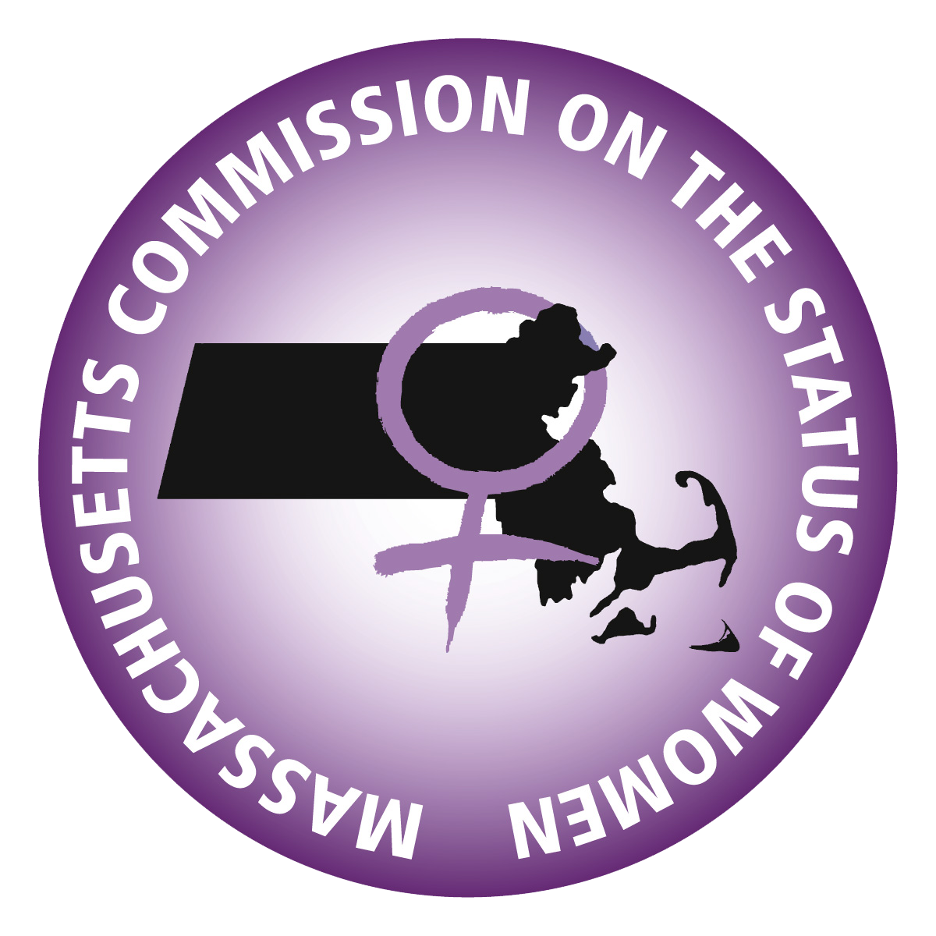
Massachusetts Commission on the Status of Women
Full Commission Meeting Agenda
January 19, 2023 4:00pm-5:30pm
Meeting Link: https://us06web.zoom.us/j/95975394212

- Call to Order
  - Roll Call
- Votes
  - Full Commission Meeting Minutes 12/15/2022
- Chair Report- Dr. Sarah Glenn-Smith
  - Strategic Plan
  - Commissioner Engagement
  - 25th Anniversary
- Treasurer’s Report- Nina Liang
  - Q2 Expenses
  - FY24 Budget Request
  - Finance Committee Secretary
- ED Report- Shaitia Spruell
  - Staff Changes
  - Website
  - Testimony Data
  - Meetings with Appointing Authorities: MCWL- January 24, 2023
- Program & Planning Report – Rebecca Bact
  - Advocacy Day (& Spring Regional Convening): May 31, 2023
  - Regional Absenteeism
  - GELI
  - Speaker’s Bureau – Request from Junior League of Boston for Keynote on March 11, 2023
  - Lynn Hearing: 1/9/2023 Register Here
- Legislative & Public Policy Report – Mary-dith Tuitt
  - Menstrual Equity Summit: Saturday January 28, 2023 9am-4pm RSVP Here
  - Upcoming Commissioner Survey on Priorities
- New Business
- Adjourn
Note: The listing of items are those reasonably anticipated by the Chair, which may be discussed. Not all items listed may be discussed and other items not listed may also be addressed to the extent permitted by law. The Chair may vary the order of items discussed.
Attachments:
December Report Slide Deck
12/15/2022 Full Commission Meeting Minutes
Strategic Plan 2019-2020
Q2 Expenses Report
FY24 Budget Request Workbook

