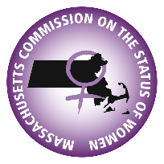
Massachusetts Commission on the Status of Women
Finance Committee Agenda
January 12, 2023
3:00pm-4:00pm
Web Meeting Link: https://us06web.zoom.us/j/82328240464

- Call to Order

- Minutes Approval

- FY23 Budget Quarterly Review _FY23 EXPENSE REPORT.xlsx Budget Report_Q2.docx
  - Table Modifications_Expenditure Modification Memo.docx
  - Subscriptions

- FY24 Budget MCSW FY24 Planning Budget

- FinCom Secretary

- Questions & Next steps
  - Next Meeting: February 9th, 2023 3:00pm

Voting Members:
Nina Liang, Committee Chair
Marianne Fleckner, Committee Vice Chair
Associate Members:
Sarah Glenn-Smith
Jean Fox
Audrey Hall
Denella Clark
Allison Goldberg

