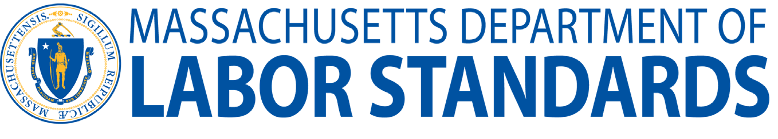
Phone: (617) 626-6975
Fax: (617) 626-6944
mass.gov/dols

Application for Waiver of Minimum Wage for Students
at Hospitals or Laboratories
M.G.L. c. 151 § 7; 454 C.M.R. 27.06(1)(a)

Pursuant to M.G.L. c. 151 § 7; 454 C.M.R. 27.06(1)(a), the Department of Labor Standards (DLS) may issue to any hospital or laboratory a waiver permitting payment of not less than 80% of the basic minimum wage rate ($15.00 per hour x 80% = $12.00) to students whose employment for wages is part of a formal training program.

To apply for this annual waiver, the employer must submit this completed application form, along with a fee of one hundred dollars ($100). DLS is processing all waivers electronically. You will need to submit payment of $100.00 for the application. You can do this online at mass.gov/dls-online-payment. We accept the following card(s): Discover, MasterCard, Visa, as well as electronic funds transfer from checking or savings bank accounts. This fee is not refundable, in the event that this application is denied.

After payment is made please submit the completed application form to: MinimumWage@mass.gov.

Your application form and fee should be submitted at least 30 days prior to the requested date of applicability.

If you have any questions regarding this application, please contact DLS at (617) 626-6975.

¹A waiver is not necessary for “work by persons being rehabilitated or trained under rehabilitation or training programs in charitable, educational, or religious institutions.” See M.G.L. c. 151, §2.

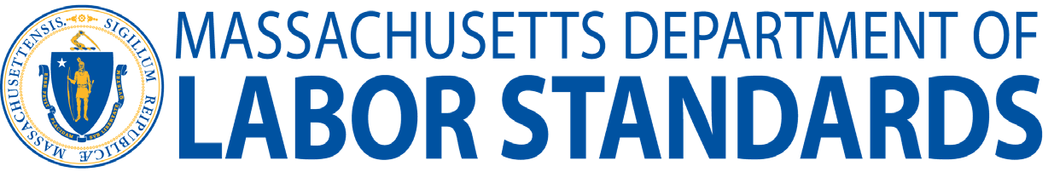
Phone: (617) 626-6975
Fax: (617) 626-6944
mass.gov/dols
Application for Waiver of Minimum Wage for Students
at Hospitals or Laboratories
M.G.L. c. 151 § 7; 454 C.M.R. 27.06(1)(a)

Please provide the following information:
- Name of establishment: ____________________________________________________________________
- Nature of business: _______________________________________________________________________
- Telephone number: _______________________________________________________________________
- Business address: ________________________________________________________________________
- Name of contact person and title: ____________________________________________________________
- Provide the number of students to be employed at sub-minimum wage: ___________________________
- Provide the name, address, and description of the location(s) where the student(s) will work:
__________________________________________________________________________________
__________________________________________________________________________________
__________________________________________________________________________________
__________________________________________________________________________________
___________________________________________________________________________________

- Provide the ratio of minors to adults working at the location(s): ____________________________________
________________________________________________________________________________________
- Provide the proposed hourly wage to be paid to student employee(s): ______________________________
- Provide the proposed hours of work: ________________________________________________________
- a. Is this the institution’s first application? □ Yes □ No
b. If this is not the first application, when was the last application made? ___________________________
c. If a previous application was approved, when was the waiver in effect? ___________________________

Please note: If the waiver application is approved, the Department of Labor Standards may attach conditions to the granting of the waiver if deemed necessary.

Signature of Applicant: _________________________ Name of Applicant: ____________________________ Title: ________________________________________ Date: ________________________________________
□ New Application/□ Renewal:
□ Granted / □ Denied Date:
Office Use Only
CMS # Check # Date Received:

