Racial Equity Data Road Map:
Data as a Tool Towards Ending Structural Racism

Table of Contents
Acknowledgements 4
Executive Summary 5
Introduction 8
Background 8
Road Map Purpose and Overview 9
Overview of Sections 10
Foundational Terms/Phrases 11
Section 1: Looking at health issues with a focus on the impact of racism 13
Section 1 Reflection 16
Section 2: Determining if program is ready to use data to address racism 17
Purpose 17
Guidelines for Use 20
Section 2 Reflection 21
Section 3: Understanding what the data say about differences in health outcomes by race and ethnicity 23
Disaggregate Data and Racial Equity 23
How to Disaggregate Data 23
Data Quality Challenges and Limitations 24
Assessing for Inequities 26
Example 27
Section 3 Reflection 28
Section 4: Using other sources of data to uncover causes of the differences 29
Identifying the Population/Community of Interest 29
Contextualizing Data with Communities/People with Lived Experience 30
Quantitative Tools for Contextualizing Community Level and Structural Factors 32
Additional Tools for Contextualizing Data 33
Case Study: Welcome Family 36
Section 4 Reflection 38
Section 5: Making plans to act on differences that are unjust or avoidable 39
Step 1: Prioritize the inequity you will address. 39
Step 2: Plot current and potential program initiatives/strategies. 40
Section 5 Reflection 42
Section 6: Presenting data in ways that help people make sense of the numbers 43
Step 1: Determine the goal of the Equity Spotlight. 43
Step 2: Determine the audience. 43
Step 3: Identify 2-3 key takeaway messages for the audience. 44
Step 4: Design your Equity Spotlight. 45
Step 5: Put the Equity Spotlight together. 46
Step 6: Pilot the Equity Spotlight. 47
Section 6 Reflection 48
Section 7: Moving from data to action 49
Planning and Implementing Interventions 49
Developing and Assessing the Effectiveness of Interventions 51
Setting an aim statement 52
Plan Do Study Act (PDSA) Cycles 53
Assessing Systems Change 55
Change Management 55
Section 7 Reflection 56
Conclusion 57
Racial Equity Glossary 58
Appendix: Racial Equity Program Readiness Assessment 62
Standard 1 – Data Capacity 62
Standard 2 – Performance Measurement 63
Standard 3 – Program Collects High Quality Data to Inform Racial Equity Work 64
Standard 4 – Program Contextualizes Data to Inform Racial Equity Work 65
Standard 5 – Program Implements a Continuous Quality Improvement (CQI) Process 67

Acknowledgements

This report was prepared by members of the Racial Equity Strategic Pathway Implementation Team (RESPIT): Stefanie Albert, Elizabeth Beatriz, Antonia Blinn, Lindsay Kephart, Kira Landauer, Susan Manning, Sabrina Selk, Christine Silva, Katie Stetler, Sarah L. Stone, Mahsa Yazdy, and Megan Young. Review and feedback on the Road Map were provided by Melanie Jetter, Emma Posner, Kate Hamdan, and Heather Catledge.
Special thanks go to: Craig Andrade, Alison Mehlman, Beatriz Acevedo, Emily Lu, Tim Nielsen, Ryan Walker, and Hafsatou Diop.
Suggested Citation: Massachusetts Department of Public Health. Racial Equity Data Road Map. Boston, MA; <Insert Release Date>. To obtain additional copies of this report, please contact: Massachusetts Department of Public Health, Bureau of Family Health and Nutrition - 250 Washington Street, 5th Floor Boston, MA 02108. Email: RESPIT@state.ma.us.

This publication can be downloaded from:

Executive Summary

“We are concerned about the constant use of federal funds to support this most notorious expression of segregation. Of all the forms of inequality, injustice in health is the most shocking and the most inhuman because it often results in physical death. I see no alternative to direct action and creative nonviolence to raise the conscience of the nation.”
-Dr. Martin Luther King Jr. speaking on the segregation of hospitals at the 2nd National Convention of the Medical Committee for Human Rights, Chicago, Illinois. March 25, 1966

Our Mission: The Massachusetts Department of Public Health (MDPH) works to ensure that all residents of the Commonwealth achieve their best health by eliminating disparities, addressing the social determinants of health and using data-driven practice. We have prepared this document that outlines ideas, suggestions, and best practices for using data to help us close gaps in health outcomes by race and ethnicity.

Why incorporate a racial equity frame in our data?: It has been fifty years since Dr. King spoke to the unacceptable inequities in health outcomes by race that result from a system of segregated health care. While progress has been made to integrate the health care system, the gap in health outcomes between people of color and white people remains. In some cases, the gap has even widened as advances in medicine increase the overall potential for health; at the same time, too little has been done to address historical structural racism that plays out in people’s lives and communities. By examining the role that data can have in perpetuating and failing to address inequities in health, we are performing an act of what Dr. King calls “creative nonviolence,” to explicitly acknowledge and specifically use racialized data. By racialized data we mean looking at data for racial inequities in ways that reflect the social constructs of race – a system of power and privilege with historical and modern day impacts and consequences. This supports efforts to disrupt the status quo; face racial inequities head on; and inform data-to-action approaches that can be used to test new ideas that may finally lead to all people having the opportunity to reach their full potential for health and wellbeing.

The Racial Equity Data Road Map: The Racial Equity Data Road Map is not a toolkit or one-size-fits all approach. Instead, it is a living document that outlines a number of steps for using data that have been piloted and tested within MDPH as one part of our journey towards achieving racial equity. As such, while the sections are presented in a way that is hopefully easy to follow, there is no set order in which they should be followed. Instead, users of the Road Map can move through the document at the pace and in the manner that makes the most sense for the program or issue being addressed, taking into consideration funding requirements, approval processes, and decision-making structures as needed. The Road Map is divided into the following seven sections:
Section 1. Looking at health issues with a focus on the impact of racism
Describes why issues ​should be looked at with a racial equity lens and introduces a tool for programs to use in their work.

Section 2. Determining if program is ready to use data to address racism
Encourages programs to use a self-assessment to better understand which systems are in place to support racial equity work using data.

Section 3. Understanding what the data say about differences in health outcomes by race and ethnicity
Describes why it is important to look at data in smaller units such as race, ethnicity, or zip code and gives suggestions on how to do this. Provides guidance on comparing data across sub-groups to see whether there are inequities.

Section 4. Using other sources of data to uncover causes of the differences
Provides suggestions on how to describe data with historical and structural context, with a focus on engaging the community.

Section 5. Making plans to act on differences that are unjust or avoidable
Introduces tools to support the process of identifying the most striking inequities and creating a plan to address them.

Section 6. Presenting data in ways that help people make sense of the numbers
Outlines important questions and things to consider in designing materials used to communicate data to key stakeholders.

Section 7. Moving from data to action
Describes how to plan, put in place, and monitor the impact of interventions to address inequities.
Conclusion: The Road Map is a summary of tools and strategies that help bring together both the intellectual (the head) and emotional (the heart) assets that are necessary to address the ongoing health inequities we face as a Commonwealth. While this document was originally crafted to meet the needs of epidemiologists and data analysts, it is hoped that anyone interested in using data to inform action can use this Road Map to inform their practice. Because no one has yet achieved the goal of fully realizing racial equity there will be a continuing need to refine and build upon what is written here as the practice of using data to inform our racial equity practice evolves. If there are mistakes, corrections or new knowledge that can improve this document, please let us know by emailing us at RESPIT@state.ma.us.

Introduction

Background
The Massachusetts Department of Public Health (MDPH) is dedicated to ensuring optimal health of all residents of the Commonwealth by eliminating disparities, addressing the social determinants of health, and using data-driven practice. According to the United Health Foundation America’s Health Rankings, Massachusetts is consistently one of the healthiest states in the nation. However, lost in that achievement is the existence of health inequities, specifically racial inequities. MDPH is dedicated to understanding the root causes of inequities seen in communities across Massachusetts and taking action to eliminate them. We have prepared the following document that outlines ideas, suggestions, and best practices for using data to help us close gaps in health outcomes by race and ethnicity.

To achieve this goal, MDPH is addressing structural and institutional racism and the way systems and policies advantage certain groups and disadvantage others. An explicit focus on racism allows for the development of frameworks, tools, and resources that can be applied to racial inequities that impact health outcomes. This also provides the opportunity to better understand how racism influences public health so that actionable strategies and solutions can be identified.

Importance
It has been fifty years since Dr. Martin Luther King Jr. spoke to the unacceptable racial inequities in health outcomes perpetuated by a system of segregated health care. While significant progress has been made to integrate the health care system, the gap in health outcomes between people of color and white people has not been eliminated. In some cases, the gap has even widened as new technologies increase the overall potential for health; at the same time too little has been done to address the history of structural racism that endures in the lives of our people and communities. By examining the role that data can have in perpetuating and failing to address health inequities, we are performing an act of what Dr. King calls “creative nonviolence,” to explicitly and specifically use racialized data to: disrupt the status quo; face racial inequities head on; and inform data-to-action approaches that can be used to test new ideas that may finally lead to all people having the opportunity to reach their full potential for health and wellbeing.

Road Map Purpose and Overview
The vision for the Road Map is to improve the use of data to inform racial equity work in MDPH-funded programs to achieve equitable health outcomes across the Commonwealth.

Improving programs’ capacity to collect and use data to promote racial equity has been identified as a priority need through the Racial Equity Movement at MDPH. This need inspired the development of this Road Map to improve the use of data to inform racial equity work in MDPH-funded programs and initiatives so that services are delivered in a more equitable way, optimizing health and well-being for all residents of the Commonwealth. Improving the use of data to inform racial equity work includes: collecting and analyzing data, collaborating with communities, framing program data in the context of historical and current policies, and identifying system factors that impact the health of communities. Additionally, it includes asking questions and using tools to aid in root cause analyses, identifying and designing solutions, and developing strategies to address inequities.

The Road Map provides a suggested methodology for programs to assess their progress in addressing racial inequities in service delivery and health outcomes. This is not a rigid process that must be followed step by step. Rather, it is a collection of guiding questions, tools, and resources that can be customized to best suit the needs of programs with different levels of capacity in data analysis, quality improvement, and racial equity reframing techniques. There are multiple entry points to the Road Map so programs may start at different places.
The Road Map is a collection of guiding questions, tools, and resources that can be customized to best suit the needs of programs, not a prescriptive checklist.

Overview of Sections
The Road Map is organized into seven sections. The purpose of each section is outlined below.

Road Map Section | Purpose
1. Looking at health issues with a focus on the impact of racism | Describes why issues ​should be looked at with a racial equity lens and introduces a tool for programs to use in their work.
2. Determining if program is ready to use data to address racism | Encourages programs to use a self-assessment to better understand which systems are in place to support racial equity work using data.
3. Understanding what the data say about differences in health outcomes by race and ethnicity | Describes why it is important to look at data in smaller units such as race, ethnicity, or zip code and gives suggestions on how to do this. Provides guidance on comparing data across sub-groups to see whether there are inequities.
4. Using other sources of data to uncover causes of the differences | Provides suggestions on how to describe data with historical and structural context, with a focus on engaging the community.
5. Making plans to act on differences that are unjust or avoidable | Introduces tools to support the process of identifying the most striking inequities and creating a plan to address them.
6. Presenting data in ways that help people make sense of the numbers | Outlines important questions and things to consider in designing materials used to communicate data to key stakeholders.
7. Moving from data to action | Describes how to plan, put in place, and monitor the impact of interventions to address inequities.

Foundational Terms/Phrases
A detailed Racial Equity Glossary of Terms can be found at the end of the document. Throughout the document key terms are bolded and linked to the Glossary. Below are explanations of common terms used in the Road Map that are important to be grounded in from the beginning:
- Racial equity work includes activities or programs that create and reinforce policies, attitudes, and actions for equitable power, access, opportunities, treatment, and outcomes for all people, regardless of race or ethnicity. The goal is to eliminate inequities between people of different races and ethnicities, and to increase success for all groups.,
- Using a racial equity lens means explicitly considering race, ethnicity, and racism in analyzing issues, looking for solutions, and defining success.
- Data for racial equity work will vary based on the question the program wants to answer or the issue it wants to address. Common individual-level demographic variables that are often helpful in understanding how racism impacts health outcomes include, but are not limited to, race and ethnicity, language, place of birth, and zip code.
- Contextualizing data means providing a narrative that describes the data and the root causes of inequities in the context of historical and current systems of oppression (e.g., racism, sexism). This must be done by engaging community partners and stakeholders in understanding and interpreting the data, and/or looking at quantitative data on individual and community experience.
- Center in the margins is to shift the starting point from a majority group's perspective, which is the usual approach, to that of the marginalized group or groups.
- Health disparities are differences between the health of one population and another in measures of who gets disease, who has disease, who dies from disease, and other adverse health conditions.
- Health inequities are differences in health status and mortality rates across population groups that are systemic, avoidable, unfair, and unjust. These differences are rooted in social and economic injustice, and are attributable to social, economic and environmental conditions in which people live, work, and play.
- Racialized data are stratified in ways that acknowledge the groups of people who have been assigned a race by society (racialized) to perpetuate and support systems of privilege and oppression, such as distinctions by race/ethnicity, language, and place of birth. Moving beyond racialized data to using data for racial equity is part of the journey described throughout this Road Map.
- People of color is a term that is used to reference the way that groups have been racialized in the United States to privilege certain groups as ‘white’ based on the countries from where their families immigrated. People of color is a term that has been used in many different ways across time. In this text, it is being used as a way to express the dichotomies that exists based on designation of a person as white or non-white. It is not to be used to broadly classify all non-white populations, or dismiss the varied history of discriminatory and violent policies against specific non-white groups.

Section 1: Looking at health issues with a focus on the impact of racism

In public health, health outcomes are traditionally examined by select demographic characteristics, including race and ethnicity, to highlight disparities in outcomes. It is less common for disparities to be framed as inequities and rarer yet to identify historical and current policy and systems factors that contribute to these inequities. Reframing how your program views health outcomes can help you understand how and why the existing disparities are unfair, unjust, and preventable. Reframing can encourage you to think carefully about the most effective ways to address racial inequities that focus on underlying structural factors. The reframe described below provides a framework to interpret data using a racial equity lens.
The way messages are framed can result in substantial differences in how data are interpreted and what potential solutions are considered.

The way messages are framed can result in substantial differences in how data are interpreted and what potential solutions are considered. The Racial Equity Reframing Tool (Figure 1.1) is one way to explicitly describe traditional approaches, and then challenge the underlying assumptions and expectations of those approaches. This exercise often exposes unspoken, pervasive assumptions that underlie how we think about our work. By surfacing these assumptions and making them explicit, your program can question whether they are helping to address inequities or if they might, in fact, be reinforcing inequities.

The Racial Equity Reframing Tool uses five questions, or framing elements, that can be discussed using qualitative data, needs assessment findings, and input from community stakeholders.
1. What is the problem?
2. What is the cause? (What/who is responsible?)
3. What is the solution?
4. What action is needed?
5. What values are highlighted?

Figure 1.1: Racial Equity Reframing Tool

Framing Element | Traditional Approach | Racial Equity Approach
1. What is the problem? | This is often the problem as defined long ago and reinforced by education and access campaigns over years of programming and funding cycles. | Where is the injustice?  Are subgroups affected differently?  Are specific groups bearing a greater burden?  What is the inequity of interest?
2. What is the cause?  What/who is responsible? | Individual behaviors/actions are often identified as the root cause of the problem. | Think through the Social Determinants of Health (SDoH—built environment, social environment, employment, education, housing and violence) as they pertain to the problem defined above. What are the root causes? Think bigger and more broadly about policies, and opportunities within the healthcare or social service systems. Think about the individual level, interpersonal level, organizational level, community level, and public policy levels. This may need to be done collaboratively with stakeholders.
3. What is the solution? | When the cause of the problem is deemed a result of individual action, the solutions developed are likely to be individual-level interventions. | How do you address the root causes identified above? What can be done about internal policies (e.g. program and agency policies)? What is the link between SDoH and larger policies (e.g., government, health system)? This can and should be multifaceted.
4. What action is needed? | Traditional approaches often center on individual-level education or clinical intervention and likely guide you to engage only the same stakeholders, use the same language, and/or analyze the same data as you have previously. | Now that you have solutions, what gets you there? Consider creative strategies. Where do you fit in this? Are you engaging partners from other agencies? Are you engaging the right partners? The community? Are you using racial justice language in your approach to partners? What processes are needed for engaging those partners?
5. What values are highlighted? | Given the problem and solution, what do you know to be true? Traditional approaches often highlight personal responsibility, individual choice, etc. | Given the newly defined problem and solutions, what is now known to be true? The Racial Equity Approach often highlights equity, fairness, shared responsibility, etc.

Figure 1.2 represents an example from a diabetes program of how a racial equity reframe was used to reimagine how they approach their prevention efforts.

Figure 1.2: Racial Equity Reframing Example – Diabetes

Framing Element | Traditional Approach | Racial Equity Approach
1. What is the problem? | High rates of diabetes | Persistent racial inequities in diabetes rates for low-income Caribbean Latino seniors. They are healthy in the Islands and they get sick when they come here.
2. What is the cause?  What/who is responsible? | Poor nutrition, lack of exercise, overweight/obesity  Individuals | Food deserts, income inequity, and racial redlining in transit lead to social isolation and lack of community support; zoning for green space, etc. in communities of color; disinvestment in communities of color; residential segregation  Businesses, policy makers, multiple institutions and unfair systems
3. What is the solution? | Improve nutrition, increase physical activity | Food security in all communities; economic investment in low-income communities and communities of color; accessible and affordable healthy foods in all communities (particularly communities of color)
4. What action is needed? | Nutrition education classes, exercise classes | Food access policies that target roots of inequities; economic policies that invest in communities of color;  partnerships across sectors and with community residents
5. What values are highlighted? | Individualism; personal responsibility; choice; individual freedom | Equity; justice; fairness; shared responsibility

As this example highlights, when a different frame is used, very different messages about the causes of the problem and very different approaches to address this issue arise. In the diabetes example, a traditional approach would lead to solutions addressing access to health care and education about healthy food and exercise choices. Applying a racial equity reframe, the impact of structural issues on an individual’s ability to make healthy choices point towards policy, systems, and environmental solutions.

Section 1 Reflection
As you apply your racial equity reframe, check-in with your team about what you have learned from this exercise.
- What surprises you?
- What assumptions did you have that were challenged?
- How does this inform your future thinking and planning?
- Do you have established relationships with the communities you serve? How would their voice change the reframe exercise?
- How can you take your initial reframe and bring it to other stakeholders?

This is an opportunity to think differently about the work and to pursue new ways of imagining solutions. This is an exercise you can do multiple times, with multiple audiences, over time and continue to learn and grow your analytic capacity for applying a racial equity reframe. At any point in your journey you can return to this step to consciously question the assumptions that are informing your work.
Practicing using an equity lens to reframe health topics supports a growth mindset as we confront the fact that many of our assumptions are dependent on a system that was built to maintain and sustain inequities. It is only through challenging our current way of thinking that we will be able to make transformational change.

Section 2: Determining if program is ready to use data to address racism

Purpose
For the purpose of this Road Map, program data readiness is defined as having the knowledge, resources, and capacity to collect and use data to promote racial equity. As your program uses this Road Map, you may engage with data in new and unfamiliar ways. After applying a Racial Equity Reframe, your program is encouraged to complete a self-assessment using the Racial Equity Program Data Readiness Assessment (found in the Appendix) to determine whether or not basic data systems are in place to support data-driven racial equity work.

The Racial Equity Program Data Readiness Assessment will help your program to:
- Understand standards that support engagement in data-driven racial equity work.
- Assess its ability to collect and use data to promote racial equity.
- Identify gaps in knowledge, resources, and capacity related to data readiness.
- Use tools and strategies to build capacity for data-driven racial equity work.

There are five Data Readiness Standards used to assess your program’s readiness to engage in and support data-driven racial equity work. Your program should strive to achieve the following:
- Data Capacity: Program has dedicated staff that can analyze data to be used in program monitoring and decision making with a racial equity lens.
- Performance Measurement: Program reports on performance measures in real time to identify areas of improvement with a racial equity lens.
- Data Quality: Program collects and reports individual level data to inform racial equity work according to MDPH standards.
- Contextualized Data: Program contextualizes data using a structural framework to understand and improve equity in outcomes in their program.
- Quality Improvement: Continuous quality improvement is thoroughly integrated in the program and a quality improvement team effectively uses improvement methods to address identified inequities.

In order to make progress on each of the five Program Data Readiness Standards, it is critical to involve community stakeholders at every step of the process, particularly in the interpretation of data, analysis of root causes of inequities, and design of effective, data-informed solutions (see Section 4).

In addition, buy-in from leadership or decision-makers is critical for ensuring resources to support infrastructure for collecting high quality data, ensuring availability of analytic expertise, and dedicating staff time to contextualizing data and making community-informed decisions about how the data can inform improvements in program outcomes. If leadership or decision-makers are not yet invested, components of this work can be implemented and used to demonstrate the value of using data to promote racial equity.

Figure 2.1: Program Data Readiness Standards

Program Data Readiness Standards exist on a continuum with three Phases: Pre-foundational, Foundational, and Aspirational. Your program will fall somewhere on the continuum for each Standard; this depends upon your program’s access to data and analytic support.

Figure 2.2: Continuum of Data Readiness Standards

Programs at the Pre-foundational phase should build program capacity, knowledge, and resources in the five Program Data Readiness Standards as they use the Road Map. For programs that are at the Foundational phase, this assessment will provide tools to continue building readiness to maximize efficiency and effectiveness while they use the Road Map.
Programs do not need to reach the Aspirational Phase for each Standard in order to use the Road Map.

Your program is encouraged to assess where you fall on the continuum for each Standard. Programs do not need to reach the Aspirational Phase for each Program Data Readiness Standard in order to use the Road Map. The strategies and methodology presented in the assessment are intended to guide your program in building capacity, resources, and knowledge as you use the Road Map.

Each Program Data Readiness Standard is associated with Transition Strategies. Transition Strategies are action-oriented activities that can be used to move along the continuum towards the Aspirational Phase for that Readiness Standard. Transition Strategies correspond with Transition Resources, which are materials and means a program may apply to carry out the Transition Strategy.

Figure 2.3: Program Readiness Transition Strategies and Transition Resources

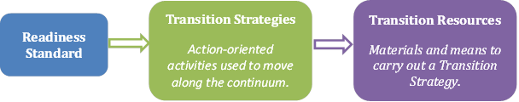

Guidelines for Use
A program self-assessment should be conducted for each of the five Data Readiness Standards. The self-assessment is designed to specifically assess data capacity to support data-driven racial equity work. There are other tools, such as the Racial Justice Self-Assessment checklist developed by the MDPH Bureau of Community Health and Prevention, that focus more broadly beyond data that can help programs identify concrete actions and steps they can take to better incorporate a racial justice lens in their work. It is recommended that the Data Readiness Assessment be completed with a team including leadership, managers, supervisors, programmatic staff, epidemiologists, and other staff who support your program.

- To determine your readiness level for a given standard, review Transition Strategies in the Racial Equity Program Data Readiness Assessment (see Appendix).
- Read each Transition Strategy from left to right, starting with the Pre-foundational Phase column. Review the Pre-foundational Phase Characteristics for each Transition Strategy. Think of practices your program engages in that fit those characteristics.
- If your program meets all of the Characteristics for the Pre-foundational Phase, move one column to the right, to the Foundational Phase. Repeat the same process for the Aspirational Phase.
- If your program does not meet all the Characteristics of a Transition Strategy then your program is currently in that Phase of that Readiness Standard.
  - Once you have identified the Phase your program is in, consider developing goals to move your program along the continuum towards the Aspirational Phase. Transition Resources can help you in this process.
  - Repeat this process for all Transition Strategies.
- If you find your program is lacking readiness through this self-assessment, you may need to engage in capacity-, knowledge-, and/or resource-building to fill any major gaps and to increase program data readiness. You can then return to the self-assessment to reassess your readiness status.
- If you find your program is at least in the Foundational Phase, continue to bolster your program’s data readiness capabilities while moving through the Road Map.

Important Notes
- Transition Strategy Characteristics of a ‘lower’ Phase carry across all Phases, even if not stated explicitly (e.g., characteristics of the Pre-foundational Phase are also characteristics of the Aspirational Phase of that Transition Strategy).
- This is not intended to be a ‘one size fits all’ tool; some Transition Strategies and Transition Resources may not be applicable to your program or may need to be adapted to your program context.
- The Transition Resources are suggestions, not mandatory.
- Your program may be Pre-foundational for one Transition Strategy and Foundational for another in the same Program Data Readiness Standard. This is expected; this self-assessment will allow you to identify gaps in knowledge, resources, and capacity to facilitate goal-setting to increase program data readiness.

Section 2 Reflection
Now that you have completed the Racial Equity Program Data Readiness Assessment, debrief as a group and discuss program strengths and areas where racial equity work is “in progress” or has not been started.
- What are the current strengths? In which areas has racial equity work been strong?
- Identify where program Standards are “Foundational.” What are the transition strategies that will bring the program to “Aspirational”?
- What areas are “Pre-foundational”? Do they cluster in one particular Readiness Standard? What are the barriers to transitioning to “Foundational”?

Section 3: Understanding what the data say about differences in health outcomes by race and ethnicity

After your program completes the Racial Equity Program Data Readiness Assessment, you are ready to begin looking at your data. Many programs collect individual-level data on the participants or clients they serve. From these data, prevalence estimates and rates are often calculated and presented in aggregate, meaning all data are grouped together to provide a summary measure (e.g., the prevalence of diabetes in Massachusetts). Alternately, data can be disaggregated (or stratified), meaning they are broken down and analyzed in smaller units (e.g., race, ethnicity, or zip code), rather than presented as an overall rate.

Disaggregate Data and Racial Equity
While aggregate data show overall health outcomes, disaggregated data can show how health outcomes can be different between racial and ethnic groups or specific communities. This gets at health disparities—the differences between the health of populations in who gets disease, who has disease, who dies from disease, and other adverse health conditions.

Disaggregating data is important to identify racial and ethnic health inequities – differences that are unjust and avoidable – that can then be addressed through changes to policy, practice, and programs. For example, the prevalence of diabetes among Asian women in Norfolk County (disaggregate) may be much higher than the overall prevalence of diabetes in Massachusetts (aggregate). The disaggregated data highlight this health inequity so that future policy and practice can address it.

How to Disaggregate Data
Using data for racial equity begins with determining if and how different races and/or ethnicities experience health outcomes differently. Steps in disaggregating data include:
- Engaging with community members. Community members can assist in identifying which racial/ethnic subgroups are most prevalent in the geographic area and which health outcomes are most salient. Involving community members may also provide additional insight into intersectional issues such as race/ethnicity, language access, and immigration status.
- Identifying sources of race and ethnicity data available to your program. Sources may include surveys or program intake/assessment forms. Consider how these data were collected—are measures self-reported or do they come from another data source such as the individual’s medical record?
- Determining which health-related outcome(s) to disaggregate. Health-related outcomes can include measures of disease or death, health behaviors, health-related social needs, and program-specific measures (e.g., use of services). For example, outcomes to consider in regard to inequities in tobacco control might include: smoking-related cancer mortalities, use of tobacco in the past 30 days, rates of successful attempts of tobacco cessation, age of first tobacco use, access to tobacco retailors, referrals to tobacco cessation programs, and completed referrals for tobacco cessation programs.
- Breaking down race and ethnicity into as fine categories as data allow. If a program can look at health outcomes by ethnicity (e.g., Chinese, Filipino, Vietnamese), the analysis will provide more detailed and specific information about a particular community as compared to grouping all ethnicities together (e.g., Asian).
- Respecting self-identification. If there are multiple sources of data on race and ethnicity, prioritize self-reported data.

Data Quality Challenges and Limitations
As you look at your program data, you may identify opportunities for improving the completeness and accuracy of the data.

Missing Data
- Use substitute (proxy) measures. If your program does not have race and ethnicity data, there are indirect or proxy measures that can be analyzed such as country of origin, language, income, education, or zip code. With any use of proxy variables, more context and interpretation will be needed to properly frame the message and limitations of those data should be acknowledged (e.g., if using zip code as a proxy, frame within context of residential segregation). When using this approach, be clear about the possibility of confounding (a distortion of the association between racial groups and an outcome that occurs when racial groups differ with respect to other factors that influence the outcome), as racial/ethnic inequities may become evident when the data are disaggregated by other variables (e.g., income or education).
- Consider the reason why data are missing. Frequently, data are missing because systems do not support the collection of race/ethnicity data, even when there is a regulatory requirement. This may be due to the lack of understanding of the importance of collecting this information, a lack of capacity to use MDPH standards (see accompanying Racial Equity Data Road Map Attachments document), discomfort with talking about or acknowledging race/ethnicity, and assumptions that asking about race/ethnicity makes communities of color uncomfortable. Consider how these missing data could potentially distort your analysis and/or interpretation.
- Engage in a quality improvement project to improve data quality, if more than 20% of data are missing. Then you can use Plan-Do-Study-Act cycles or other quality improvement methods to address missing data. See Section 7 for additional quality improvement ideas.

Suppression rules
- When the number of people within a group is small, there is a risk that presenting the data within small categories or populations may identify the individuals and comprise the confidentiality of the data; therefore, MDPH has outlined confidentiality procedures under which individual level or aggregate level data can be disclosed (MDPH’s confidentiality procedures, see procedure 7).
- Data suppression is when selected information is removed or hidden when there is concern that small numbers may identify individuals. Data suppression should be considered when data are being presented 1) by geographic areas smaller than state level, or 2) by more than one covariate (e.g., year, race, gender).

Data Collection
- Consider the terminology used. Be aware that terminology may vary based on the sources of data or how the data were collected over time. There may have been changes in definitions or data collection practices . For example, some programs may use Latino, Hispanic, Spanish, or Latinx interchangeably.
- Consider how race data are collected. Are participants able to identify as more than one race? It is important to explicitly document these data considerations as they provide context during your analysis.

Data Use
- Collapse data using recommended standards. If collapsing race or ethnicity data is necessary to create population estimates, MDPH recommends using the race and ethnicity categories developed as a collaborative post-censal (US ACS Survey estimates) population estimate between the University of Massachusetts Donahue Institute and the MDPH Bureau of Environmental Health. The preferred method is breaking down race and ethnicity into as fine categories as data allow.
- Be explicit when using maternal race/ethnicity as a proxy for infant race/ethnicity.

Assessing for Inequities
Even with small numbers, patterns or striking differences can stand out and should be investigated further.
Now that the data have been disaggregated by race and ethnicity (or a proxy variable), the next step is to assess for inequities by subgroup.

- Use proportions (ratios in which the numerator is a subset of the denominator) or rates (frequency of events during a certain time period divided by the number of people at risk for the event during that time period) instead of raw numbers alone to account for differences in the sizes of the population subgroups. This allows for valid comparisons of health events between population groups and better assessment of risk.
- Compare the results across population sub-groups and decide whether meaningful differences exist. It is not necessary for there to be a statistically significant difference. When comparing differences across small groups, the sizes of the populations compared are often not large enough for a difference to be considered statistically significant even if a meaningful difference does exist. Even with small numbers, patterns or noticeable differences can stand out and should be investigated further. In some cases small numbers may signal a concern, especially if no cases are expected.

Example
This example demonstrates the importance of using rates when comparing health events:

During 2016, there were 2,715 low birth weight (LBW, weighing <2500 grams) infants born to White, non-Hispanic mothers in Massachusetts. During the same year, there were 801 LBW births to Black, non-Hispanic mothers. Given these two data points, you might conclude that LBW births are more of an issue for White mothers than Black mothers. However, there were 42,448 births to White mothers and only 7,095 births to Black mothers in Massachusetts during 2016. Therefore, only 6.4% of infants of White mothers were LBW compared with 11.3% of infants of Black mothers. By comparing proportions instead of the actual numbers it becomes clear that Black mothers have a higher likelihood of delivering a LBW infant than White mothers in Massachusetts.

Below are resources with further information about measuring health inequities:
- A framework for measuring health inequity
- A three-stage approach to measuring health inequalities and inequities
- Defining and measuring disparities, inequities, and inequalities in the Healthy People initiative
To truly assess for inequities, rather than just the magnitude or burden of health disparities on certain subpopulations, it is critical to connect the disparities to social and structural determinants of health.
The results of the disaggregation and analysis will be in the form of either an informal or formal data brief dependent upon program needs and deadlines. To really understand the problem, you will need to conduct root cause analyses (Section 4) and consider groundwater approaches (Section 5). The data brief can then be shared with key stakeholders as part of community engagement and contextualizing data, as described in the next section. This is the first step towards developing an Equity Spotlight (Section 6).

Section 3 Reflection
Now that you have examined your disaggregated data and determined if and how different races and/or ethnicities experience health outcomes differently, reflect on the following with your team:
- Are you comfortable with the completeness and quality of your data, or is additional work needed in this area?
- Did you identify disparities among racial groups in the health outcomes you are examining?
- Which stakeholders will you engage to assist in interpreting the data and planning your next steps?
Check in with your team to determine if you are ready to begin incorporating contextual data to shape the narrative in a way that considers historical and current policies and system factors that impact the health of communities.

Section 4: Using other sources of data to uncover causes of the differences

Having disaggregated and analyzed the data to better identify and understand inequities, your program can now contextualize racial equity data. Part of contextualizing data is describing the problem and using supplemental information gathered from the community. This can be in the form of qualitative and quantitative data.

Contextualizing data for equity is the critical process of providing a narrative to describe racially explicit data that addresses both historical and current systems of oppression (e.g., racism, sexism). The purpose of contextualizing data is to frame data in ways that allow it to be interpreted and understood in the larger context of historical and structural factors at play within communities, rather than focusing on individuals. This allows programs to design solutions that directly address structural factors. Without this process, data often become race neutral or race silent.
Contextualizing data is a cyclical and iterative process.

A case study from the MDPH Welcome Family home visiting program is provided at the end of this section, to demonstrate what contextualizing data can look like in practice.

Identifying the Population/Community of Interest
The first step of contextualizing data is to identify the population/community that will be centered in the work. Previously, this was referred to as focusing on the “target” population. The population/community should be described as specifically as possible. To center to the margins is to shift the focus from the advantaged group's perspective, which is the traditional approach, to that of the marginalized group or groups. The position of “outsiders within” is valuable in facilitating this process. For example, a program might initially define its population as young Hispanic mothers who live in a specific city. Once the primary population has been identified, the program should push itself to further define the centered population, with questions such as:
- Should languages spoken be considered?
To center to the margins is to shift the focus from the advantaged group's perspective, which is the usual approach, to that of the marginalized group or groups.
- Would sexual orientation or gender identity expression influence the interpretation of the population of interest?
- How might socioeconomic status influence or inform the understanding of the data?
- What other factors raised by our community members or specific to our work would inform our understanding of the data?

While not all programs will have data to answer each of these questions, it is still an important programmatic discussion to consider these and other factors that the community may identify as necessary.

Contextualizing Data with Communities/People with Lived Experience
Once the population has been specifically and carefully defined, it is crucial to engage or re-engage with the community/population that is being centered. This is essential for framing program data in the context of historical and current policies and identifying system factors that impact the health of communities, in order to understand and interpret the data. Ensuring the inclusion of community expertise, feedback, participation and decision making are critical elements to using a racial equity approach to data use and interpretation. Without this element, our programs and practices are likely to fail, or worse, to further reinforce existing inadequate and inequitable power structures. It is also important to recognize the ways in which the program has engaged with the community in the past. The program may need to reflect on ways to mend this relationship, restore trust, and ensure respectful engagement of community members including compensation for time and expertise.

Community engagement methods could include stakeholder interviews, focus groups, or surveys. However, it should always include welcoming members of the community to work with the program and to be key decision makers. Centering populations requires a higher level of engagement. To help you assess your current level of community engagement, you can refer to the Community Engagement Guidelines for Community Health Planning.

Figure 4.1: Community engagement processes
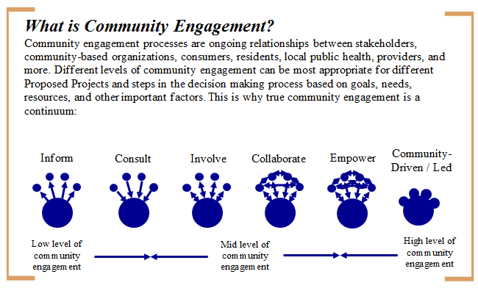

The centering approach leads to the understanding that not all words used in professional settings are appropriate or respectful to the communities centered. It will therefore be critical to familiarize yourself with respectful language as part of this process. There are many tools that outline appropriate terms to use and not to use. There are both external resources such as the Progressive’s Style Guide as well as internal MDPH materials such as the Bureau of Community Health and Prevention’s Office of Statistics and Evaluation Health Equity Working Group Style Guides. The Style Guides are being developed in concert with MDPH data standards.

Quantitative Tools for Contextualizing Community Level and Structural Factors
There are numerous measurement tools that can assist data analysts with context at the local and community level, including:
- Life Course metrics developed by the Association of Maternal and Child Health Programs (AMCHP) in partnership with state health departments (such as adverse childhood experiences, concentrated disadvantage, and residential racial segregation)
- America’s Health Rankings (such as Community & Environment indicator)
- The Index of Concentrations at the Extremes
- The Child Opportunity Index
- Maps of racial segregation

Internal to MDPH, the Population Health Information Tool (PHIT) and Community Reports outline the social determinants of health for each community of the Commonwealth, with explicit call outs to structural and historical inequities. This short video introduces the concept of the social determinants of health and provides an introduction to the PHIT Community Reports. Environmental Public Health Tracking (EPHT) is the ongoing collection, integration, analysis, and interpretation of data about environmental hazards and health effects potentially related to environmental exposures. Massachusetts EPHT data are available on an interactive web portal.

There are also individual level measures that are likely not part of your program measures but could still add valuable context to how you understand and interpret your data. For example, perceived experiences of discrimination (individual level) including the Everyday Discrimination Scale.
Structural analyses can help you think critically about what structures or systems may be limiting your ability to reach your program’s potential.
These types of structural analyses can help you think critically about whether your program will be able to effectively meet the needs of everyone in the community, which is important for future prioritization work (described in Section 5), and what structures or systems may be limiting your program’s ability to reach its potential.

Additional Tools for Contextualizing Data
Environmental scans and root cause analysis are two additional tools that can be useful in contextualizing data. Consider using these tools when engaging with the community/population to be centered.

Environmental Scan
Environmental scanning is the gathering and monitoring of information about a program's internal and external environment. One popular method of environmental scanning is conducting a Strengths, Weaknesses, Opportunities, and Threats (SWOT) analysis. Strengths and weaknesses are internal to your program/organization—things that you have some control over and may be able to change. Examples include who is on the team, the population being served, programming and services provided, and location of services. These factors determine the decisions a program makes.

Environmental scans should also examine factors external to the program, such as competition, economics, technology, legal issues, and social/demographic factors. During this process, bright spots, evidence informed strategies, community needs and positive deviance can be identified and reviewed.

Outcomes of the environmental scan at the program or organizational level should be used for monitoring the success of implementation:
  - Quantity—how much did we do?
  - Quality—how well did we do it?
  - Is anyone better off?

Root Cause Analysis
A root cause analysis is a systematic process that helps to identify causes associated with a problem of interest and to think about the “why” behind the problem.

One tool recently used by the MDPH Bureau of Community Health and Prevention is the Narrative Equity Analysis Tool (NEAT), a process to get to root causes to identify and describe structural drivers of inequities. There are three steps in the NEAT process:
- Identify a health risk behavior or health outcome from your program, and inequities in that behavior/outcome
- Fill out the NEAT diagram for the specific inequity
- Use the diagram to contextualize and frame the risk behavior or outcome

Figure 4.2: Narrative Equity Analysis Tool Diagram (NEAT)

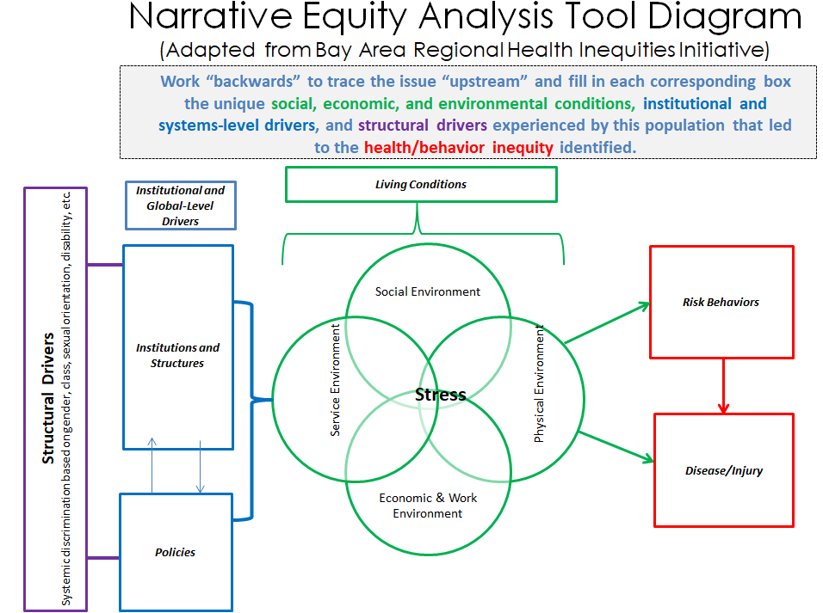

A worksheet with questions is also available to guide a team through completion of the NEAT. An example of using the worksheet when completing the NEAT tool can be found in the Attachments.

There are a number of other tools that can be used to help in understand the underlying reason for identified inequities, including:
  - 5 Whys
  - Fishbone Diagram
  - Cause and Effect Diagram Adding Cards (CEDAC)
  - Pareto Charts

Information about these tools can also be obtained by emailing PMQI@mass.gov.

Figure 4.3: Example of contextualizing data during the State Health Assessment/State Health Improvement Plan reframing

Before: Identifying disparities by subgroups is useful for planning interventions and targeting policies aimed at improving access for members of those subgroups. More than one-third of Black non-Hispanic adults (35.6%) were obese compared to Hispanic (28.9%), and White non-Hispanics (22.7%).
After: The conditions in which people live, learn, work, and play do not offer all citizens of the Commonwealth equal opportunity to modify their behavior. For example, a history of policies rooted in structural racism has resulted in environments with inequitable access to healthy foods, safe spaces for physical activity, walkable communities, quality education, housing, employment, and health care services. The health implications of these structural inequities are evident in the fact that Black and Hispanic residents of the Commonwealth are consistently and disproportionately impacted by obesity and its related conditions. For example, more than one-third of Black non-Hispanic adults (35.6%) were obese compared to Hispanic (28.9%), and White non-Hispanics (22.7%).

NOTE: This example not only provides data, but also explicitly names and provides details about the structural factors that play into differences in outcomes.

Case Study: Welcome Family
Welcome Family is an MDPH-funded program that offers a universal one-time nurse home visit to families with newborns in five Massachusetts communities. With support from MDPH, the five local Welcome Family home visiting programs set out to analyze their performance measure data by race/ethnicity, identify inequities, and take action to eliminate those inequities.

The problem: One of the programs identified, based on analysis of their performance measure data stratified by race and ethnicity, that they had a lower home visit completion rate with Hispanic clients compared to non-Hispanic clients.

Root cause analysis: As a team, the program conducted the 5 Whys exercise to identify potential causes of this problem. They focused on systems and structures (e.g. history, cultural beliefs, and staff language capacity) rather than individual behavior as the contributors to a lower home visit completion rate.

Community engagement: The program then met with staff from four different community-based agencies who work with this population (including a grassroots organization, non-profit society, medical center, and local child development program). They shared the ideas they had brainstormed during the 5 Whys exercise, and sought additional input/feedback on the root causes of the identified problem, asking questions such as:
  - What other data are needed to understand the causes of the inequity?
  - What other context about the community, such as needs and assets, can you provide to help understand the causes of the inequity?
  - How are historical or current systems of oppression (e.g. racism, sexism) contributing to the inequity?

Fishbone diagram: After meeting with community partners, the program then developed a fishbone diagram using their problem statement and identified root causes. A copy of their fishbone diagram can be found in Figure 4.4 below.

Figure 4.4: Fishbone Diagram- Developed by the Welcome Family Home Visiting Program
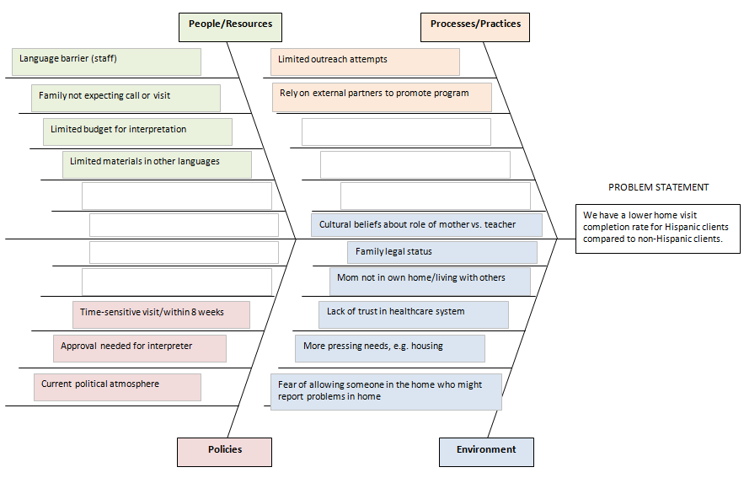

Section 4 Reflection
As you complete this section, check in with your team to consider whether your identified disparity is actually an inequity (unjust, unfair and preventable). This will allow you to start the process of designing solutions to address the inequity. You may need to go back and further stratify your data, rethink your analysis, or even do a deeper dive of your reframe based on the information that comes up during your contextualizing of the data. This is a normal part of the racial equity journey!

Section 5: Making plans to act on differences that are unjust or avoidable

Now that you have identified the population/community, defined the inequities, and framed the program data in the context of historical and current policies and practices, it is time to prioritize which inequity your program will address first and plot current program initiatives and strategies related to addressing that inequity.

Step 1: Prioritize the inequity you will address.
If more than one inequity has been identified in the preceding sections, you will want to prioritize which to focus on first. A recommended approach for prioritizing is using the Health Equity Feasibility Grid (Figure 5.1) to plot each inequity. Note: if only one inequity is identified, move to Step 2 below.
- First, think through the feasibility of addressing the inequity by considering practical supports (e.g. funding, internal capacity, partnerships, etc.) and constraints (e.g. timing of funding, political will, etc.). Is the feasibility of addressing the inequity low, medium, or high?
- Next, consider the potential impact of addressing the inequity. If the inequity is reduced or eliminated, what impact will that have on the community impacted? Is the impact low, medium, or high?
- Finally, review where the inequities fall on the grid. Which one will the team address first? The team may decide to start with the inequity that is most feasible, or where there is a simple solution. With time and practice, however, the team should begin to address more challenging inequities as well.

CAUTION: The Health Equity Feasibility Grid can be used to plot the feasibility/impact of any initiatives or projects, even those unrelated to inequities. This is why it is critical to first identify the inequities and then plot them separately from other issues your program may be addressing.

Figure 5.1: Health Equity Feasibility Grid
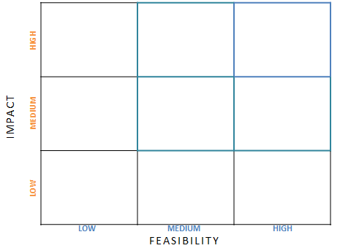

Step 2: Plot current and potential program initiatives/strategies.
After you choose the specific inequity to address first, move to plotting current and potential program initiatives and strategies related to addressing that inequity.
- First, using the matrix below (Figure 5.2), consider whether the current program initiatives and strategies use a downstream (direct or clinical services), upstream (policies or environment), or interconnected systems (groundwater) approach. At the same time, consider the degree or severity of the inequity. Are current strategies addressing the larger system and how many people are the strategies impacting? Plot each initiative/strategy in the appropriate location in the matrix.
The groundwater is a metaphor for structural racism developed by the Racial Equity Institute. It demonstrates that racial inequity looks the same across multiple systems, such as health care, education, law enforcement, and child welfare.
- Next, engage stakeholders and community members to come up with additional ideas and strategies together to address the inequity. While it is likely the team may have an understanding of the program and its structure, it is critical to include the voice of those who are receiving services or with lived experience/expertise. They will have insight into barriers and conditions impacting outcomes.

Figure 5.2: Plotting Current and Proposed Program Initiatives and Strategies
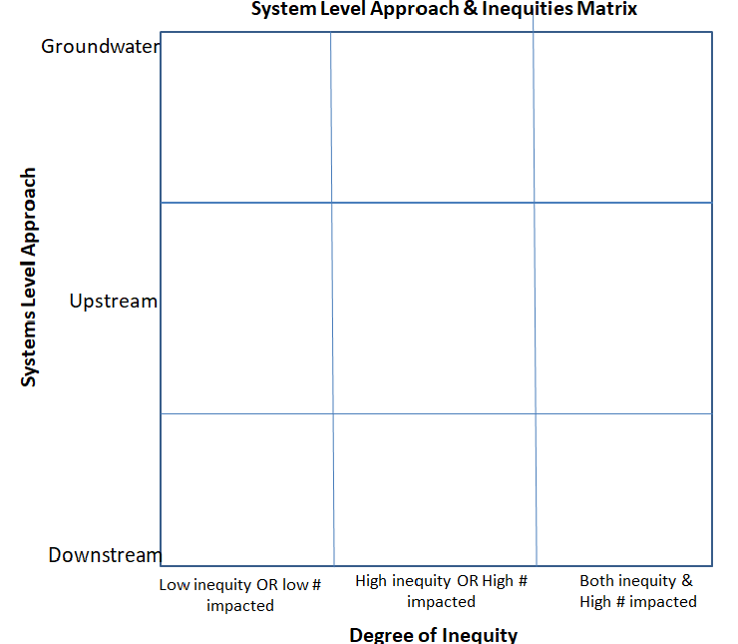

As solutions are being designed, continually revisit these guiding questions:
- What inequity is this strategy (i.e., activity or program) trying to address?
- Who will benefit from this strategy?
- Who could be harmed by this strategy? What will you do to avoid this?
- Who influences how this activity or program is put into place? Who else should provide input or influence this activity or program?
- Who decides how the activity or program is put into place?

It may seem as if there is an obvious change or solution to address the inequity. However, it is important to maintain a critical racial equity lens and to challenge assumptions when easy fixes are identified. Think about both using a groundwater approach and focusing on the social determinants of health to plan new strategies and interventions. Challenge yourself to think about ways to push your strategies towards more upstream and multi-system approaches. Refer to the Attachments for a graphic depiction of this concept. Remember the analysis is the tool for helping to identify the most appropriate action to address the inequity.

Section 5 Reflection
An equity lens helps to remind us that our biggest impact is when we can address system issues with upstream and groundwater efforts.
As you complete this section, check-in with your team about whether you are ready to move on to effectively communicating the root causes of the inequity and proposed solutions. Have you done enough to understand that the solutions considered are informed by the community? Did you share ideas about upstream and multi-system approaches to addressing the problem? The solutions you have developed are crucial for success. Do not hesitate to go back to a previous step if you do not feel that you have the information or solutions you need to proceed.

Section 6: Presenting data in ways that help people make sense of the numbers

Now that racial inequities have been identified (Section 3), contextualized (Section 4), and prioritized (Section 5), the findings and strategies should be communicated to stakeholders. Developing an “Equity Spotlight” (i.e., a communication tool highlighting and framing the inequity such as a factsheet, presentation, website, etc.) can be a useful way to share information. It can also help build buy-in and deepen understanding of racial equity. This section outlines six steps with important questions and considerations in designing an Equity Spotlight.
An Equity Spotlight is a communication tool highlighting and framing the inequity.

Step 1: Determine the goal of the Equity Spotlight.
One goal of the Equity Spotlight is to share your health inequity and the program’s commitment to address it. It should be clear why these data are being highlighted.
- Is the goal to increase people’s awareness of the inequity? (This is likely only appropriate if you are engaging with people outside the community being affected. The community experiences the inequity every day.)
- Is the intention to contextualize an issue and frame it from a systems perspective that addresses root causes?
- Is the goal to highlight opportunities for intervention?
- Are the data intended to demonstrate how current programs do not adequately support certain communities?

Maybe it is all of the above. It is important to be clear on the goal of the Equity Spotlight in order to narrow the scope of the communication and determine key messages.

Step 2: Determine the audience.
The next step is determining who will access and use the product.

Figure 6.1: Examples of Audiences

Key Stakeholders | Example Members
MDPH program staff | Program managers, Bureau leadership, Support staff, Field staff
Staff of the program whose data were analyzed | Dentist at the community health center, community health worker (CHW) working directly with clients
Vendor | Local implementing agencies, contracted agencies, community based agencies
Funder | Centers for Disease Control and Prevention (CDC), Health Resources & Services Administration (HRSA), private foundations
Community residents | Families, youth, children and youth with special health needs, people with lived experience
Participant receiving services from the program | Young parents, students with disabilities
Legislature/policy makers | State legislators and their staff, municipal government partners

The identities and lived experiences of the audience will influence the best way to communicate with them. It is important to consider and explicitly address factors such as:
- Race | - Culture
- Ethnicity | - Religion
- Gender identity expression | - Sexual orientation
- Age | - Ability
- Preferred language | - Lived experience with the issue
- Literacy level

Step 3: Identify 2-3 key takeaway messages for the audience.
What exactly should a reader know after reading the Equity Spotlight? What is the story being told? Generally, Equity Spotlights address the following three questions:
- What is the inequity? Describe the inequity. Why is it important? What is the magnitude of the inequity? What data point(s) are being used to demonstrate it?
- Why does this inequity exist? Referring back to your efforts to contextualize the data, explain why this inequity occurs. When using a racial equity lens, it is essential a structural analysis be used to understand and frame the inequity (rather than describing individual-level risk factors or behaviors).
- What can be done about it? Inequities are by definition preventable. Communicating what could and needs to change (and, as appropriate, the potential role of the audience) can serve as a call to action.

If there are many narratives and data points to share, reflect on the goal of the Equity Spotlight and determine what information is essential. A critical part of this process is engaging with key stakeholders and those most impacted by the inequity to refine and prioritize the key takeaway messages.

Now that you have determined your takeaway messages, ask yourself:
- Do these messages tell a story that is compelling and actionable?
- Do these messages support the goal of the Equity Spotlight?
- Are the messages appropriate for the audience?
- Do these messages inadvertently blame the individual or population experiencing the inequity? Can the message be used to reinforce harmful stereotypes about the population experiencing the inequities?
- Do these messages emphasize that the inequity is preventable?

Step 4: Design your Equity Spotlight.
After the key messages have been determined, consider the rest of the content of the Equity Spotlight. Depending on the audience, some background information will be needed. This includes: information about the health issue/topic area, racial equity, structural racism, and the terminology used in the Equity Spotlight.

Key Components to Include

- Key takeaway message(s)
- Key definitions (especially around defining equity, necessary technical terms, and any acronyms used)
- Data highlighting inequity – provide a hook or compelling statistic
- Clear, understandable graphics
- Information related to the program that is necessary for the audience to know
(e.g., population served, eligibility criteria)
- Framing that recognizes the structural and systemic drivers of the inequity
- Next steps, solutions, and/or opportunities for intervention

An Equity Spotlight can come in many different formats, with different lengths, types of visuals, and delivery methods. Consider the advantages and trade-offs of different formats for the audience and the goal of the Equity Spotlight. Some common formats to consider are: infographics, one page fact sheets, longer reports, webpages, peer-reviewed manuscripts, oral presentations, and facilitated workshops.
There may not be one best format to reach the desired audience. Consider multiple formats.

Also consider the best way to present the information. How much and what part of the messaging should be text or visual (e.g. charts, diagrams, frameworks)? What information best supports the primary message? Additional information can be helpful to frame the message, but it can also be distracting, so use sparingly.

Step 5: Put the Equity Spotlight together.
Once you have all the key components and know the best format to reach your audience, you can create your product. Below are some additional tips to consider when creating your Equity Spotlight.
- Consider accessibility for people with disabilities.
- Use plain language. There are a variety of tools and checklists that can assist from before you start writing, to formatting and visual clarity as well as testing and revising the product.
- Pay attention to the literacy level of your document. It is recommended to create materials at no higher than an 8th grade reading level.
- Does your product need to be translated, and into which languages? Refer to the MDPH Language Access Plan for guidance.
- Remember that visuals can be more powerful than words.
  - Epi Info™, developed by CDC, is public domain software for public health that allows data collection, analysis and visualization, including mapping.
  - Free tools to make engaging presentations, infographics and other visual content include Visme and Piktochart.
  - The Racial Equity Resource Guide also has resources on infographics.
  - The Depict Data Studio website has a useful “chart chooser” to help create appropriate graphics.

Step 6: Pilot the Equity Spotlight.
Once you have created the Equity Spotlight, it is now time to pilot it with internal and external stakeholders. Share the Equity Spotlight with other internal program staff for initial feedback on messaging and images. Gather staff input and incorporate feedback.

Then pilot the Equity Spotlight with key members of the intended audience for feedback on messaging and images. Incorporate feedback into your Equity Spotlight.

Questions to consider when piloting your Equity Spotlight include:
- Are all the terms clear and easy to understand?
- What is the takeaway message?
- What is being said about the population affected by the inequity?
- Is there anything missing? Is there more you would like to know?

Section 6 Reflection
The Equity Spotlight is an important tool to share information with key stakeholders, deepen understanding of racial equity, and build buy-in for moving from data to action. Make sure the story being told reflects your earlier efforts to frame the data in the context of broader historical and structural factors and prioritize upstream and multi-system (groundwater) strategies to addressing the problem. This is an opportunity to make a clear and compelling call to action to address the impact of structural racism on the identified inequity.

Section 7: Moving from data to action

After you have identified the inequity that your program will address, selected potential strategies, and crafted an Equity Spotlight to present the data in a way that helps people make sense of the numbers, it is time to implement interventions and assess their effectiveness at addressing the inequity. Interventions should be evidence-based or informed, tailored to the population most affected by the inequity, and designed to address the root causes of the inequity. Ideally, plans for measuring the effectiveness of interventions are designed in alignment with the implementation plan to allow for real-time assessment and timely modifications to improve health outcomes. Community stakeholders should be engaged throughout the implementation and evaluation process.

Planning and Implementing Interventions
When planning interventions, consider those that have been previously tested and shown to be effective through formal evaluation or community experience. There are a number of sources of information on existing evidence-based public health interventions, including:
- CDC’s Community Guide, a collection of evidence-based findings of the Community Preventive Services Task Force that can help organizations select interventions to improve health and prevent disease.
- MCH Evidence, a resource for maternal and child health (MCH) programs to develop evidence-based action plans and strategies to improve MCH outcomes.
- Real World Examples from the Finding Answers: Disparities Research for Change project, a collection of innovative projects across the country that designed and implemented interventions to reduce quality of care disparities in cardiovascular disease, diabetes, and depression.

It is important to consider factors that might influence the success of an intervention in a specific community, including the likelihood it can be put into place, cultural environment, resource availability, and political will. The work you have done with community stakeholders in Section 4 using other sources of data to uncover causes of the observed inequity can be used to adapt the intervention to match your community’s context, needs and goals.

There are multiple approaches to implement interventions that can impact health outcomes at various levels. The CDC Health Impact Pyramid (Figure 7.1) describes the impact of public health interventions at different levels and provides a framework to improve health outcomes. At the base of the pyramid are efforts that address social determinants of health (e.g., poverty) with the greatest potential to improve population health. The upstream and multi-system strategies discussed in Section 5 impact this level. As you move up the pyramid, interventions require more individual effort (e.g., healthy eating) and tend to have smaller population impact. Since the causes of racial inequities are complex, effective interventions should address multiple levels of the pyramid.

Figure 7.1: CDC Health Impact Pyramid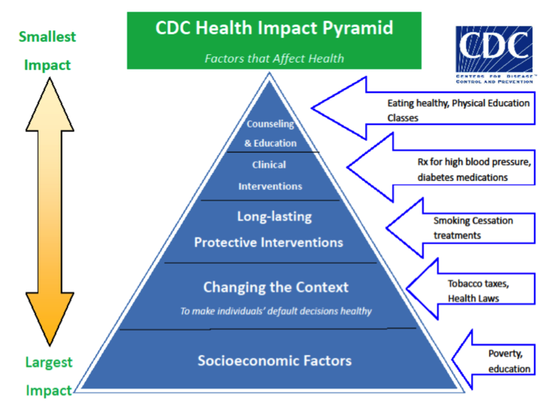

Developing and Assessing the Effectiveness of Interventions
If your interventions focus on higher levels of the pyramid – for example, individual counseling or education about healthy eating and exercise – then conducting rapid cycle tests of change is a good approach to measuring their impact. A frequently used model is the Institute for Healthcare Improvement’s Model for Improvement. The Model for Improvement consists of two parts: a series of three core questions followed by a Plan, Do, Study, Act (PDSA) cycle. PDSA is a proven method to make successful improvements. It is a problem solving model used for improving a process or carrying out a change in a series of small steps. A description of the PDSA model with equity framing is described briefly below. When applying a racial equity lens to the Model for Improvement, consider additional questions to the three core questions, such as those shown in Figure 7.2. Once you have answered these questions, you are ready to develop an aim statement.

Figure 7.2: Equity-Adapted Model for Improvement
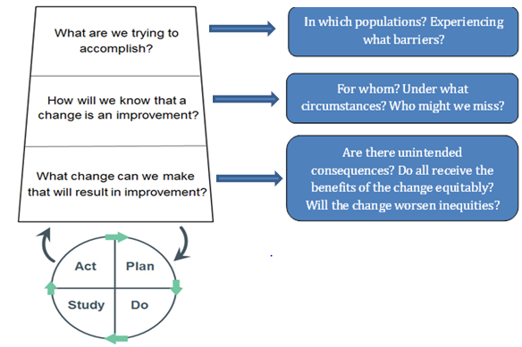
Source: Adapted from the Institute for Healthcare Improvement, Associates in Process Improvement

Setting an aim statement
In quality improvement work, one of the first steps in the change process is writing an aim statement that summarizes what your program or team hopes to achieve over a specific amount of time including the magnitude of change or reduction in inequity to be achieved.

The National Institute for Children's Health Quality (NICHQ) has developed guidance on writing aim statements. First, consider the following:
- What concrete goals do you want to achieve?
- Who will benefit from this improvement? Whose interests are served?
- What will be done? Is it supported by evidence or experience?
- Where will the change occur?
- When will it start and stop?
- What are the boundaries of the processes? What is in, what is out?

With the answers in mind, develop an aim statement. Answer “what,” “for whom,” “by when,” and “how much,” then put it all together into a full statement.

It is important that your aim statement be SMART (specific, measurable, attainable, realistic, and time-bound). However, to ensure that the improvement activity is conducted equitably, consider adding two additional components, I=Inclusive and E=Equitable to develop a SMARTIE aim statement.

Inclusive – It brings traditionally marginalized people, particularly those most impacted, into processes, activities, and decision- and policy-making in a way that shares power.
Equitable – It includes an element of fairness or justice that seeks to address systemic injustice, inequity, or oppression.

Here is an example of a SMART aim statement improved to a SMARTIE aim statement:

Table 7.1: Developing SMARTIE aims from SMART aims

SMART Aim Statement | SMARTIE Aim Statement
Improve enrollment in the program from 50% to 65% by December 20, 2022. | Improve enrollment in the program from 50% to 65% with at least a 10% increase among people of color, who are often lost to follow up, by December 20, 2022.
By 12/31/22, we will increase the home visit completion rate by 3%. | By 12/31/22, we will increase the home visit completion rate for Hispanic caregivers by 3% so that services are distributed more equitably across races and ethnicities.

Plan Do Study Act (PDSA) Cycles
Once you have developed your SMARTIE aim statement, begin the PDSA cycle.
- In the Plan stage of the PDSA cycle you can make predictions about the expected result, including whether the intervention will benefit populations equitably. You should also determine how the effect of the change should be measured, and how you will assess whether there are unintended consequences for certain groups of people. Once again, it is critical to engage the populations that are most affected by the problem in the Plan stage to ensure that the change strategies you are testing are acceptable and relevant to the community.

- Testing the change occurs during the Do stage. This is when the planned test is carried out and any problems and observations are documented. Measurement is an important part of implementing and testing change and is necessary for monitoring whether the strategy that is put in place is achieving the desired aim. Data should be collected on a series of measures including:
  - Process measures – are the steps in the process performing as intended?
  - Outcome measures – how is the intervention affecting the outcome of interest?
  - Balancing measures – are there unintended effects on other parts of the system?
Be intentional about selecting process measures that allow you to monitor whether the intervention is being implemented equitably to all populations served. PDSA cycles do not require overhauling data collection methods or processes and programs do not need a formal data system to be able to conduct PDSAs.

- In the Study stage, analyze the data collected during the Do stage and consider the following:
  - Did the observed inequities improve or worsen?
  - If improved, by how much? Do all populations benefit equitably?
  - Is the objective for improvement met? Is it met among all populations?
  - Were barriers experienced more among some populations compared to others?

- In the Act stage, review the results of your PDSA cycle and determine if it led to the intended results. Based on these results, decide whether you will Adapt, Adopt or Abandon the strategy being tested:
  - Adapt: If the inequity did not improve, reflect on why and further refine or plan another test cycle.
  - Abandon: Based on your analysis you might decide to start from scratch and plan a new test cycle altogether. Since the problem is unresolved, you would then move back to the Plan stage to consider new options for implementation. At this point it is crucial to re-engage the community to identify alternative solutions to test.
  - Adopt: If the inequity improves, you should determine if the improvement is adequate and should be sustained.

As you learn from your results you may need to refine or change your aim statement, your change strategy and/or your measures. You might conduct multiple cycles of PDSAs that are linked together and build upon one another (called “ramp cycles”).

Each step of the PDSA cycle should be documented so that you have a record of the result and can share what you learned with other stakeholders. Consider using a PDSA presentation template or worksheet for presenting the components of the PDSA. An example of a completed worksheet can be found in the Attachments.

Assessing Systems Change
If your change strategies include policy and systems changes that are more focused at the base of the health impact pyramid, “implementation science” may have more tools to assist you in assessing the effectiveness of the interventions. Implementation science provides a framework for translating evidence-based/informed practices into programs and policies that impact health outcomes. For more information about implementation science, visit the National Implementation Research Network’s Active Implementation Hub – a free, online learning environment for use by any stakeholder involved in active implementation and scaling up of programs and innovations. The goal is to increase the knowledge and improve the performance of people engaged in actively implementing any program or practice.

Assessing the impact of systems change interventions is complex and can be challenging, and a detailed overview of systems change evaluations is beyond the scope of this Road Map. The Tamarack Institute is an excellent resource for information and guidance on designing, planning and evaluating systems change.

Change Management
Change can be hard, and there are resources to help teams move through change in a productive way.
- Learn more about change management and overcoming resistance to change on the ASQ website.
- The IHI Psychology of Change Framework (Figure 7.3) may help in understanding the underlying psychology of change and using its power to impact quality improvement efforts and achieve breakthrough results, sustainably, and at scale.
- Another tool is Palmer’s Change Model, which is flexible and can be used throughout a change process. It applies strategic thinking to influence others and facilitates commitment and behavior change through team dialogue and action.

Figure 7.3: IHI Psychology of Change Framework

Section 7 Reflection
Now that you have selected your change strategy based on analysis of the data and community input, developed your implementation plan, and determined how you will monitor the effectiveness of your intervention, consider the following questions:
- What can be done to increase the chances of success?
- Whose support is needed for this change strategy?
- What results will show that this innovation is working?
- How long will it take for those results to appear?
- How might you amplify – or help people see – these results sooner?
- What barriers do you foresee in sustaining the effort? How might those be overcome?

Conclusion

We hope that the collection of guiding questions, tools, and resources offered here will help you to take concrete steps to better identify, understand, and act to address racial inequities in program implementation and health outcomes. Key steps covered in this Road Map have included:
- Looking at health issues with a focus on the impact of racism
- Determining if a program is ready to use data to address racism
- Understanding what the data say about differences in health outcomes by race and ethnicity
- Using other sources of data to uncover causes of the differences
- Making plans to act on differences that are unjust or avoidable
- Presenting data in ways that help people make sense of the numbers
- Moving from data to action

Using this Road Map will support MDPH programs to authentically engage the community; frame data in the broader historical and structural contexts that impact health; communicate that inequities are unfair, unjust and preventable; and design solutions that address the root causes of these issues.

The Road Map is intended to be used in a flexible way that best meets the needs of programs based on their unique goals, structures, and capacity in data analysis and quality improvement. It is also a living document that will be updated based on feedback from its users. Because no one has achieved the goal of fully realizing racial equity, there will be a need to continually refine and build upon this Road Map as the practice of using data to inform our racial equity efforts evolves. If there are mistakes, corrections or new knowledge that can improve this document, please let us know by emailing us at RESPIT@state.ma.us.

Thank you for your commitment to eliminating institutional and structural racism to ensure optimal health of all Massachusetts residents.

Racial Equity Glossary

- Center in the margins is to shift the starting point from a majority group's perspective, which is the usual approach, to that of the marginalized group(s).

- Contextualizing data means providing a narrative that describes the data and the root causes of inequities in the context of historical and current systems of oppression (e.g. racism, sexism). This must be done by engaging community partners and stakeholders in understanding and interpreting the data, and/or looking at quantitative data on individual and community experience.

- Data for racial equity work will vary based on the question the program wants to answer or the issue it wants to address. Common individual-level demographic variables that are helpful in understanding how racism impacts health outcomes include, but are not limited to, race and ethnicity, language, nativity, and zip code.

- Groundwater approach refers to the applied practice of the groundwater metaphor, which is designed to help practitioners internalize the reality that we live in a racially structured society, and that that is what causes racial inequity. The metaphor is based on three observations: 1) racial inequity looks the same across systems, 2) socio-economic difference does not explain the racial inequity; and 3) inequities are caused by systems, regardless of people’s culture or behavior.

- Health disparities are differences between the health of populations in measures of who gets disease, who has disease, who dies from disease, and other adverse health conditions.

- Health equity is the opportunity for everyone to attain his or her full health potential. No one is disadvantaged from achieving this potential because of his or her social position (e.g., class, socioeconomic status) or socially assigned circumstance (e.g., race, gender, ethnicity, religion, sexual orientation, geography).

- Health inequities are differences in health status and mortality rates across population groups that are systemic, avoidable, unfair, and unjust. These differences are rooted social and economic injustice, and are attributable to social, economic and environmental conditions in which people live, work, and play.

- Implicit bias, also known as unconscious or hidden bias, is a negative association that people unknowingly hold. It is often expressed automatically, without conscious awareness.

- Institutional racism is the discriminatory treatment, unfair policies and practices, and inequitable opportunities and impacts within organizations and institutions, based on race.

- Internalized racism is the set of private beliefs, prejudices, and ideas that individuals have about the superiority of Whites and the inferiority of people of color. Among people of color, it manifests as internalized racial oppression. Among Whites, it manifests as internalized racial superiority.

- Interpersonal racism is the expression of racism between individuals. These are interactions occurring between individuals that often take place in the form of harassing, racial slurs, or telling of racial jokes.

- People of color is a term that is used to reference the way that groups have been racialized in the United States to privilege certain groups as ‘white’ based on the countries where their families immigrated from. People of color is a term that has been used in many different ways across time. In this text, it is being used as a way to express the dichotomies that exists based on designation of a person as white or non-white. It is not to be used to broadly classify all non-white populations, or dismiss the varied history of discriminatory and violent policies against specific non-white groups.

- Racial equity means acknowledging and accounting for past and current inequities, and providing all people, particularly those most impacted by racial inequities, the infrastructure needed to thrive. People, including people of color, are owners, planners, and decision-makers in the systems that govern their lives. Everyone benefits from a more just, equitable system.

- Racial equity lens means explicitly considering race, ethnicity, and racism in analyzing issues, looking for solutions and defining success.

- Racial equity work includes activities or programs that create and reinforce policies, attitudes, and actions for equitable power, access, opportunities, treatment and outcomes for all people, regardless of race. The goal is to eliminate inequities between people of different races and ethnicities, and to increase the success for all groups.,

- Racialize refers to the act or process of imbuing a racial characteristic to something (or someone).

- Racialized data are stratified in ways that acknowledge the groups of people who have been assigned a race by society (racialized) to perpetuate and support systems of privilege and oppression, such as distinctions by race/ethnicity, language, and place of birth. Moving beyond racialized data to using data for racial equity is part of the journey described throughout this Road Map..

- Structural racism is racial bias across institutions and society over time. It is the cumulative and compounded effects of an array of factors such as public policies, institutional practices, cultural representations, and other norms that work in various, often reinforcing, ways to perpetuate racial inequity.

Appendix: Racial Equity Program Readiness Assessment

Standard 1 – Data Capacity
Phase | Pre-foundational | Foundational | Aspirational
Definition | Program does not have capacity or support to analyze data. | Program has access to staff who can analyze racial equity data. | Program has dedicated staff that can analyze data to be used in program monitoring and decision making with a racial equity lens.
Transition Strategy | Characteristics of Transition Strategies, by Phase
Ensure data access & use | Program does not have access or use data to inform program processes and decision-making. | Program uses data to inform program processes and decision-making. | Program uses data to ensure that strategies and policies it implements or supports are created with a racial equity lens.
Analyze data for racial equity | Program routinely analyzes aggregate race and ethnicity data. | Program routinely disaggregates and analyzes data by race and ethnicity. | Contextual language that is explicit about structural racism is routinely included in data dissemination products.
Analytic staff provides support to translate data findings | Program does not have analytic staff to support data analysis. | Program has analytic staff to analyze and interpret data. | Analytic staff incorporate a racial equity lens into all aspects of data analysis, program monitoring, and decision making.
Dedicate time to explore racial inequities using data | Program does not dedicate time to explore racial inequities using data. | Racial inequities are explored using data but no formal structures, processes, or dedicated time is in place to do so. | Exploring racial inequities using data is included in analytic staff job description; staff receives supervisor support to explore racial inequities using data.
Transition Resources
- Robert Wood Johnson - A New Way to Talk about Social Determinants of Health
- Counting a Diverse Nation: Disaggregating Data on Race and Ethnicity to Advance a Culture of Health
- Conducting a Health Equity Data Analysis

Self-Assessment: Where are you?

Standard 2 – Performance Measurement
Phase | Pre-foundational | Foundational | Aspirational
Definition | Program does not have performance measures (PMs). | Program has PMs, but they are not timely and are not useful tools to identify areas of improvement. | Program reports on PMs in real time to identify areas of improvement with a racial equity lens.
Transition Strategy | Characteristics of Transition Strategies, by Phase
Align performance measures with program goals | Program does not have PMs, or program has PMs but they are not informed by program goals. | Program staff understands how to align PMs with program goals; PMs reflect program goals. | PMs are aligned with program goals; PMs identify areas for improvement related to program objectives; PMs explicitly address racial equity.
Ensure performance measures are SMARTIE | Program does not have PMs. | Program has PMs but they are not SMARTIE (specific, measurable, achievable, realistic, time-bound, inclusive, and equitable). | PMs are easily understood by and communicated to staff and stakeholders; PMs are SMARTIE.
Set appropriate objectives for performance measures | Program does not have objectives for PMs, or objectives are inappropriate or misaligned with PMs and program goals. | Program staff understands how to set appropriate objectives for PMs; objectives are aligned with PMs and program goals. | Objectives are appropriate, aligned with corresponding racial equity PMs and program goals; staff know how to interpret objectives to inform improvement efforts.
Report on data in a timely manner and more than annually | Program does not have the capacity to report on data in a timely manner; program has no formal structures or processes to allow for timely data reporting. | A formal structure and process for data reporting is established; data are only reported on annually; program has limited capacity for data reporting. | Program has capacity to collect and report racial equity PM data; PMs are within scope of data accessible to program; program reports on data more than annually.
Transition Resources
- Examples of MDPH Programmatic Strategic Plans: MA Cancer Control Plan 2017-2021; MA Asthma Action Plan 2015-2020
- SMARTIE Goals Worksheet

Self-Assessment: Where are you?

Standard 3 – Program Collects High Quality Data to Inform Racial Equity Work
Phase | Pre-foundational | Foundational | Aspirational
Definition | Program does not collect individual level data to inform racial equity work. | Program has some individual level data to inform racial equity work that is not currently aligned with MDPH standards. | Program collects and reports individual level data to inform racial equity work according to MDPH standards.
Transition Strategy | Characteristics of Transition Strategies, by Phase
Train staff in how to collect high quality data in a sensitive way | Staff have not been trained recently in how and the importance of collecting data to inform racial equity work. | Some staff have been trained recently in how and the importance of collecting data to inform racial equity work. | Regular trainings and coaching are in place for all staff on how and the importance of collecting data to inform racial equity work.
Track missing data | Program does not regularly assess missing data. | Program has implemented focused strategies to reduce missing data. | Program has CQI process in place to reduce the amount of missing data.
Transition Resources
- Institute for Healthcare Improvement (IHI) Psychology of Change Framework
- Understanding and Managing Organizational Change: Implications for Public Health Management (article)
- Alliance for Innovation on Maternal Health (AIM): Reduction of Peripartum Racial/Ethnic Disparities Bundle - Complete Resource Listing
- IHI Run Chart Tool (online resources)

Self-Assessment: Where are you?

Standard 4 – Program Contextualizes Data to Inform Racial Equity Work
Phase | Pre-foundational | Foundational | Aspirational
Definition | Program is not aware of what contextual data they need or where and how to access contextual data. | Program is aware of where and how to access contextual data, but has not used them to understand and address racial equity in their work. | Program contextualizes data using an upstream, structural framework to understand and improve outcomes in their program.
Transition Strategy | Characteristics of Transition Strategies, by Phase
Train staff | Program staff have attended racial equity training. | Program staff have not received additional training to contextualize data using an upstream, structural framework to understand and improve program outcomes. | Program staff receive ongoing training to continue contextualizing data using an upstream, structural framework to understand and improve program outcomes.
Define the context | Program is not aware of what contextual data are helpful to understand and address racial equity in their work. | Program is aware of what contextual data are helpful to understand and address racial equity in their work, but has not contextualized their data. | Program continuously assesses contextualizing data to understand and address racial equity in their work.
Identify quantitative and qualitative data sources | Program is not aware of quantitative or qualitative data sources available. | Program is aware of quantitative or qualitative data sources available. | Program uses quantitative and qualitative data sources to understand and address racial equity in their work.
Engage community stakeholders | Program does not engage community stakeholders. | Program collaborates with community stakeholders in some aspects of program implementation or monitoring (e.g. advisory boards, needs assessments) | Program collaborates with community stakeholders to understand and address racial equity in their work.
Transition Resources
- MDPH-hosted activities (Contact BFHN Racial Equity Coordinator for more information)
  - Two day racial equity training
  - Racial equity labs
  - Affinity groups
  - Brown bag lunches
  - Racial Equity 4th Floor Library
- Racial Justice Self-Assessment Checklist (developed by MDPH)
- Community Health Needs Assessment
- Creating Healing Organizations
- Promoting Family Engagement and Involvement
- Voices for Racial Justice: Authentic Community Engagement Seattle Inclusive Outreach and Public Engagement Guide

Self-Assessment: Where are you?

Standard 5 – Program Implements a Continuous Quality Improvement (CQI) Process
Phase | Pre-foundational | Foundational | Aspirational
Definition | Program has no continuous quality improvement (CQI) process. | Program has informal or ad hoc CQI process. | CQI is thoroughly integrated in the program and a CQI team effectively uses improvement methods to address identified challenges.
Transition Strategy | Characteristics of Transition Strategies, by Phase
Train staff | Staff has not received formal training in CQI. | Staff is trained to identify and implement CQI activities. | Program implements train-the-trainer and/or staff pursues ongoing training, professional development, and cultural changes for CQI practices.
Implement a CQI structure and  process | Program does not have a CQI process or structure; program does not have the capacity or identified resources and knowledge to do so. | Program has a documented CQI process. | Program has an established CQI structure and formal CQI process that aligns with the program’s key strategic goals.
Transition Resources
- MDPH-hosted Lean Six Sigma training (contact Office of Performance Management and Quality Improvement for more information)
- National Institute for Children’s Health Quality (NICHQ) online trainings: QI 101 and QI 102
- Population Health Improvement Partners trainings and tools
- IHI Resources and Trainings
- IHI Forming a CQI Team

Self-Assessment: Where are you

“Let us realize that the arc of the moral universe is long but it bends toward justice.”
-Dr. Martin Luther King Jr.

Boston Public Health Commission, Racial Justice and Health Equity Initiative Professional Development Series Glossary
Government Alliance on Race and Equity, http://www.racialequityalliance.org/about/our-approach/benefits/
Annie E. Casey Foundation, http://www.aecf.org/m/resourcedoc/grantcraft-GrantMakingWithRacialEquityLens-2007.pdf
Framing the Dialogue on Race and Ethnicity to Advance Health Equity: Proceedings of a Workshop. National Academies Press.
Adapted from Terry Keleher, The Applied Research Center (ARC)
Chin M. H. (2015). Using patient race, ethnicity, and language data to achieve health equity. Journal of general internal medicine, 30(6), 703–705. doi:10.1007/s11606-015-3245-2 https://www.ncbi.nlm.nih.gov/pmc/articles/PMC4441661/
Strate, S., Renski, H., Peake, T., Murphy, J.J., Zaldonis, P. (2016). Small area population estimates for 2011 through 2020. [White Paper]. Population Estimates Program, Economic and Public Policy Research, University of Massachusetts Donahue Institute.
“How can we avoid “blaming the victim” when we present information on poor outcomes for different racial, ethnic, language or immigrant groups in our community?” Center for Assessment and Policy Development, 2013
Ford, C. and Airhihenbuwa, C. “Critical Race Theory, Race Equity, and Public Health: Toward Antiracism Praxis.” Am J Public Health 2010 April; 100 (Suppl 1): S30-35 https://www.ncbi.nlm.nih.gov/pmc/articles/PMC2837428/
Ford, C. and Airhihenbuwa, C. “Critical Race Theory, Race Equity, and Public Health: Toward Antiracism Praxis.” Am J Public Health 2010 April; 100 (Suppl 1): S30-35 https://www.ncbi.nlm.nih.gov/pmc/articles/PMC2837428/
Ford, C. and Airhihenbuwa, C. “Critical Race Theory, Race Equity, and Public Health: Toward Antiracism Praxis.” Am J Public Health 2010 April; 100 (Suppl 1): S30-35 https://www.ncbi.nlm.nih.gov/pmc/articles/PMC2837428/ Accessed on 12/09/19
The Sum Of Us, “A Progressive’s Style Guide”
The Groundwater Approach, Racial Equity Institute
CDC. Selecting Effective Interventions
NICHQ, QI Tips: A Formula for Developing a Great Aim Statement
The Management Center, SMARTIE Goals Worksheet, http://www.managementcenter.org/resources/smartie-goals-worksheet/ Accessed on 12/09/2019
Institute for Healthcare Improvement, “Science of Improvement: Establishing Measures”
Institute for Healthcare Improvement, “Science of Improvement: Linking Tests of Change”
State of the Science Implicit Bias Review 2013, Cheryl Staats, Kirwan Institute, The Ohio State University.
GrantCraft, Grantmaking with a Racial Equity Lens, http://www.aecf.org/m/resourcedoc/grantcraft-GrantMakingWithRacialEquityLens-2007.pdf
Boston Public Health Commission, Racial Justice and Health Equity Initiative Professional Development Series Glossary.
Government Alliance on Race and Equity, http://www.racialequityalliance.org/about/our-approach/benefits/

