b Massa Massachusetts Department of Environmental Protection
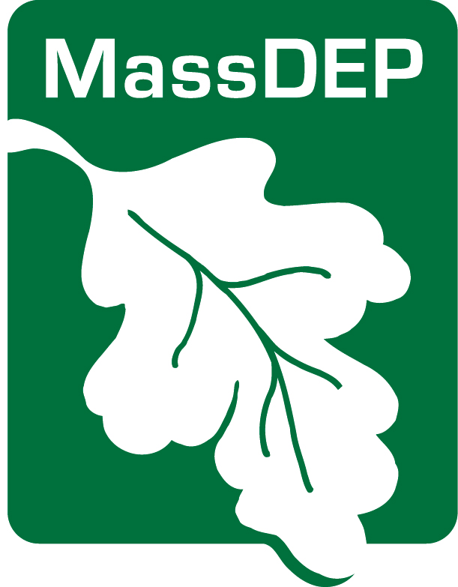
Drinking Water Program
Public Notification

CERTIFICATION

Make sure to send your regional office of the DEP Drinking Water Program and local board of health a copy of each type of notice and a certification that you have met all the public notice requirements within ten days after issuing the notice (310 CMR 22.15(3)(b)). When you certify, you are also stating that you will meet future requirements for notifying all new billing units or new customers of the violation or situation as specified by MassDEP.

PWS ID City/Town:

PWS Name: |  | Community Non-community
Describe the violation or
situation specified by MassDEP:
Occurring on:  Date(s) of violation or situation | NON Number  If applicable:
The public water system indicated above hereby affirms that public notice has been provided to consumers in accordance with 310 CMR 22.16 including: delivery, content, format requirements, notification deadlines and that the public water system will meet future requirements for notifying all new billing units or new customers of the violation or situation as specified by MassDEP.
Consultation with MassDEP on
date
Notice distributed by on
method date
AND

Notice distributed by on
method date
I certify under penalty of law that I am the person authorized to fill out this form and the information contained herein is true, accurate and complete to the best of my knowledge and belief.

date name

______________________________________________________________
Signature of owner or operator

Western Regional Office, 436 Dwight St., Springfield, MA 01103
Central Regional Office, 8 New Bond St., Worcester, MA 01606
Northeast Regional Office, 205B Lowell St. Wilmington, MA 01887
Southeast Regional Office 20 Riverside Dr., Lakeville, MA 02347
Boston – Program.Director-DWP@mass.gov

Rev. March 2019

