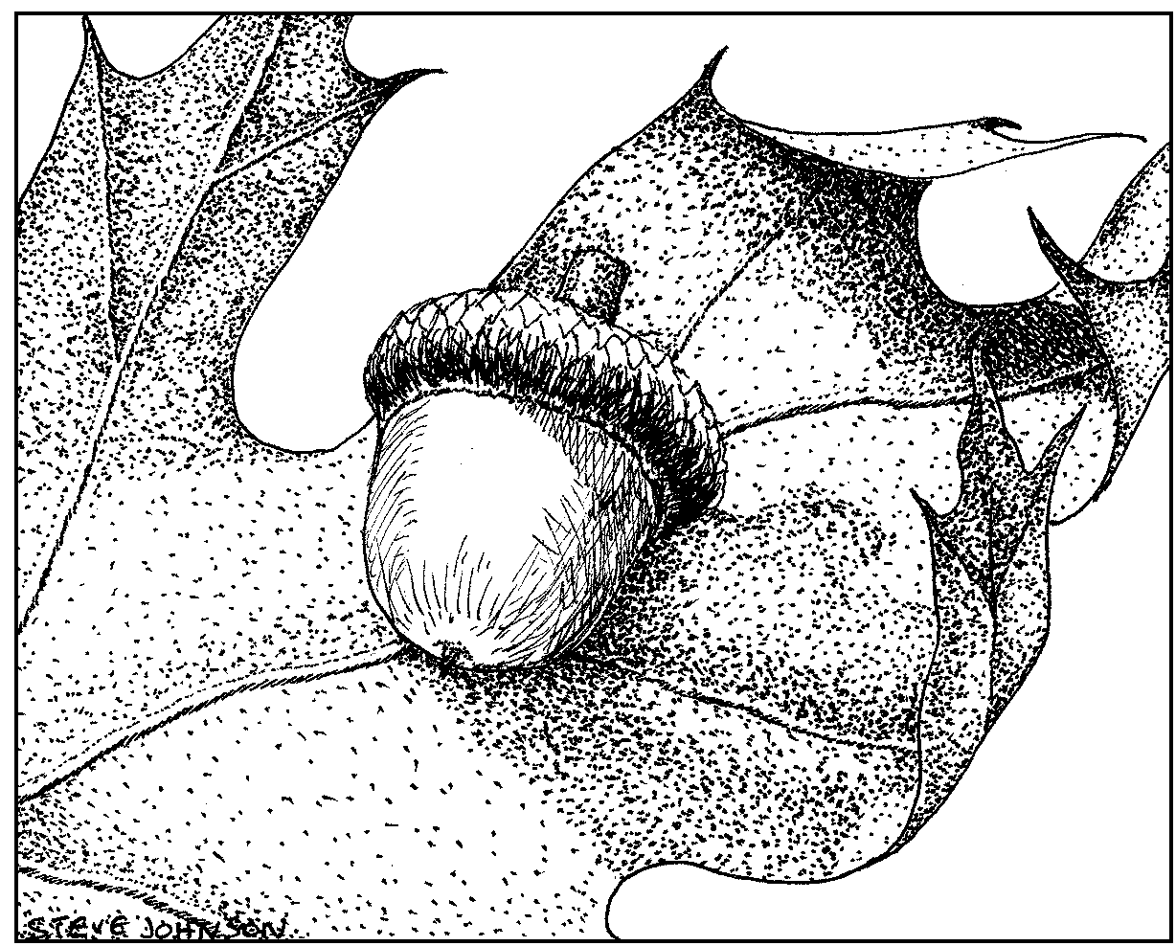
Forest Management Plan
Submitted to the Massachusetts Department of Conservation and Recreation for enrollment in CH61/61A/61B and/or Forest Stewardship Program

 | CHECK-OFFS |  |  |  |  |  | Administrative Box
CH61 |  | CH61A | CH61B | STEWARDSHIP |  | Cost Share | Case No. |  | Orig. Case No.
cert ☐ |  | cert ☐ | cert ☐ | new ☐ |  | EEA ☐ | Owner ID |  | Add. Case No.
recert ☐ |  | recert ☐ | recert ☐ | renew ☐ |  | Other ☐ | Date Rec’d
amend ☐ |  | amend ☐ | amend ☐ | Climate ☐ |  | Birds ☐ | Plan Period
 |  |  |  | Conservation Rest. ☐ |  |  | Rare Spp. Hab.
Plan Change to |  |  |  | CR Holder
OWNER, PROPERTY, and PREPARER INFORMATION
Property Owner(s)
Mailing Address Phone
Email Address

Property Location Town(s) Road(s)
Plan Preparer Mass Forester License #
Mailing Address Phone

RECORDS
Assessor’s Map No. | Lot/Parcel No. | Deed  Book | Deed  Page | Total  Acres | Ch61/61A  61B  Excluded  Acres | Ch61/61A  61B  Certified  Acres | Stewshp  Excluded  Acres | Stewshp  Acres
 |  |  | TOTALS

Excluded Area Description(s) (if additional space is needed, continue on separate paper)

HISTORY Year acquired Year Management began

Are boundaries marked: Yes ☐ blazed/painted/flagged/signs posted (circle all that apply) No ☐ Partially ☐
What treatments have been prescribed, but not carried out (last 10 years if plan is a recert.)?
stand no. treatment reason
(If additional space is needed, continue on separate page)
Previous Management Practices (last 10 years)
Stand # | Cutting Plan # | Treatment | Yield | Acres | Date
Remarks: (if additional space is needed, continue on separate page)

Page of

