Testimony of John Oliveira
Commissioner for the Massachusetts Commission for the Blind
Joint Committee on Ways and Means
Fiscal Year 2025 Budget
March 12, 2024

Good morning, Chair Williams, Chair Gomez, and distinguished members of the Joint Committee on Ways and Means. My name is John Oliveira, Commissioner of the Massachusetts Commission for the Blind (MCB). This budget cycle marks my first as Commissioner. I am grateful to Secretary Walsh for her confidence and trust in appointing me to this role this past September. However, I am no stranger to the agency. I have worked at MCB for more than 35 years, in almost every role, most recently serving as Deputy Commissioner for the past decade.

Helen Keller was one of the first commissioners when MCB was established in 1906. For 118 years, our agency has been serving residents of the Commonwealth who are legally blind. I am pleased to have this opportunity to testify today about the important work of our agency and how the Healey-Driscoll Administration’s proposed Fiscal Year 2025 (FY25) budget will support our efforts to provide individualized training, education, and empowerment to the approximately 30,000 residents of Massachusetts who are legally blind.

The Administration’s FY25 budget proposal funds MCB at $28.3 million, a 4.4% increase over Governor Healey’s FY24 H1 budget recommendation. The budget maintains our existing staff and provider workforce through annualizing collective bargaining agreements and provider rate increases. In addition, the proposal includes $250,000 to maintain the Legislature’s earmark in the FY24 GAA that enabled MCB to hire additional social rehabilitation counselors and rehabilitation teachers.

The proposed budget will allow us to continue important initiatives and sustain our three core programs for the community we serve in Massachusetts: Social rehabilitation to further independent living; Vocational rehabilitation to achieve employment; and Turning 22 to provide residential care, day programming, case management, and specialized services for residents who are DeafBlind, as well as residents who are legally blind and have other complex disabilities.

My team shared with you two charts that show the breakdown of our consumers by county and age. More than two-thirds of the residents we serve are aged 60 or older, with the average age being 81. Age-related vision impairment exceeds any other etiology in Massachusetts. The chart below provides a representation of the occurrence of vision loss by county and the causes of vision loss. The data stems from a project funded by MCB which explored the delta between legal blindness (20/200) and vision loss.

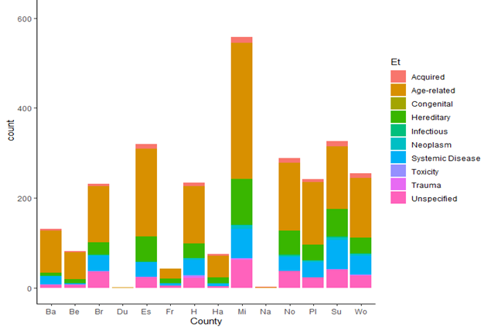

Source: New England College of Optometry. (2020). Understanding the Delta Between Legal Blindness and Visual Impairments. Massachusetts Commission for the Blind. https://www.mass.gov/doc/understanding-the-delta-between-legal-blindness-and-visual-impairments/download

As an excerpt from the report states the following on the prevalence of low vision now and in the future:

Most irreversible low vision conditions in the United States are caused by age-related eye diseases. These include age-related macular degeneration, diabetic retinopathy, and glaucoma as the most common. Eighty percent of Americans with low vision are over age 65. Although the annual death rate in the elderly low vision population slows the rate of growth in prevalence, the aging of the U.S. population is accelerating as the generation known as the “baby boomers” move into their older years. Thus, the number of people with low vision is expected to double over the next two decades.

Last spring, MCB contracted with MassINC to conduct a comprehensive survey of our consumers. The results showed our ability to make a meaningful difference in the lives of the people we serve.

Those who received services from us reported high levels of satisfaction. Perhaps more importantly, they reported a better quality of life, higher level of satisfaction with social relationships, greater rates of independent living, and use of multiple modes of transportation. The survey found ample evidence we are providing quality services that are making an appreciable, and appreciated, difference in the lives of our consumers.

But as in any complex social services undertaking, there is room to grow. We are excited to use these results to develop, improve, and provide programs and services that help the residents of the Commonwealth who are legally blind break down barriers and live life on their own terms. We plan to target certain populations for additional outreach to ensure every consumer has the chance to benefit from our services.

With independence as the primary goal, we help people build adaptive skills through all our programs and services. The goal of our vocational rehabilitation program is to help our consumers retain, return to, or secure employment. We assist them in pursuing career pathways to higher wage employment. Our transition services provide teenagers with opportunities for learning independent living, job skills, or support for higher education and training.

We are driven by the motivation of our consumers to achieve or sustain their economic independence, self-reliance, and social integration at a level consistent with their interests, abilities, and informed choice. Consumers who receive our services learn or re-learn skills and become successful and active members of their communities. With appropriate adaptive skills training, and assistive technology instruction, many limitations due to vision loss can be overcome. Perseverance, adaptability, respect, resilience, and inclusion are the focus of MCB.

Every staff member is committed to delivering services and to making a difference in the lives of the people we serve.

We are grateful for the Legislature’s unwavering support. As always, I want to thank you for the opportunity to speak to you today and look forward to working with you as we continue to provide vital programs and highly individualized services to our consumers. I am happy to answer any questions you may have.

