The Commonwealth of Massachusetts
Executive Office of Health and Human Services
Department of Public Health
Bureau of Infectious Disease and Laboratory Sciences
305 South Street, Jamaica Plain, MA 02130
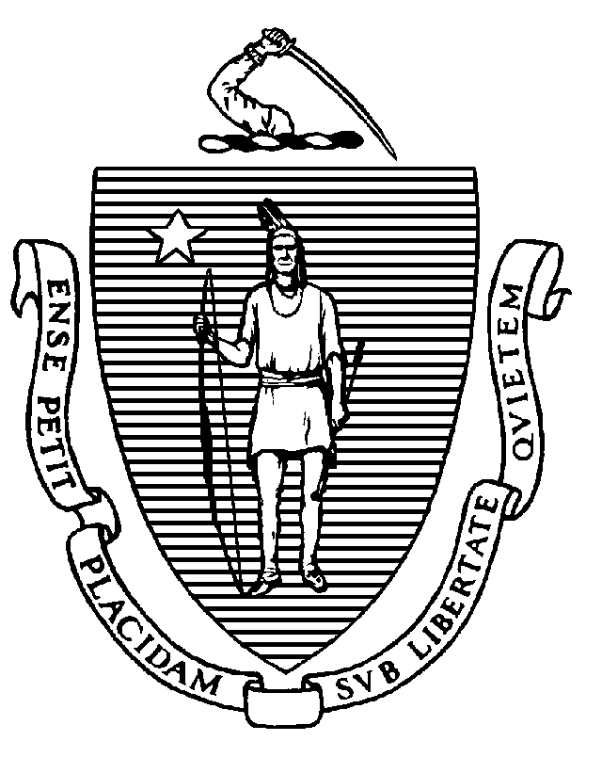

KATHLEEN E. WALSH
Secretary
ROBERT GOLDSTEIN, MD, PhD Commissioner

Tel: 617-624-6000
www.mass.gov/dph

MAURA T. HEALEY
Governor
KIMBERLEY DRISCOLL
Lieutenant Governor

To: School Health and School Nurses
Local Boards of Health
Exchange and Visiting Student Program Administrators
School Administrators
Healthcare Providers

From: Angela Fowler, MD, MPH
Associate Medical Director for Vaccine Preventable Diseases
Bureau of Infectious Disease and Laboratory Sciences

Date: March 1, 2024

Subject: Immunization Requirements Apply to International Students at All Grade Levels

Measles is a highly contagious, potentially very serious illness, which continues to occur in the United States largely due to importation. Although measles has been eliminated in the US, international travelers continue to bring measles into the US. Currently, there is a substantially increased threat for measles importation to the US related to a dramatic rise in the number of measles cases worldwide. Notably, the Centers for Disease Control and Prevention (CDC) recently issued an alert about several cases of measles occurring in the US related to international travel - to date, 11 states have reported measles cases in their jurisdictions since December 1, 2023.

Measles is one of the world's most contagious diseases and can spread very quickly and cause outbreaks among people who are not vaccinated. Community-wide vaccination with the measles-mumps-rubella vaccine (MMR) is the most effective way to prevent measles. The MMR vaccine is very safe and effective. All children should receive two doses of MMR vaccine to ensure they are immune. The first dose is usually given at 12–15 months and a second dose given at ages 4 to 6 years. Teens and adults who were not vaccinated as children should receive two doses of MMR vaccination. The CDC suggests that 95% of the population needs to be fully vaccinated or immune to achieve herd immunity to protect individuals and communities from outbreaks.

It is required and extremely important that all persons participating in educational programs in Massachusetts are up to date with MMR vaccine and all other required vaccines. Massachusetts regulations specify the immunizations required of students before admission to school (105 CMR 220.000: IMMUNIZATION OF STUDENTS BEFORE ADMISSION TO SCHOOL). These regulations include “any individual from another country attending or visiting classes or educational programs as part of a formal academic visitation or exchange program.”

Student shall mean any individual attending, or enrolled or registered to attend, a pre-school program as defined in 105 CMR 220.400, kindergarten through 12th grade in a public or private school, or a postsecondary institution, as defined in 105 CMR 220.600, provided the educational program is offered either on or off-site in Massachusetts. The term student shall also include any individual from another country attending or visiting classes or educational programs as part of a formal academic visitation or exchange program.

These regulations apply to all such visiting students, even if their program is for a short duration.

School personnel should collect immunization records at every grade level from students whose immunization requirements have not yet been satisfied.
Please ensure that pertinent individuals in administrative offices and health sections within your institution or town are aware of the immunization requirements. Please work together to make implementation of vaccine requirements a formal part of any international exchange program or academic visitation program in your jurisdiction, at public and private schools at all grade levels including high schools and post-secondary institutions.

For questions about vaccine preventable diseases, please call the Divisions of Epidemiology and Immunization at 617-983-6800 and ask to speak to an epidemiologist.

- More information about school requirements and vaccination can be found at https://www.mass.gov/info-details/school-immunizations.

Please forward this memo to pertinent colleagues in your staff, institution, and municipality.

