How to Request a Certified Statement of Registration for a License
Please follow the instructions below to Request a Certified Statement of Registration for a License on the external site.
Step 1: Sign into the external site.
Step 2: If you have NOT already linked a license to this account, you may skip this step.
Select the View Other Types button on the Other License, Certification, and Registration Types card at towards bottom of the page.
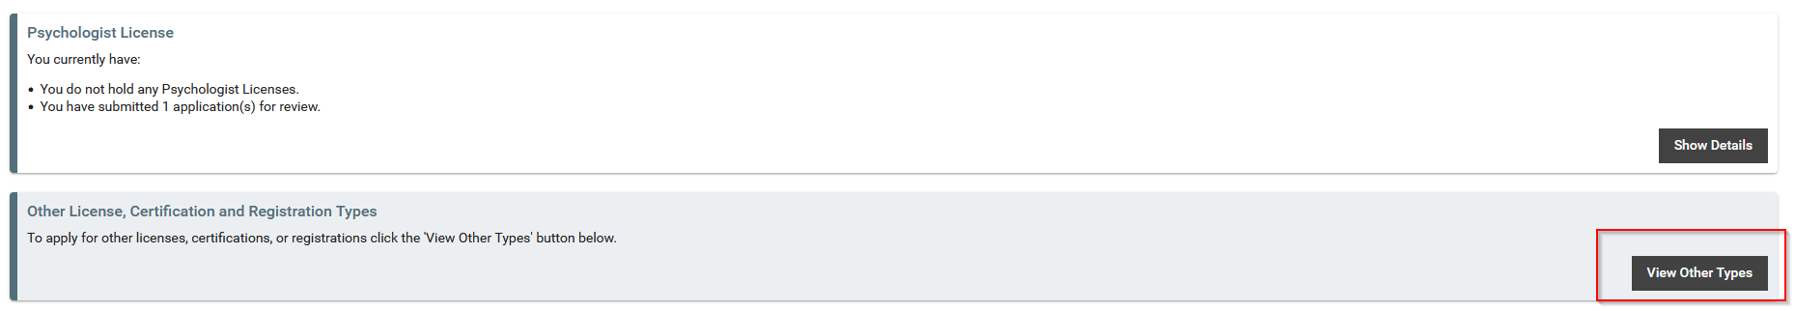

Step 3: Select View More from the Request a Certified Statement of Registration card towards the top of the page.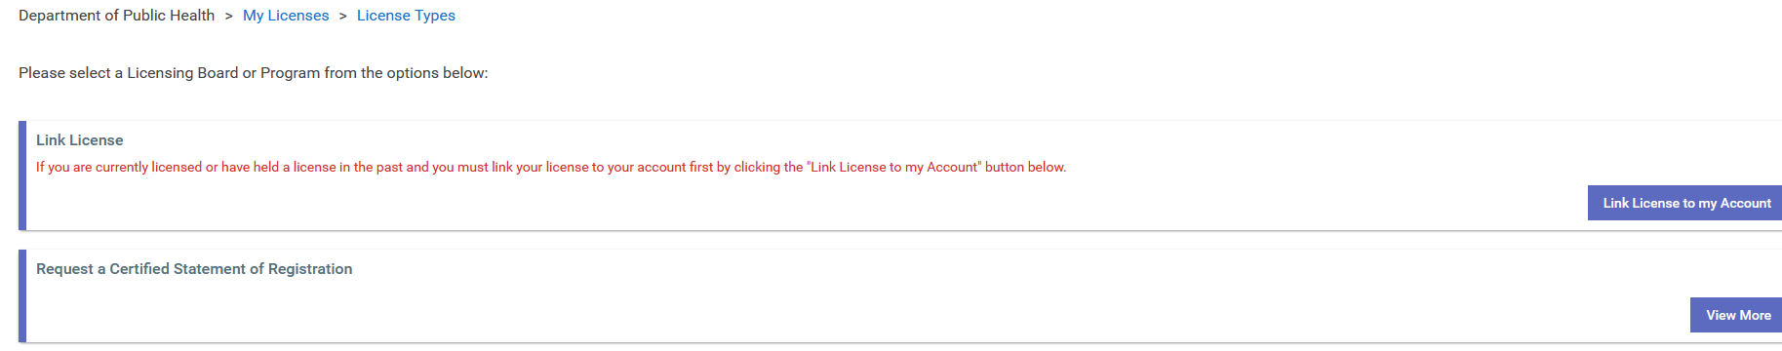

Step 4: Select Start Application from the Certified Statement of Registration Request Card.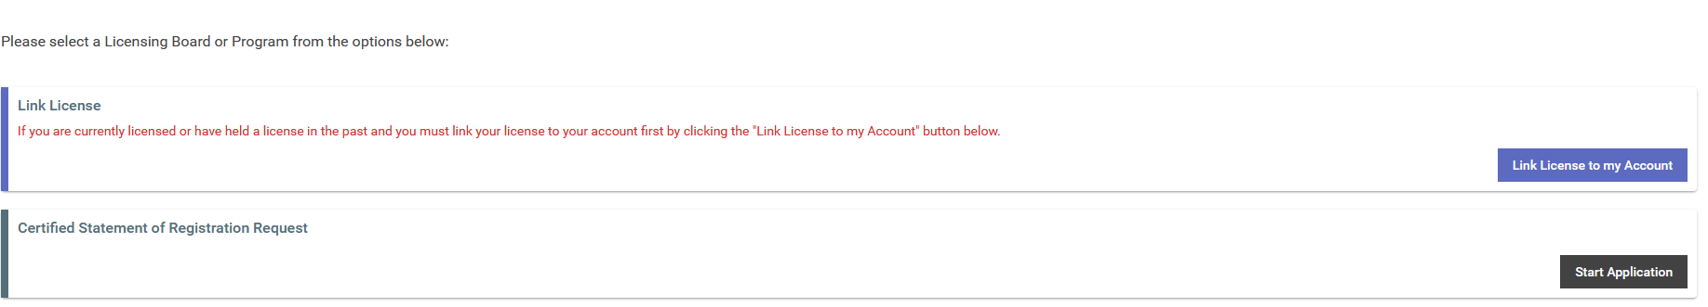

Step 5: Complete the application, pay, and submit.

