Hepatitis C
Hepatitis C Virus (HCV) Testing Practices: Key Findings from an
Assessment of Clinical Laboratories in Massachusetts, 2022

August 2023
The Massachusetts Department of Public Health (DPH) estimates that more than 250,000 people in Massachusetts have hepatitis C infection. Treatment is highly effective, and testing to identify infection is critical in engaging people in treatment and preventing transmission.
In 2022, DPH surveyed 57 Massachusetts clinical laboratories to assess current HCV testing practices. The self-administered survey examined laboratory practices related to test ordering, types of tests performed, and reflex testing. Over 80% (46 laboratories) completed the survey. At the time of the survey, HCV testing was available through 44 (98%) Massachusetts-based laboratories. Key findings for these 44 laboratories are presented here.
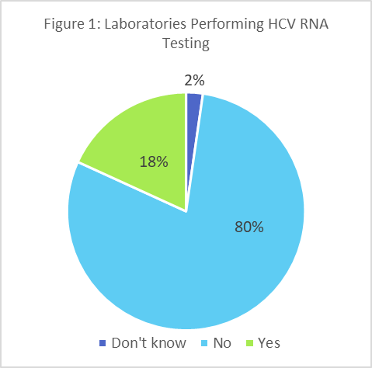
Current Hepatitis C Testing Capacity. The majority (75%) of laboratories reported performing antibody testing “in-house,” while the remaining laboratories referred these tests to other clinical or commercial laboratories. Those laboratories that perform HCV antibody testing reported performing in excess of 400,000 antibody tests in 2021. The majority (80%) of laboratories do not perform HCV RNA testing in-house, and instead refer HCV RNA testing to other clinical or commercial laboratories (Figure 1). Among laboratories reporting in-house RNA testing (18%), more than 15,000 HCV RNA tests were conducted in 2021.
Test orders accepted: Of these 44 laboratories, 36 (82%) reported that their test ordering system permits clinicians to order hepatitis C antibody testing with reflex to RNA testing to identify active infection (Figure 2). However, 33 (75%) also permit clinicians to order antibody tests without the recommended reflex testing. Eight laboratories reported having no ordering option for antibody testing with reflex to HCV RNA testing; RNA testing must be ordered separately from antibody testing.
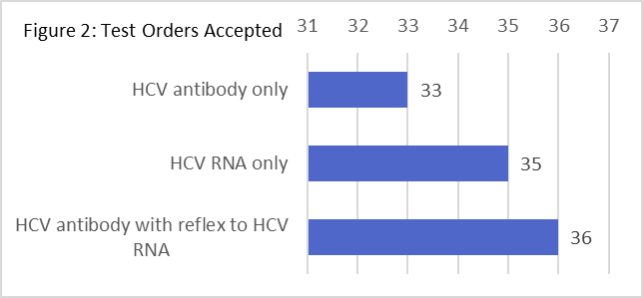

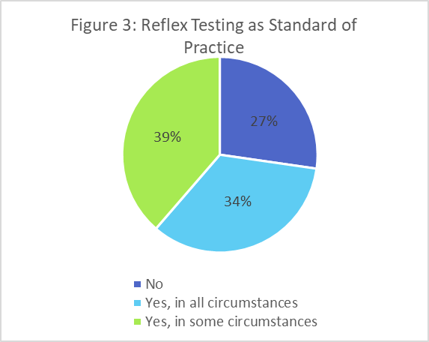
Hepatitis C RNA reflex testing practices: HCV antibody testing with reflex to HCV RNA testing (if the antibody test result is positive) is available in most laboratories — but is standard practice in only 34% of laboratories (Figure 3). For 39% of laboratories, reflex testing is available upon provider request or if testing is performed due to blood-borne exposures.
Among the laboratories that perform reflex testing in some or all circumstances, 65% report that reflex testing is performed on the same sample on which antibody testing is performed, while 29% reported using a second sample collected at the same time.The remaining laboratories reported requiring a second draw for RNA testing following a positive antibody test result.
Future plans for reflex testing: For 12 laboratories, testing for HCV RNA on reflex for positive HCV antibody test results was not performed at the time of survey. Of these laboratories, 11 indicated that they had no future plans to implement reflex testing.
Recommendations: Testing to identify HCV infection should be initiated with an antibody test. Positive/reactive results should be followed by an HCV RNA test, which is necessary to identify current hepatitis C infection and to initiate treatment. For most people, treatment for HCV infection is uncomplicated, highly effective, and can be initiated at the time of diagnosis. There is no need to wait for potential spontaneous viral clearance.
Laboratories are encouraged to adopt the CDC-recommended testing algorithm and implement reflex to testing for HCV RNA for all HCV antibody positive test results as a standard of practice. Antibody and RNA testing should be performed on samples collected from a single draw, either by spitting samples or drawing multiple tubes so that patients need not return for a second draw. These changes may require changes to test order processes and workflows.
Resources for laboratories:
- Recommended testing sequence for identifying HCV infection: cdc.gov/hepatitis/hcv/pdfs/hcv_flow.pdf
- Interpreting HCV test results: aphl.org/aboutAPHL/publications/Documents/ID-2019Jan-HCV-Test-Result-Interpretation-Guide.pdf
- Updated operational guidance for HCV testing: cdc.gov/mmwr/volumes/72/wr/mm7228a2.htm

