CHARLES D. BAKER
Governor
KARYN E. POLITO
Lieutenant Governor

The Commonwealth of Massachusetts
Executive Office of Health and Human Services Department of Public Health
250 Washington Street, Boston, MA 02108-4619

MARYLOU SUDDERS
Secretary
MARGRET R. COOKE
Commissioner

Tel: 617-624-6000
www.mass.gov/dph

ORDER OF THE COMMISSIONER OF PUBLIC HEALTH
COVID-19 Public Health Emergency Order No. 2022-18 Issued September 30, 2022

On May 28, 2021, pursuant to Section 2A of Chapter 17 of the General Laws, Governor Baker declared that an emergency exists that is detrimental to the public health in the Commonwealth due to the continuing threat of COVID-19, and authorized the Commissioner with the approval of the Public Health Council to adopt measures to facilitate COVID-19 testing and vaccination, to mandate special measures to protect higher risk populations or to effectuate continued surveillance of COVID-19, and to respond as necessary to outbreaks of the virus as they may arise.

Consistent with the Governor’s May 28, 2021 declaration, on June 9, 2021, the Public Health Council approved and authorized the Commissioner of Public Health to take such actions, incur such liabilities, and establish such rules, requirements and procedures which are necessary to prepare for, respond to, and mitigate the spread of COVID-19 in order to protect the health and welfare of the people of the Commonwealth.

Accordingly, having received that authorization from the Council and with the approval of the Governor, I issue the following Order:

- Registered nurses, licensed practical nurses and advanced practice registered nurses who are licensed in another State and who are not currently licensed in Massachusetts who present to the Board of Registration in Nursing before December 31, 2022 verification that such license is in good standing in that other State where it was issued shall forthwith be issued a corresponding Massachusetts license that shall remain valid until December 31, 2022. Nurses licensed under this provision may provide services within the scope of practice authorized by the applicable license, both in-person in Massachusetts and across State lines into Massachusetts using telemedicine where appropriate.
No such licenses shall issue for applications made to the Board of Registration in Nursing after December 31, 2022. This Order extends the earlier end date for issuance of such licenses by the Board specified in COVID-19 Public Health Emergency Order No. 2022-15.

- A board or licensing authority shall notify the Commissioner when it becomes aware of any individual instance where, due to special concerns, application of this Order may be contrary to the public interest. The Commissioner shall in her sole discretion determine whether to apply or suspend the terms of this Order in any such individual instance. This Order does not limit or otherwise alter the

authority of a board or licensing authority to take disciplinary action against a license, including but not limited to suspension or revocation.

- For purposes of this Order, the following terms shall apply:
“License” shall include a license, registration, certification or authorization.
“In good standing” shall include a license that is subject to probation or non-disciplinary conditions, but shall not include a license that is revoked, cancelled, surrendered, suspended, or subject to disciplinary restrictions.

- Any license extended pursuant to COVID-19 Public Health Emergency Order No. 2022-15 remains subject to the terms of that Order and shall be valid only until December 31, 2021

All applicable statutes, regulations, and guidance not inconsistent with this Order remain in effect.

This Order shall be effective immediately and shall remain in effect until December 31, 2022, unless extended or rescinded by me prior to that date, or the public health emergency is terminated by the Governor, whichever shall happen first. The recission or termination of this Order prior to December 31, 2022 shall not affect the continuing validity of a license issued or extended under its terms.

IT IS SO ORDERED.

Margret R. Cooke
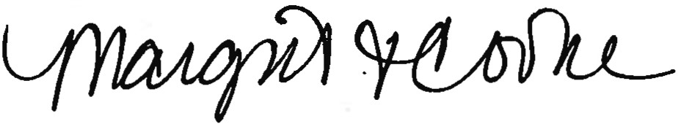
Commissioner, Massachusetts Department of Public Health September 30, 2022

