Massachusetts Department o f Public Health

C O V I D - 1 9 C o m m u n i t y
I m p a c t S u r v e y ( C C I S ) : R e f l e c t i n g o n I m p a c t & L o o k i n g A h e a d

April 2022
P r e s e n t e d b y L a u r e n C a r d o s o , P h D

1

C C I S
T E A M
M E M B E R S

CCIS Project Leads
W.W. Sanouri Ursprung, Lauren Cardoso, Beth Beatriz, Glory Song, Caroline Stack, Kathleen Fitzsimmons, Emily Sparer-Fine, Ta-wei Lin, Lisa Potratz, Heather Nelson, Amy Flynn, Lisa Arsenault, Abby Atkins
CCIS Steering Committee
Lauren Cardoso, W.W. Sanouri Ursprung, Beth Beatriz, Abbie Averbach, Ruth Blodgett, Ben Wood, Sabrina Selk, Jessica del Rosario Nicole Daley, Lisa Potratz
CCIS Analytic Team, Data to Action Team, Data Dissemination Team, Communications Team
Allison Guarino, Andrea Mooney, Angela Laramie, Ann Marie Matteucci, Anna Agan, Arielle Coq, Barry Callis, Beatriz Pazos Vautin, Ben Wood, Brittany Brown, Chelsea Orefice, Dana Bernson, David Hu, Dawn Fukuda, Ekta Saksena, Elise Pechter, Emily White, Fareesa Hasan, Frank Gyan, Glennon Beresin, Hanna Shephard, Hannah Walters, Hermik Babkhanlou-Chase, James Laing, Jena Pennock, Jennica Allen, Jennifer Halstrom, Justine Egan, Kathleen Grattan, Kim Etingoff, Kirby Lecy, Lamar Polk, Lauren Fogarty, Lauren Larochelle,
Mahsa Yazdy, Marianne Mabida, Matthew Tumpney, Megan Hatch, Megan Young, Melody Kingsley, Michelle Reid,
Miriam Scrivener, Nassira Nicola, Nicole Daniels, Nicole Roos, Rebecca Berger, Rebecca Han, Robert Leibowitz, Susan Manning, Thomas Brigham, Timothy St. Laurent, Vera Mouradian, Victoria Nielsen, Ziming Xuan, Elizabeth Showalter, Priyokti Rana, Mayowa Sanusi, Emily Lawson, Alana LeBrón
2
3.09.2022 Release

Many groups that were critical in the success of this effort and gave important input on the development and deployment of the survey:

- Academic Public Health Volunteer Corps and their work with local boards of health and on social media
C C I S
C O M M U N I T Y
P A R T N E R S
- Mass in Motion programs, including Springfield, Malden,
and Chelsea
- Cambodian Mutual Assistance
- The Mashpee Wampanoag Tribe
- The Immigrants’ Assistance Center, Inc
- Families for Justice as Healing
- City of Lawrence Mayor’s Health Task Force
- The 84 Coalitions, including the Lawrence/Methuen Coalition
- Boys and Girls Clubs, including those in Fitchburg
and Leominster and the Metro South area
3.09.2022 Release
- Chinatown Neighborhood Association
- Father Bill’s
- UTEC
- MassCOSH
- Stavros Center for Independent Living
- Greater Springfield Senior Services
- Center for Living and Working
- DEAF, Inc.
- Massachusetts Commission for the Deaf and Hard
of Hearing
- Viability, Inc.

3

Why did we conduct the COVID-19 Community Impact Survey (CCIS)?

4

B A C K G R O U N D

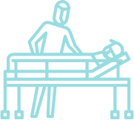
Context
The pandemic is exacerbating pre-existing public health concerns and creating new health crises to address. Even people who have not become sick with COVID-19 are managing stress, uncertainty, and isolation during this challenging time. DPH and its partners need real time data to prioritize resources and inform policy actions.

Goal
DPH conducted a survey to understand the specific needs of populations that have been
disproportionately impacted by the pandemic, including its social and economic impacts.

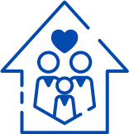
Actions
DPH will use and share these data to prioritize our pandemic response and to create new, collaborative solutions with community partners.

5

How did the CCIS fill these data gaps?

6

P R E C I S I O N P U B L I C H E A LT H DA T A N E E D S
The Need

Timely & nimble enough to capture emerging health needs | Detailed enough to illuminate not just disparate outcomes but also actionable root causes of these inequities | Granular enough to tell us where to tailor efforts to certain geographies and populations | Cross cutting enough to inform how related content areas across the department intersect and should be coordinated

C C I S A P P RO A C H
- Conducted a self-administered online survey (fall 2020) with over 33,000 adults and 3,000 youth in the
final sample
  - Paired with population specific focus groups
- Covered a wide range of topics specific to adults and youth respectively
  - Perceptions & experiences of COVID-19, Basic needs, Access to healthcare, Pandemic-related changes in employment, Mental health, Substance use, and Safety
- Available in 11 languages; additional focus groups also conducted in ASL
- Open ended questions captured previously unknown needs and barriers
- Weighted results to the state average, with different weights applied to youth and adult samples
- Recruitment via network of community-based organizations (CBOs)
- Employed a snowballing sampling strategy to ensure we reach key populations
  - eg. People of color, LGBTQ+ individuals, People with disabilities, Essential workers, People experiencing housing
instability, Older adults, and Individuals living in areas hardest hit by COVID-19

The Need
D A T A I N N O V A T I O N S

Community engagement at every point ensures better questions, answers, and interpretation (eg. question development, pilot testing, recruitment, focus groups, dissemination)

Developed a novel weighting/sampling approach scalable across DPH to generate granular results

Mixed methods – focus groups and open responses allowed us to hear more nuanced stories and unknown health needs.

Population focused not condition focused- high representation by race, ethnicity, sexual orientation, gender identity, transgender status, types of disability, education, language spoken, industry/occupation, geography, employment status, age, etc.

A C T I O N I N N O V A T I O N S

Built in Action workstreams (eg. data to action workgroup; public data access workgroup; community data technical assistance; contextualized webinars; and web reports.

Build racial and social justice framing and call to action to aid external audiences in acting on findings

Built in community engagement infrastructure to rapidly get direct
community input and get data back to community
?
Sheds light on light on both “who” and “why” MA residents have been impacted, not just the “what” – (captures intersection of multiple root causes like occupation; SDOH: childcare; ability to socially distance)

Did it work?

11

O U R E F F O R T S W E R E S U C C E S S F U L

Unprecedented sample sizes allow results by number of groups including:
  - race, ethnicity, substance use history, incarceration history, sexual orientation, gender identity, transgender status, types of disability, income, education, language spoken, industry/occupation, geography, employment status, age, etc.
- Compared to past surveillance surveys, CCIS priority population samples reached:
- 10x as many Alaska Native/Native Americans
- 10x as many LGBTQ respondents
- 5x as many residents who speak languages other than English
- 5x as many Hispanic residents
- 5x as many Asian residents
- Over twice as many respondents in other populations including the deaf/hard of hearing and Black community

*example comparison rates were calculated in comparison to the 2019 Behavioral Risk Factor Surveillance Survey (BRFSS) sample sizes
12

as likely to lose someone close to them due to COVID-19, compared to all youth
faced housing insecurity (50% more than respondents not parents)

lost their job (2nd highest among all
CCIS ethnic groups)

reported experiencing poor mental health 15+ days in the past month and

SOME KEY POPULATION- FOCUSED FINDINGS

to worry about getting
food or groceries, compared to

reported feeling sad
or hopeless for 2+ weeks in past year
respondents without a cognitive disability

as likely to worry about getting access to broadband than White NH
respondents
as likely as White Non-Hispanic adults to change the status or nature of their employment to take care of children.

respondents experienced racial discrimination during the pandemic

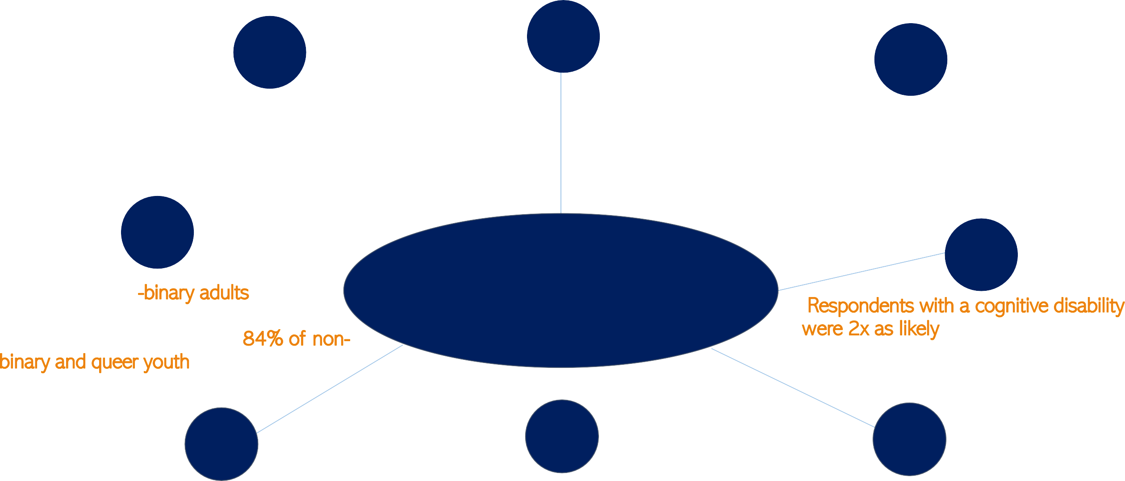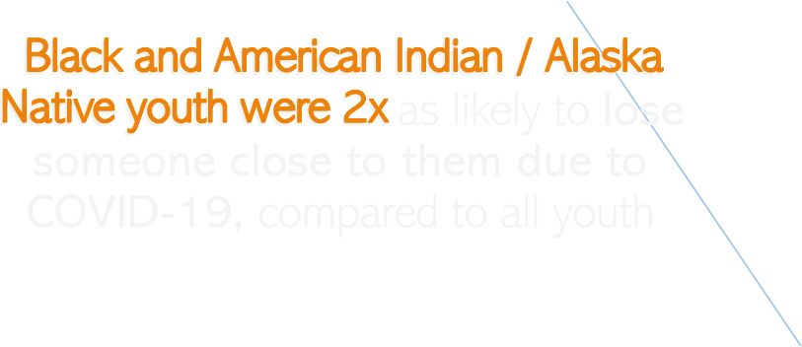

These innovations enabled us to share contextualized, granular data internally and to the public in an unprecedented
way.
14

26 reports released
1 Interactive dashboard
25 webinars recorded
5 live webinar events
12 PHC presentations
30+ data presentations(to DPH staff, interagency workgroups, community groups, committees, advisory groups, national organizations, etc.)
29K+ views on the CCIS website
25+ data to action discussions across DPH
7 DPH bureaus involved
60+ DPH staff volunteering to support
11 focus groups conducted
19 town/county level metrics released in tables
37 free text questions hand coded 39,206 free text responses hand coded 50+ CCIS Tweets from DPH Twitter
118 key findings released in our Q&A document

C C I S I N N U M B E R S

15

A V A I L A B L E C H A P T E R S & R E C O R D E D W E B I N A R S

Adult Survey
- General Methods/Descriptive Stats
- Personal Risk Mitigation
- Access to Testing
- Access to Healthcare
- Social Determinants of Health
- Vaccine Implications
- Mental Health
- Employment
- Substance Use
- Intimate Partner Violence
- Parents & Families

Youth Survey
- Part 1 - Mental health, changing responsibilities, and COVID experiences and perception
- Part 2 - Education and employment
- Part 3 - Youth safety and healthcare access

Population Spotlights
- Young parents
- Persons with disability
- Sexual orientation and gender identity (SOGI)
- Asian American and Pacific Islander (AAPI)
- Black
- American Indian and Alaskan Native (AI/AN)
- Hispanic/Latinx
- Discrimination/Framing Matters
- Housing
- Rural Communities
- Caregivers: adults with special needs and parents of children & youth with special healthcare needs
- Essential workers
- Coming soon: Older Adults

A C C E S S I N G C C I S D A T A / A N A LY S I S

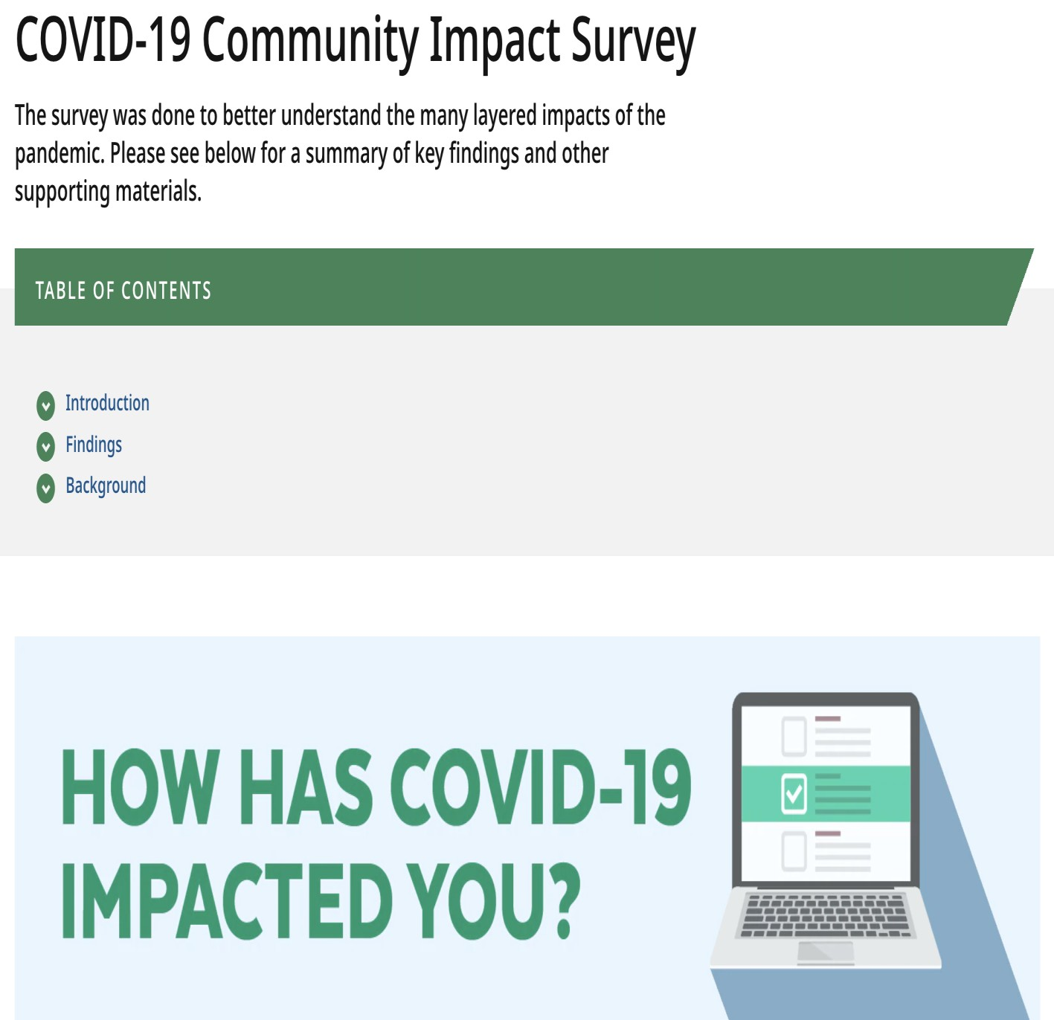
CCIS Data is posted on its own webpage:
●
●
  - https://www.mass.gov/covidsurvey

On the website you will find:
- Complete slide deck of all the CCIS data that has been released to date.
- Recorded webinars for each of the chapters
released to date
- Data tables with CCIS data by MA county, municipality, and demographic groups.
- Q&A document with more information about the survey and high-level talking points from each chapter and spotlight.
- Interactive dashboard

These innovations also enabled us to create critical change across the
Commonwealth
18

Population-focused

IMPACT

Prioritized inclusion of previously invisible populations
“We have been data poor, relying on limited data sources with small sample sizes. The kids and families we serve have great needs and have been historically unseen & unheard. The CCIS has provided a rich resource for us to make smart, strategic, evidence-based decisions that can make a difference in their lives.”
- CCIS Partner

48% of Parents of Youth and Children with Special Health needs reported persistent poor mental health (vs. 30% of other parents)

Share needs of populations at state-level to inform policy making, in this case elevating need for respite care to be covered by Mass Health

Population-focused

IMPACT

Utilized data standards that are granular, inclusive, and reflective of populations’ experiences

Codify equity in other data collection systems

Mass Health is adopting the use of our rural definitions

BMC’s Pediatric ED is utilizing CCIS SDOH questions

MAVEN now uses SOGI data standards

IMPACT
“Native Americas were once again visible in the
data…The fact that CCIS connected the bureau with tribal members to pilot and then took their feedback and brought the data back was so important.”

- CCIS Partner

Strengthened trust in DPH in communities where there is a history of distrust
Community Engagement
Prioritized community
engagement with historically marginalized communities

Action workgroups

IMPACT

Were nimble and shared breaking needs data for prioritization

“With CCIS data in mind, VEI prioritized improving vaccine access to people with disabilities. In the disability setting,
people got vaccinated who wouldn’t have because of CCIS data.”
- CCIS Partner

CCIS illustrated the many unique barriers persons with disabilities face in accessing information and services related to COVID risk mitigation

Initiatives could quickly pivot to meet the needs of priority populations.

Racial & Social Justice Frameworks

IMPACT

Utilized social justice framing when releasing results that drew linkages between inequities and systemic drivers

Normalize the inclusion and naming of systemic drivers of inequities (structural racism, heterosexism, ableism) as health priorities
Health systems, municipalities and other entities conducting health needs assessments and improvement plans across the state, stated that the CCIS reports provided them with the evidence and framing needed to prioritize these systemic drivers in their health assessments and associated funding allocations.

We didn’t do everything right and learned
some lessons about where we can
improve

Challenges Solutions
L E S S O N S L E A R N E D
Time & human resource constraints
Building a team

In roads with some priority populations
Built relationships, will continue to do so

CBOs stretched thin
Provide financial support where possible

Distilling results into digestible formats
Building communications strategy

Being fully accountable to partners
Consider full spectrum of work & engagement

We are now building on these lessons learned to create a sustainable data system that continues to engage communities, move our work upstream, and center health and
racial equity.

Reduce inequities in health outcomes, including outcomes experienced during the pandemic

Build a sustainable data system centered on racial and health equity to identify and support policy and practice ACTION

Strengthen Relationships with Key Partners Using Core Community Engagement Principles
V I S I O N F O R C C I S 2 . 0

Replicate Successes and Incorporate
Lessons Learned from CCIS 1.0

